Archive courses that don’t have reading lists
Build a set of courses without reading lists:
Go to Admin > Manage Sets
Select Add Set and choose either logical or itemized
Choose Set content type: Courses
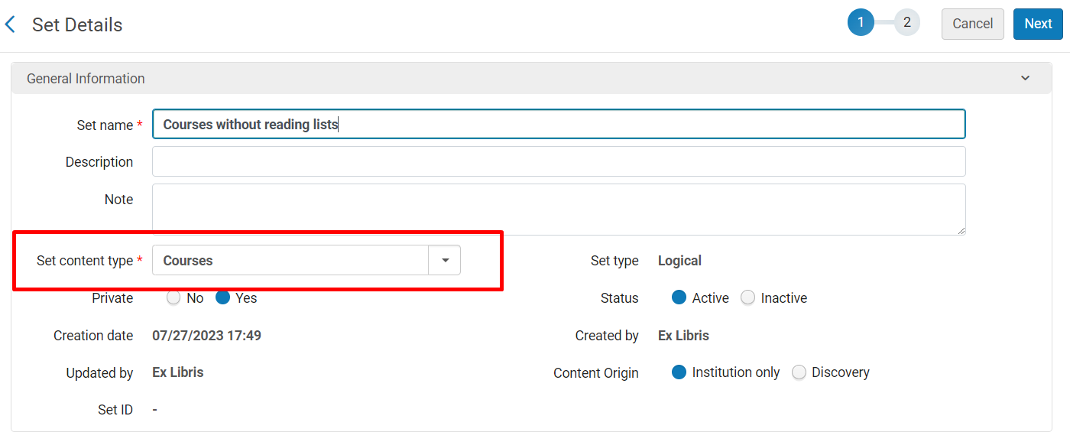
Click Next
The courses screen includes a filter for Associated Lists. Choose None to see all courses that don’t have a reading list
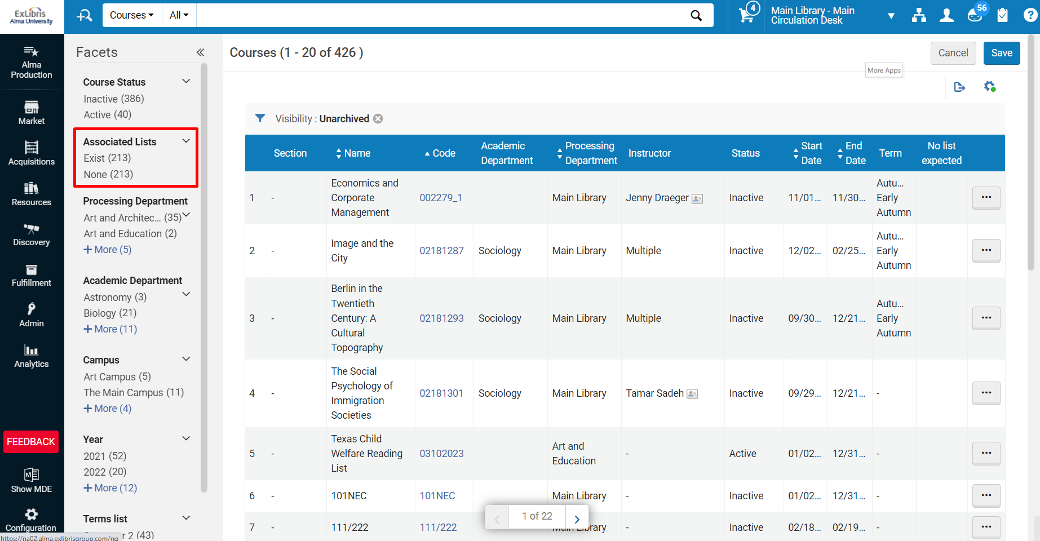
From there, add additional filters as needed (course year may be helpful) and choose Save
Archive the courses:
Go to Admin > Run a Job
Find the Course Bulk Update job
Select your new set
On the Enter task parameters screen, select Set course visibility and choose Archived from the drop down:
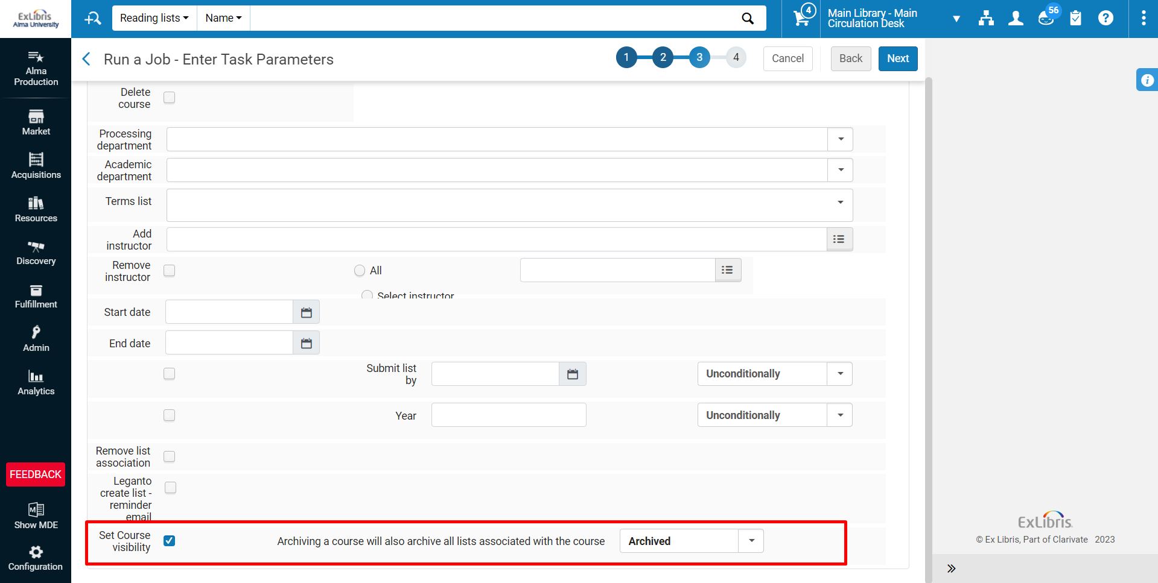

NOTE: You can choose to either delete courses or archive courses from this screen. We recommend archiving because the data about the courses is preserved in analytics. In knowing that the courses existed, you could potentially build reports such as “what percentage of courses in a given department had reading lists”.
Select Next to review the job parameters, then click Submit.

See:
Video: Archiving Courses in Leganto
Documentation: Manual Jobs
Documentation: Managing Search Queries and Sets

