Getting to Know Alma
Requests

Request a Physical Item
This document includes one exercise that reviews what you have learned in the Fulfillment Requests session, including how to place a request on a physical item.

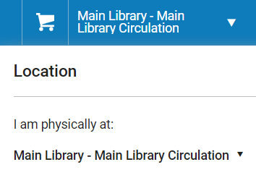
For this exercise you will need to be logged into Alma and have Fulfillment privileges and set your location as the Main Library – Circulation desk.

In this exercise you will be requesting a physical item. To complete this exercise, you will need:
- An active patron account.
  - To find a patron account, on the left-hand menu go to Admin > Manage Users. Click the Public tab and select a patron that has an account that is not expired. Write down their first and last name.

- In the persistent search bar at the top of the page change the search type to All titles and index to Keywords. Leave the search scope as Institution, then enter a keyword or title for the collection you want to activate.

- Click the magnifying glass to search.

- Use the Facets to narrow your search, if needed. | 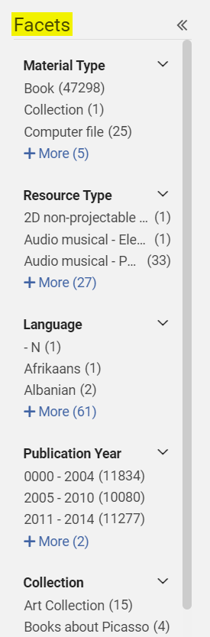
- In the item row click the Physical tab to see the current holdings. | 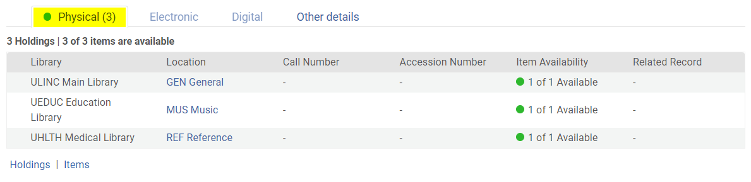

- Click the row action tool and select Request. | 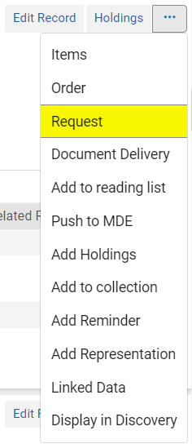
- Open the Request Type drop-down. This is for a physical item, so you’ll choose Patron physical item request. | 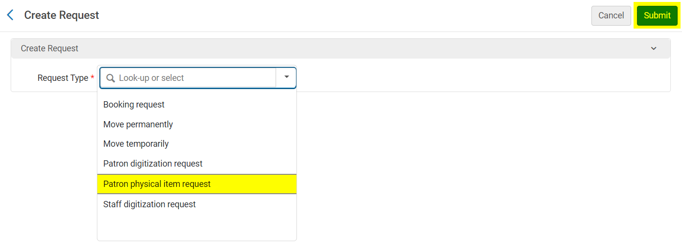
- Search for the patron by either typing in their name or clicking the Select from a list 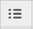 button.  - You can change the pickup location if needed  - Click Submit when you’re done entering information. | 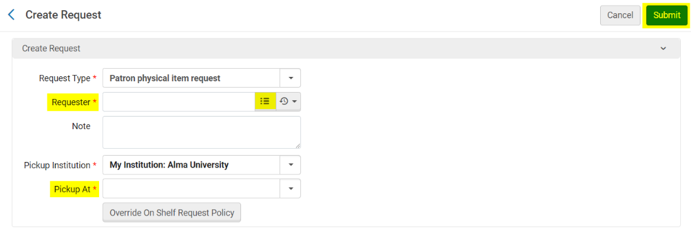
The item has been requested! More information can be found in the documentation.

