Enable students to filter citations by online access
Some institutions want students to be able to filter reading lists to easily see all citations which are available online. You can do provide this option by creating an “Online access” tag and adding it to the relevant citations. It is possible to add the tag in bulk.
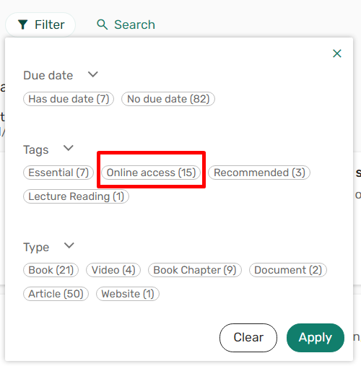
- Configure the Online access tag
Creating a new tag is a two-step process.
Go to Fulfillment Configuration > Courses > Tags and add the Online access tag. Save your changes.
Then go to Fulfillment Configuration > Courses > Tag Mapping. Add a row and map your tag to either section or citation level and choose the tag visibility. Set the tag visibility to Public so students will be able to see the tag.
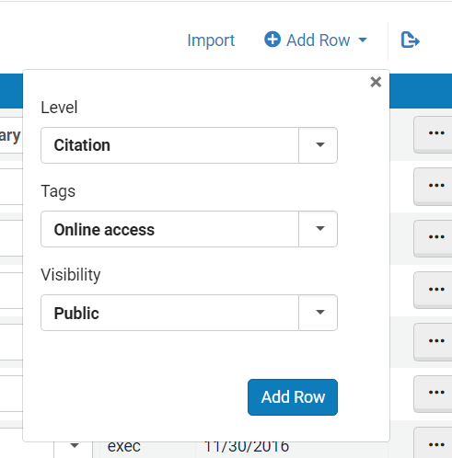
See: https://knowledge.exlibrisgroup.com/Alma/Product_Documentation/010Alma_Online_Help_(English)/030Fulfillment/080Configuring_Fulfillment/070Courses#Configuring_Citation_and_Section_Tags
- Identify all citations with online access
There are two analytics reports that you can use to identify citations with online access.
- Shared Folders/Community/Reports/Shared Reports/Reports/Leganto Course Reading lists/Ex Libris—Electronic items on reading lists. This will give you all citations linked to an MMSID with e-inventory.
- Shared Folders/Community/Reports/Shared Reports/Reports/Leganto Course Reading lists/Library resources without MMS ID. This shows items on reading lists that are covered by the library but don’t have an MMS ID (accessed via Link Resolver)
You may want to filter the reports to show a more specific list of citations.
Note that these reports will not include citations with uploaded files, DCS links, or websites. It is possible to build a report to show such citations. For uploaded files, use the report parameter Citation Uploaded file (Reading list Citations). For resources provided via the DCS, use the report parameter CLA/DCS Link (Reading List Citations).
Ensure the report includes the Citation ID. Export the file and create a set from a file or create a set from the Alma Analytics report. To create a set from an analytics report you will need to save a copy of the report to your institution’s folder.
- Add the tag to citations in bulk
Use the Reading List Citation Update Task (Admin > Run a Job). Run it against the set of records you created in step 2 above. In the Add tags section, select your Online access tag. Complete the job wizard to run the job.
See: https://knowledge.exlibrisgroup.com/Alma/Product_Documentation/010Alma_Online_Help_(English)/050Administration/070Managing_Jobs/020Manual_Jobs_on_Defined_Sets

