Linking to Leganto resource lists--New UI
Background:
Once a reading list exists, librarians, instructors and students can easily link to the list, to specific sections or to specific items within the list.
Leganto supports two types of links:
- Shareable links: Shareable links can be used anywhere. Users can paste links into a syllabus, website, email, or other document. Shareable links can be used by any user, assuming they have permission to view the list.
- LTI links: LTI links can be used only in the learning management system (LMS). Links must be added to the LMS as an external tool link.
 | Shareable links | LTI links
Use | Anywhere | In the learning management system, with Leganto previously set up as an external tool.
Authentication | User might be authenticated via SSO or might be prompted to log in.  Can be used by guest users. | The user ID and course code are passed as part of the LTI link. The user is automatically authenticated and directed to the correct list for the course.
“Course Students” | Lists published to “Course students” can only be accessed via a shareable link if the student has accessed the course via an LTI link or been enrolled in the course in Alma, | Lists published to “Course students” can only be accessed via LTI link. The student can access the course in the LMS and is therefore authorized as a student in the course.

Users have two options for generating links to lists, sections or items:
- Copy link from “Share” icon in Leganto
  - Shareable links
  - LTI links: Users can paste the link into the LMS as an external tool link. For information about how to paste LTI links per LMS, see Direct Linking on the Ex Libris Developer Network.
- Create LTI link using external tool in LMS
Copying links:
When enabled by the library, users can click on the share icon to copy a link:
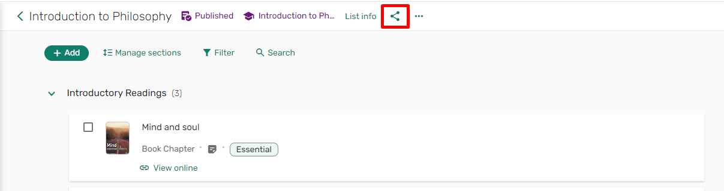
Share link to list
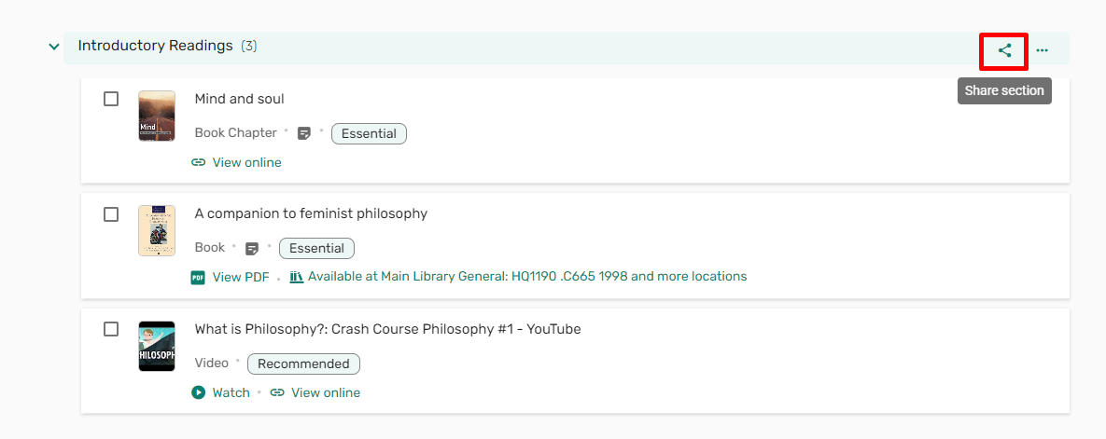
Share link to section
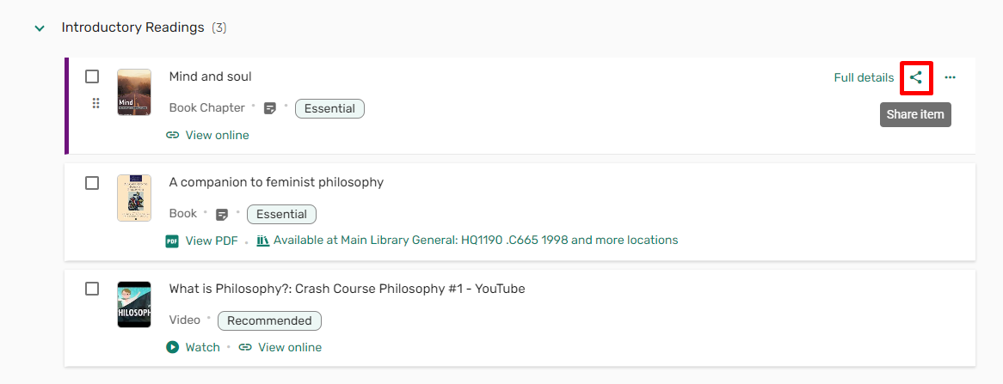
Share link to item

LTI links can only be generated when accessing Leganto via an LTI link. They can only be used in the LMS.
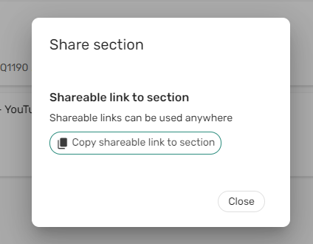
Share section when accessing Leganto via standalone
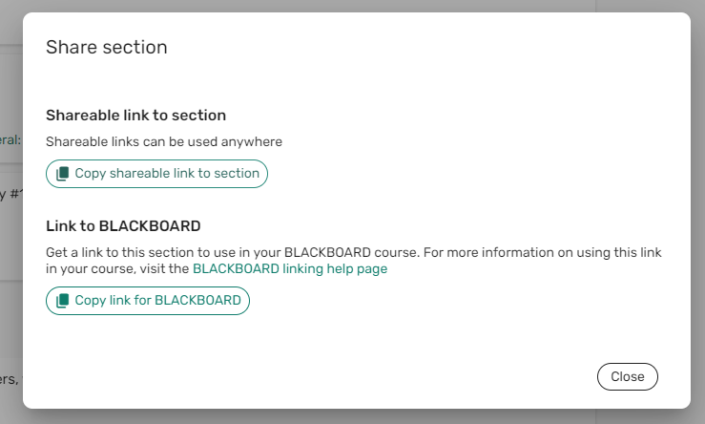
Share section when accessing Leganto via an LTI link
LTI links:
By default, the LTI tool in the LMS is set to link to a specific course. The steps to add an LTI link vary per LMS. Talk to your LMS administrator if you’re not sure how to add an LTI link to Leganto.
In addition, LTI links to specific lists, sections or items can be created using the “Link selection” feature of the LMS. You can see an example of the link selection feature in this video. While the video shows Moodle, the feature is similar in all LMSs. Blackboard, Canvas, Moodle and D2L Brightspace support the link selection feature when using LTI 1.3 but it needs to be set up by your LMS administrator.
Accessing links:
Links point to the list, section, or items for users who have permission to access the linked resource. For example, if the list is not published, students with a link to the list will not be able to see it.
Access to links is first determined by the list’s publication status:
- Unpublished lists: Links can be viewed by librarians, Leganto course operators, and list collaborators.
- Published lists: Links can be viewed by librarians, Leganto course operators, and list collaborators. In addition, students and other users can view according to the publication visibility:
  - Anyone: Guest users will be able to access the link.
  - All students at the institution: All authenticated users will be able to access the link.
  - Course students: Only students enrolled in the course will be able to access the link. Course students includes any user who has accessed Leganto via an LTI link in the course, or any user who was enrolled in the course in Alma.
More about managing course enrollments in Alma:
- See: Configuring importing course enrollment jobs
- See: Managing user and course enrollment information in Alma
Assuming the user can access the list, student access to sections or items also requires that the section or item not be currently hidden from students.
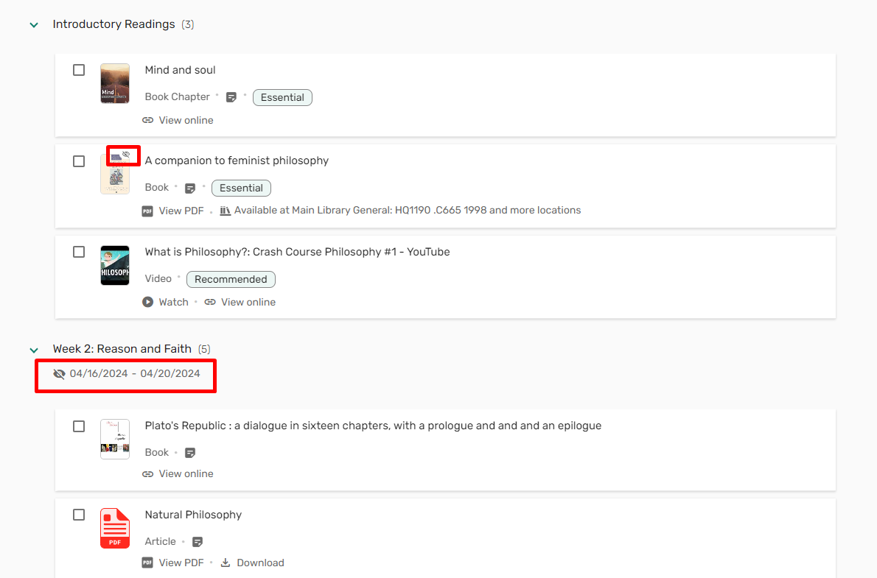
Hidden item and hidden section
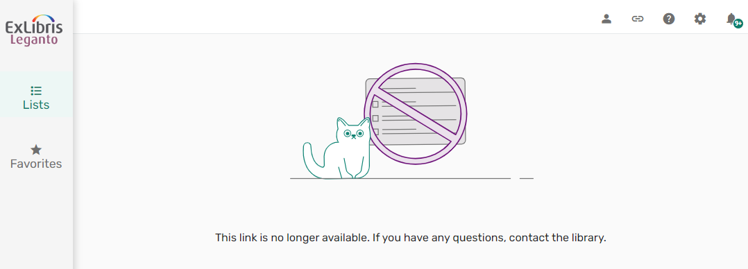
Link to hidden section—past dates
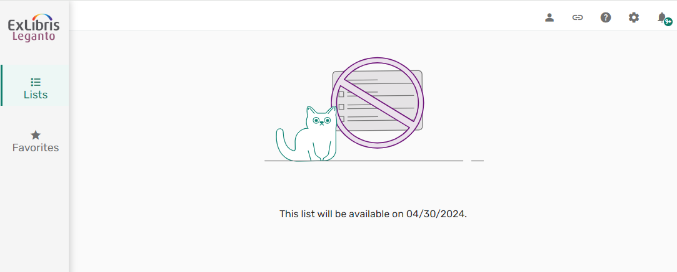
Link to hidden section—future dates
Rolling over links:
When rolling over a reading list in Alma or duplicating or reusing a reading list in Leganto, it is possible to rollover shareable links. If the option to have existing links point to the new list once published is selected (screenshots follow), any permalink pointing to the original/duplicated list (including section and item links) will automatically point to the new list once the new/duplicate list is published.
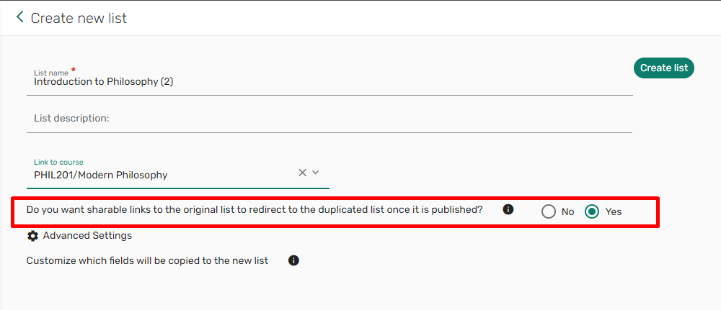
Duplicate or Reuse a list in Leganto
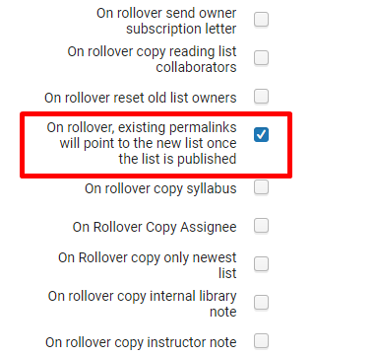
Course rollover using the Course Loader integration profile in Alma
LTI links include the course code. If the course has been rolled over, the LTI link will point to the list, section, or item for the list associated with the course the user accessed Leganto from.
Linking configuration options:
The library can enable or disable all linking options. Go to Configuration > Leganto > UI and edit the following menus:
List menu:
- Shareable_link: set to Yes to enable shareable links to the list
Section menu:
- direct_link_from_LMS: set to Yes to enable the user to generate LTI links to the section. Only available when accessing Leganto via an LTI link
- Shareable_link: set to Yes to enable shareable links to the section
Citation menu:
- direct_link_from_LMS: set to Yes to enable the user to generate LTI links to the item. Only available when accessing Leganto via an LTI link
- Shareable_link: set to Yes to enable shareable links to the item
When both linking options are disabled, the share icon will not appear:
Item without share icon

