How to load CSV file?
We start with creating a CSV template
In the template we detail the information that will be in the CSV file

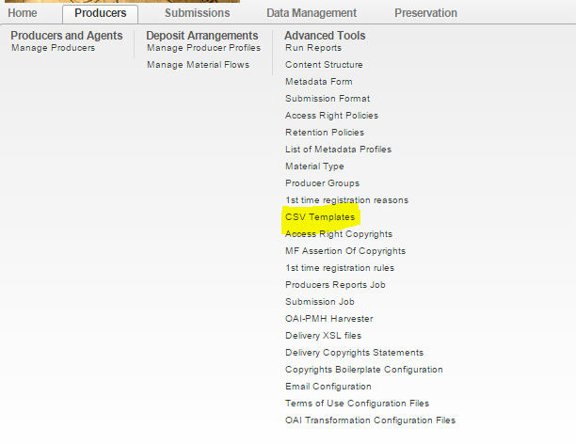

We'll create a content structure for the CSV table (we can add new or take an existing one)

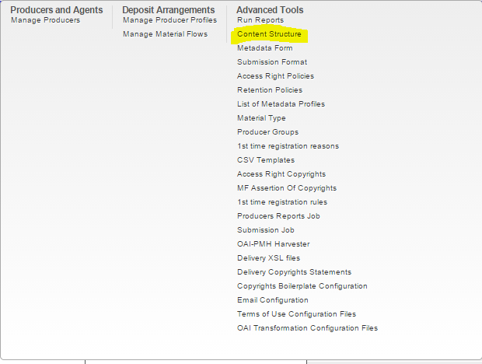

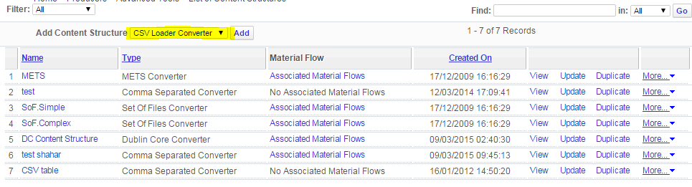

Choose the CSV template

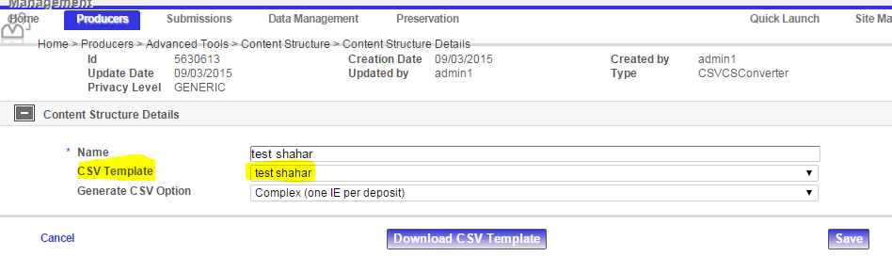
Now create material flow for the deposit

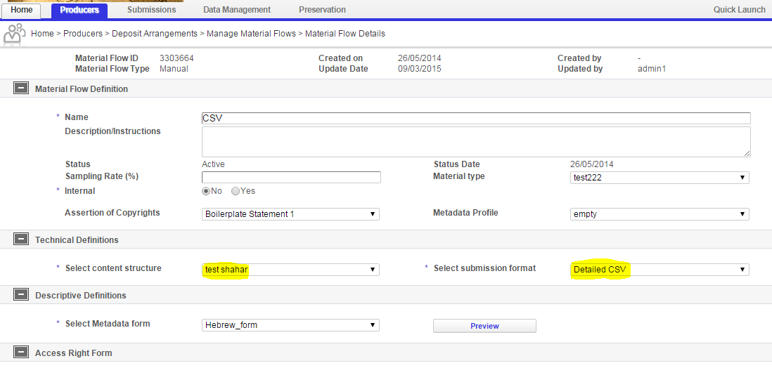

Select the content structure you created and a CSV submission format

When you deposit choose the material flow you created
Zip the files you want to load
Create the CSV file (by editing an existing one or by download the CSV template from the content structure or by generate the file on the deposit step)

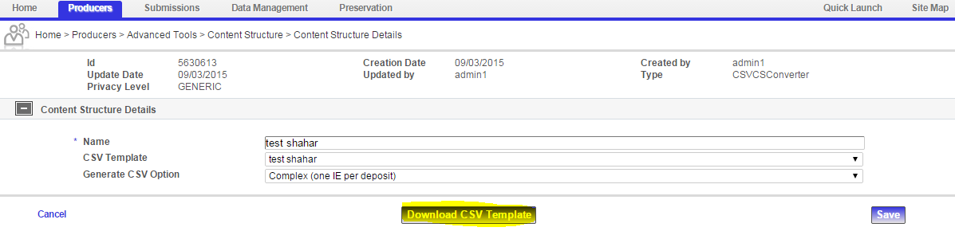

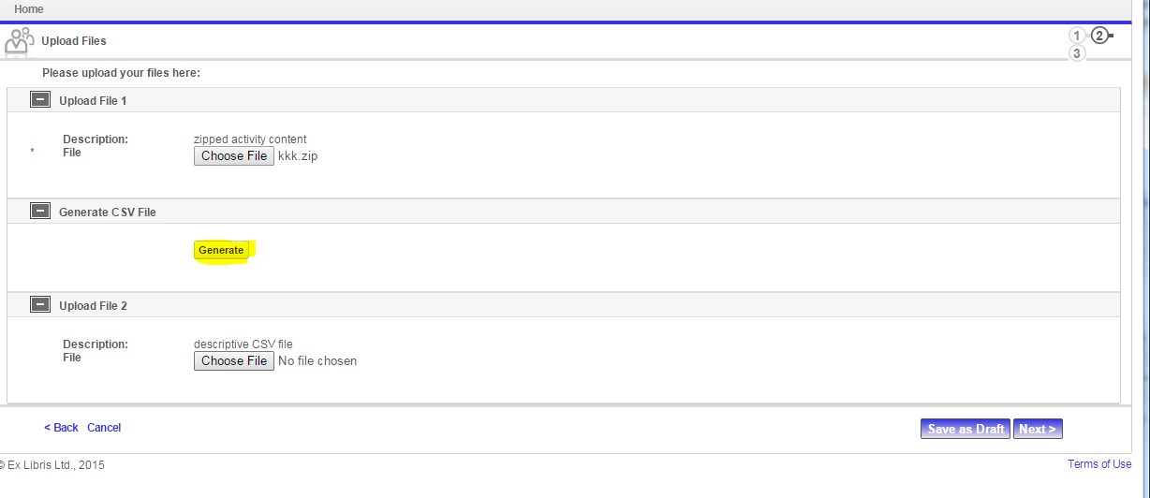
When depositing load the zipped content and the CSV file

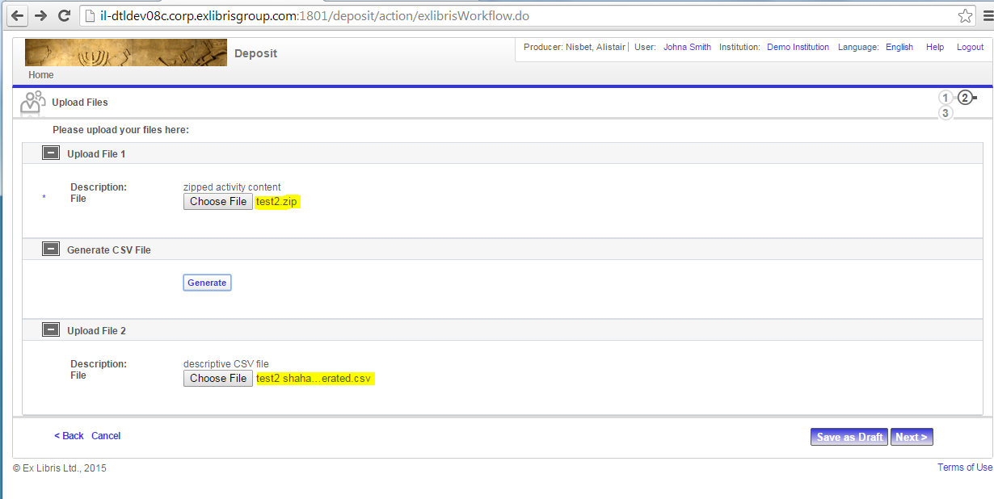

Important notes about the CSV file:
- Make sure the formats matches
- File original path is: '/'
