Input file $alephe_scratch/exl-ret-01 with the following system numbers (records without ADM record):
000000008XXX01
000000036XXX01
000000087XXX01

First I added an expand procedure with a script in order to create a dummy field (necessary for creating an item) which holds default item information. This field must exist even when you don’t create any item. I've added the following information to the dummy field:

Sub Library | MAIN
Collection | SUPP
Item Status | 05
Material | Unknown

xxx01/tab/import/adm_fix
! 2 3 4 5 6 7 8 9
!-!!!!!-!!-!-!!!-!!!-!!!!!-!!!!!!!!!!!!!!!!!!!!!!!!!!!!!!-!!!!!!!!!!!!!!!!!!!!!!!!!!!!!!!!!!!!!!!!!!!!!!!!!!!!!!!!!!!!!!!!!!!!!!!!!!!!!!!!!!!!!!!!!!!!!!!!!!!!
1 LDR ADD-FIELD 998 ,L,$$aMAIN$$bSUPP$$c05$$dUN

xxx01/tab/tab_expand
ADM fix_doc_do_file_08 adm_fix

This is the table which migrates information from field 998 into item record fields:

xxx01/tab/import/tab_hol_item_create
! 1 2 3 4 5 6 7 8 9 0 1
!!!!!!!!!!!!!!!!!!!!!!!!!-!!!!!!!!!!-!-!!!!!!!!!!-!!!!!-!!!!!!!!!!-!!!!!-!!!!!!!!!!-!!!!!-!!!!!!!!!!-!!!!!
SUB-LIBRARY a N
COLLECTION b N
Z30-MATERIAL d N
Z30-ITEM-STATUS c N

Now p_manage_50 can be started with the following options:

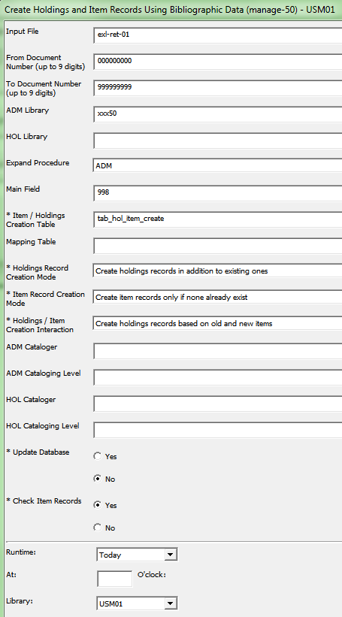
I ran the service for test purposes only in report mode so that no item was created but only reported in the log file (see below)

Results of manage-50 run from log file:

NOTE: this job was run with the update
database flag set to 'No'. No
changes were made to the database;
the counts indicate how many records
would have been created.
-------------------------------------------
Number of bib records read: 000000003
Number of ADM records created: 000000003
Number of HOL records created: 000000000
Number of item records created: 000000000

