To Add a New Staff User
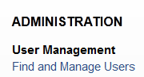
Under Find and Manage Users, click on Add User and select Staff.
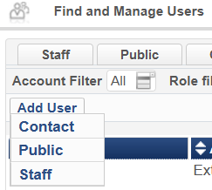
Then enter the fields for the user record. First and Last Name, password, User Group, Job Category etc.
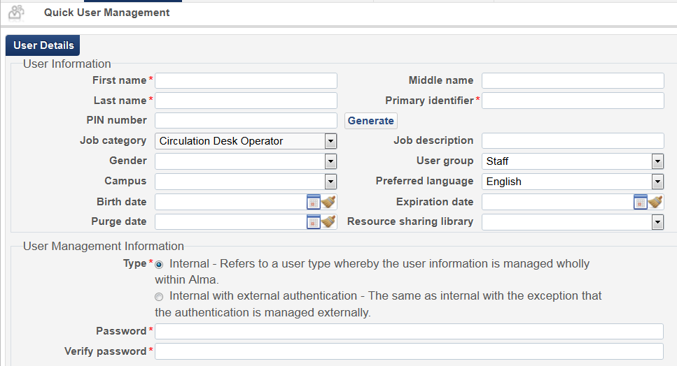
The Job Category “Circulation Desk Operator” and “Fulfillment Operator” (as well as other Job Categories) have Roles that are automatically assigned via Role Templates and Role Assignment Rules. In other words, if in the user record you assign the user a Job Category, roles can be automatically assigned. The Automatic Role Assignment Rules can be configured via the Alma menu, Administration, User Management Configuration, Configuration Menu.

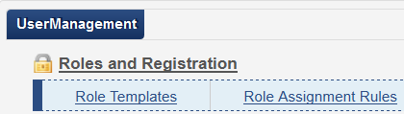

For details on Role Templates and Role Assignment Rules, see the online Help under
Configuring User Management : Configuring Role Templates

Configuring User Management : Configuring Role Assignment Rules

