How to Run the Patron SIS Loader Manually
During implementation, customers need to run the SIS Loader manually. After implementation, when the customer is live with Alma, there could be cases in which the customer may need to run it manually.
This is assuming that the S/FTP definition for SIS has been defined as well as the SIS Integration Profile.
From the Alma menu, under Administration>General Configuration, click on Configuration Menu
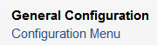
Click on Integration Profiles
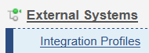
Click on Student Information System –
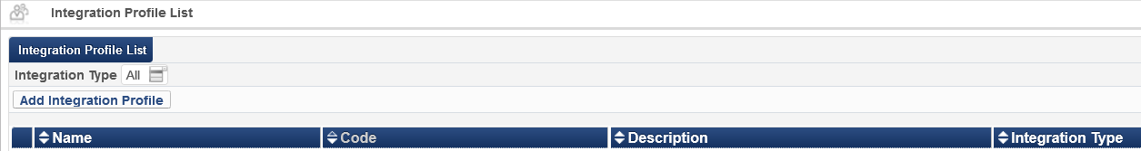
Once in the SIS profile, click on the Actions tab.
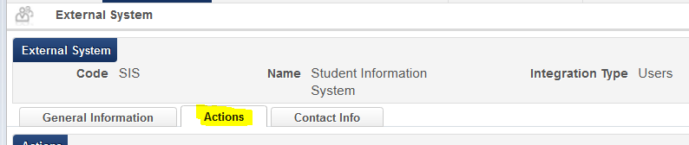
Click on Run in the Synchronize area -
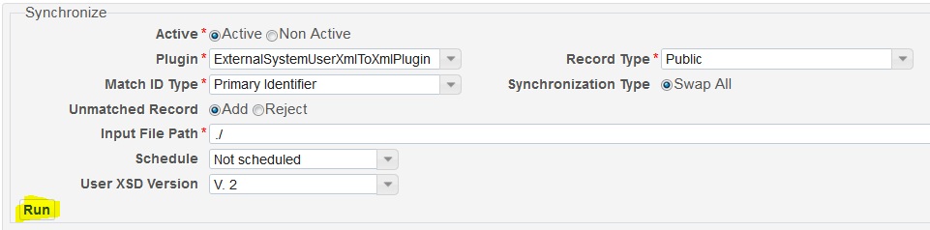
The job will run.
To see the Report of the SIS job, from the Alma> Administration, click on Monitor Jobs
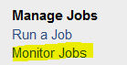
From the Monitor Jobs, go to Running. It will list the SIS job if it’s still running.
Once the job has finished, click on the History tab. Filter by Users if there is a long list of jobs. Click on Actions>Report next to the SIS job.
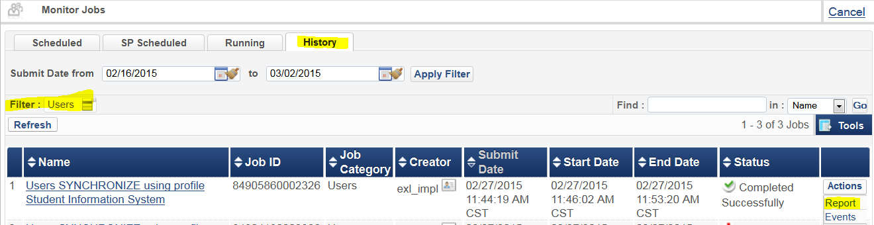
It will show you the number of users imported and will list if any failed and why.
Analyze the Job Report. If any users failed to load, they will be counted in the Rejected users.

