Access Rights: viewing digital objects from Primo – who is allowed and who is restricted.

- Digital object has no access right rule connected
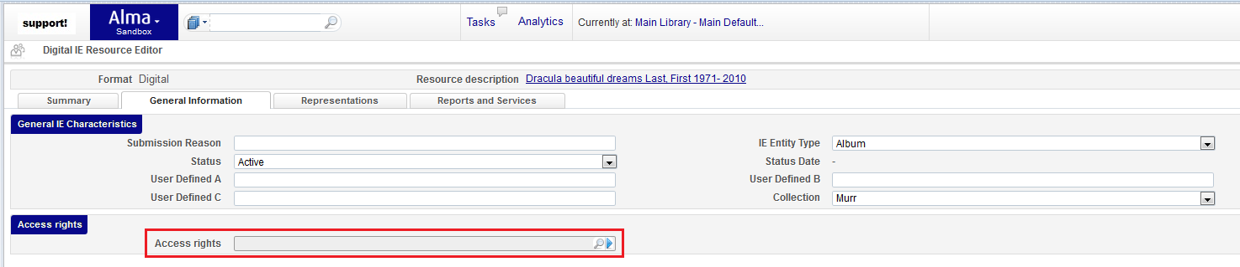
Customer Parameter access_right_default_policy (Accessed by Implementation/Support only) is taken into consideration
Values: Restrict/Allow
Restrict => All the users are not allowed to deliver the object
Allow => All the users are allowed to deliver the object
- Digital object is connected to an Access Right
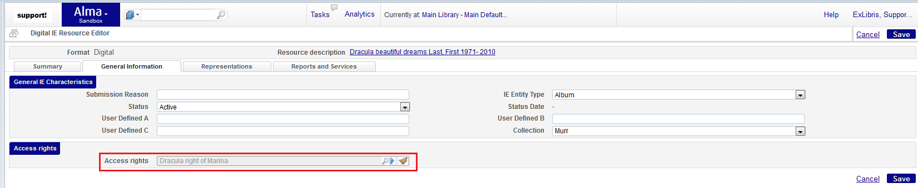
The Access Right is taken into consideration.
Access Right explanation
Fulfillment Configuration > Digital Fulfillment > Access Rights > Choose an Access Right > Access Rights Rules tab
Logic
Alma checks each rule and allows/restricts an object by the rule parameters. If a user does no meets any criteria, Alma allows/restricts by the Default Rule
- Access Right Rule
a. Input Parameters
b. Output parameters = Allow/Restrict
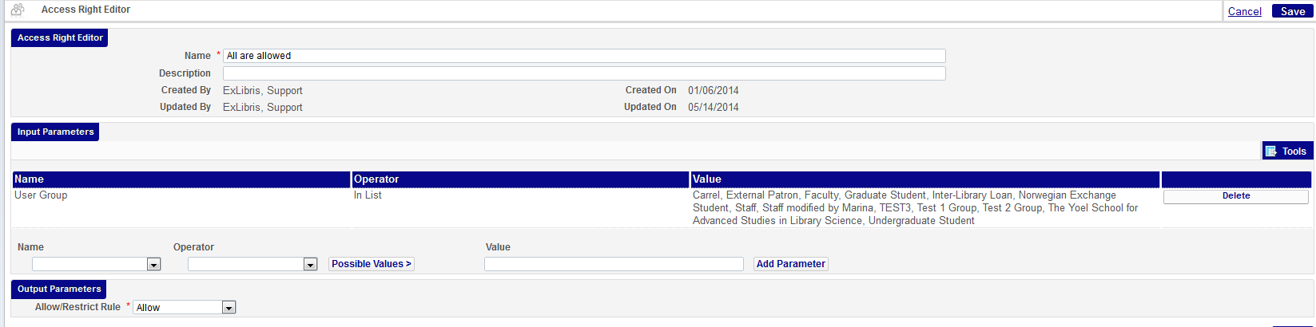
Example illustration: if a user who attempts to view an object belongs to one of the User Groups which appears in the list, Alma will allow viewing of an object.
- Default Access Right Rule
Values: Allow/Restrict
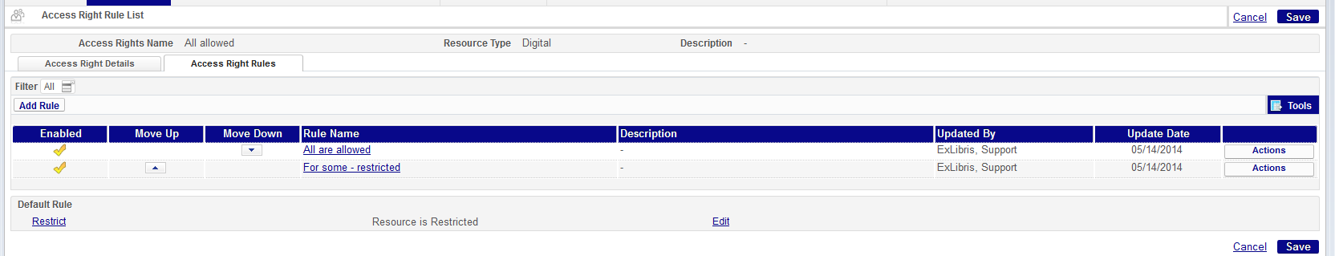
Example illustration: If a user who attempts to view an object does not meet any rules’ criteria, Alma will restrict an object from viewing according to the Default Rule.

