
Workflow Configuration Questionnaire
Version 2.0

CONFIDENTIAL INFORMATION
The information herein is the property of Ex Libris Ltd. or its affiliates and any misuse or abuse will result in economic loss. DO NOT COPY UNLESS YOU HAVE BEEN GIVEN SPECIFIC WRITTEN AUTHORIZATION FROM EX LIBRIS LTD.
This document is provided for limited and restricted purposes in accordance with a binding contract with Ex Libris Ltd. or an affiliate. The information herein includes trade secrets and is confidential.
DISCLAIMER
The information in this document will be subject to periodic change and updating. Please confirm that you have the most current documentation. There are no warranties of any kind, express or implied, provided in this documentation, other than those expressly agreed upon in the applicable Ex Libris contract. This information is provided AS IS. Unless otherwise agreed, Ex Libris shall not be liable for any damages for use of this document, including, without limitation, consequential, punitive, indirect or direct damages.
Any references in this document to third-party material (including third-party Web sites) are provided for convenience only and do not in any manner serve as an endorsement of that third-party material or those Web sites. The third-party materials are not part of the materials for this Ex Libris product and Ex Libris has no liability for such materials.
TRADEMARKS
"Ex Libris," the Ex Libris bridge , Primo, Aleph, Alephino, Voyager, SFX, MetaLib, Verde, DigiTool, Preservation, URM, Voyager, ENCompass, Endeavor eZConnect, WebVoyage, Citation Server, LinkFinder and LinkFinder Plus, and other marks are trademarks or registered trademarks of Ex Libris Ltd. or its affiliates.
The absence of a name or logo in this list does not constitute a waiver of any and all intellectual property rights that Ex Libris Ltd. or its affiliates have established in any of its products, features, or service names or logos.
Trademarks of various third-party products, which may include the following, are referenced in this documentation. Ex Libris does not claim any rights in these trademarks. Use of these marks does not imply endorsement by Ex Libris of these third-party products, or endorsement by these third parties of Ex Libris products.
Oracle is a registered trademark of Oracle Corporation.
UNIX is a registered trademark in the United States and other countries, licensed exclusively through X/Open Company Ltd.
Microsoft, the Microsoft logo, MS, MS-DOS, Microsoft PowerPoint, Visual Basic, Visual C++, Win32,
Microsoft Windows, the Windows logo, Microsoft Notepad, Microsoft Windows Explorer, Microsoft Internet Explorer, and Windows NT are registered trademarks and ActiveX is a trademark of the Microsoft Corporation in the United States and/or other countries.
Unicode and the Unicode logo are registered trademarks of Unicode, Inc.
Google is a registered trademark of Google, Inc.

Copyright Ex Libris Limited, 2026. All rights reserved.
Document released: July 2009

Web address: http://www.exlibrisgroup.com
Table of Contents
1 Configuration of Verde Workflows 4
1.1. Acquisitions Workflow 4
1.1.1. Workflow Tasks Configuration 5
1.2. License Workflow 18
1.2.1. Workflow Tasks Configuration 19
1.3. Review and Renewal Workflows 30
1.3.1. Review E-Product Workflow 30
1.3.2. Acquisition Renewal Workflow 35

Configuration of Verde Workflows

Acquisitions Workflow
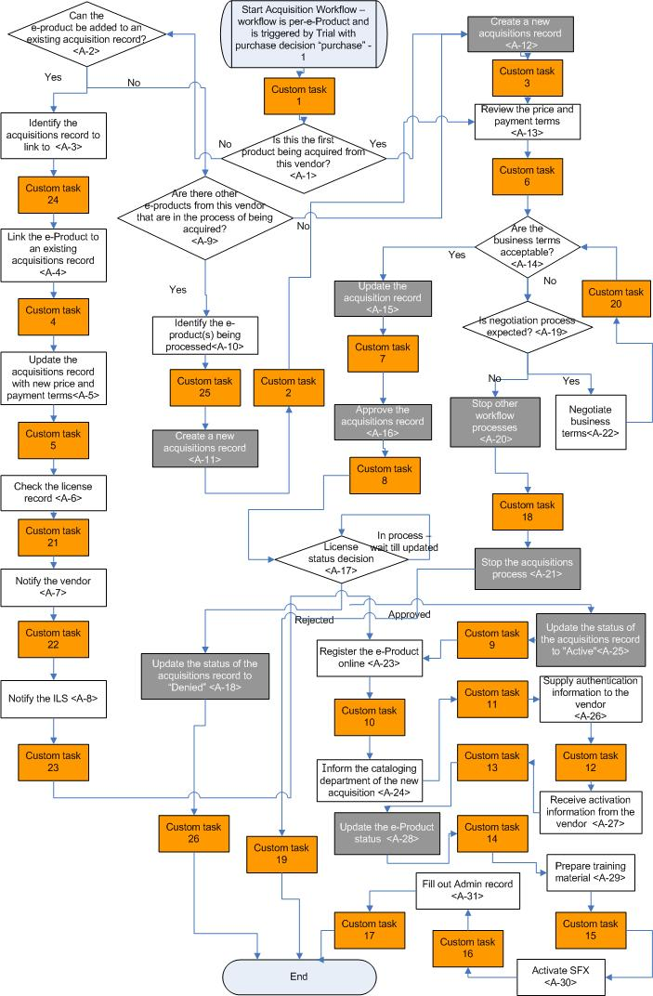
Figure 1. Acquisitions Workflow
Would you like to use this workflow? Yes No

Workflow Tasks Configuration
Table 1. Acquisitions Workflow Tasks Configuration
Task ID | Current Values |  |  | Required Values
Task ID | Task  Name | Task Description | Role | Task Name | Task Description | Role | External URL | E-mail Alert on Task Opening  (mailing list) | E-mail Alert on Task Closing  (mailing list) | E-mail Alert  based on role  (YES/NO)
AEWP_User_Custom_1 | Site specific task | Site specific task | Acquisitions |  |  |  |  |  |  | YES
A-1 | Is this the first product being acquired from this vendor? | Determine if this is the first product that has been ordered from this vendor, by linking to the e-Product and reviewing other e-Products available from the same interface list | Selector |  |  |  |  |  |  | YES
A-2 | Can the e-Product be added to an existing acquisition record | Determine if the e-Product can be added to an existing acquisitions record for the same vendor | Selector |  |  |  |  |  |  | YES
A-3 | Identify the acquisitions record to link to | Locate the acquisitions record to which this e-Product will be linked. Copy the acquisitions number and input in this task | Acquisitions |  |  |  |  |  |  | YES
AEWP_User_Custom_24 | Site specific task | Site specific task | Acquisitions |  |  |  |  |  |  | YES
A-4 | Link the e-Product to an existing acquisitions record | Use the link acquisitions function on the e-Product acquisitions tab to link the e-Product to an existing acquisitions record for the same vendor | Acquisitions |  |  |  |  |  |  | YES
AEWP_User_Custom_4 | Site specific task | Site specific task | Acquisitions |  |  |  |  |  |  | YES
A-5 | Update the acquisitions record with new price and payment terms | Update the acquisitions record and enter the new price and payment terms agreed to with the vendor | Acquisitions |  |  |  |  |  |  | YES
AEWP_User_Custom_5 | Site specific task | Site specific task | Acquisitions |  |  |  |  |  |  | YES
A-6 | Check the license record | Check the license record and see if it needs to be modified | Licensor |  |  |  |  |  |  | YES
AEWP_User_Custom_21 | Site specific task | Site specific task | Acquisitions |  |  |  |  |  |  | YES
A-7 | Notify the vendor | Notify the vendor that a new e-Product is being acquired | Acquisitions |  |  |  |  |  |  | YES
AEWP_User_Custom_22 | Site specific task | Site specific task | Acquisitions |  |  |  |  |  |  | YES
A-8 | Notify the ILS | Notify the ILS about the new product | Selector |  |  |  |  |  |  | YES
AEWP_User_Custom_23 | Site specific task | Site specific task | Acquisitions |  |  |  |  |  |  | YES
A-9 | Are there other e-Products from this vendor that are in the process of being acquired? | Can this e-Product be processed together with other e-Products from the same vendor? | Acquisitions |  |  |  |  |  |  | YES
A-10 | Identify the e-Product(s) being processed | Identify the e-Products for processing. Enter the e-Product codes separated by a semi-colon (;) | Selector |  |  |  |  |  |  | YES
AEWP_User_Custom_25 | Site specific task | Site specific task | Acquisitions |  |  |  |  |  |  | YES
A-11* | Create a new acquisitions record | Create a new acquisitions record; link the relevant e-Products to the record | Acquisitions |  |  |  |  |  |  | YES
AEWP_User_Custom_2 | Site specific task | Site specific task | Acquisitions |  |  |  |  |  |  | YES
A-12* | Create a new acquisitions record | Create a new acquisitions record for the e-Product record | Acquisitions |  |  |  |  |  |  | YES
AEWP_User_Custom_3 | Site specific task | Site specific task | Acquisitions |  |  |  |  |  |  | YES
A-13 | Review the price and payment terms | Review the price and payment terms that have been negotiated | Acquisitions |  |  |  |  |  |  | YES
AEWP_User_Custom_6 | Site specific task | Site specific task | Acquisitions |  |  |  |  |  |  | YES
A-14 | Are the business terms acceptable? | Review the business terms and decide if they are acceptable. | Acquisitions |  |  |  |  |  |  | YES
A-15* | Update the acquisitions record | Update the status of the acquisitions record to ‘Ready to be Approved’ | Acquisitions |  |  |  |  |  |  | YES
AEWP_User_Custom_7 | Site specific task |  |  |  |  |  |  |  |  | YES
A-16* | Approve the acquisitions record | Approve the acquisitions record. | Acquisitions  Manager |  |  |  |  |  |  | YES
AEWP_User_Custom_8 | Site specific task | Site specific task | Acquisitions |  |  |  |  |  |  | YES
A-17 | License status decision | Check the status of the license record | Acquisitions |  |  |  |  |  |  | YES
A-18* | Update the status of the acquisitions record to "Denied" | Update the status of the acquisitions record to "Denied" | Acquisitions |  |  |  |  |  |  | YES
AEWP_User_Custom_26 | Site specific task | Site specific task | Acquisitions |  |  |  |  |  |  | YES
A-19 | Is negotiation process expected? | Is progress expected on the outstanding issues that are being negotiated? | Acquisitions |  |  |  |  |  |  | YES
A-20* | Stop other workflow processes | Stop other workflow processes | Acquisitions |  |  |  |  |  |  | YES
AEWP_User_Custom_18 | Site specific task | Site specific task | Acquisitions |  |  |  |  |  |  | YES
A-21* | Stop the acquisitions process | Update the status of the acquisitions record to "Denied". Record the reason for not acquiring the e-Product | Acquisitions |  |  |  |  |  |  | YES
AEWP_User_Custom_19 | Site specific task | Site specific task | Acquisitions |  |  |  |  |  |  | YES
A-22 | Negotiate business terms | Continue to negotiate business terms with the vendor | Acquisitions |  |  |  |  |  |  | YES
AEWP_User_Custom_20 | Site specific task | Site specific task | Acquisitions |  |  |  |  |  |  | YES
A-23 | Register the e-Product online | Register the e-Product on the vendor’s website | Selector |  |  |  |  |  |  | YES
AEWP_User_Custom_10 | Site specific task | Site specific task | Acquisitions |  |  |  |  |  |  | YES
A-24 | Inform the cataloging department of the new acquisition | Inform the cataloging department of the new acquisition so they can catalog the new record | Selector |  |  |  |  |  |  | YES
AEWP_User_Custom_11 | Site specific task | Site specific task | Acquisitions |  |  |  |  |  |  | YES
A-25* | Update the status of the acquisitions record to "Active" | Update the status of the acquisitions record to "Active" | Acquisitions |  |  |  |  |  |  | YES
AEWP_User_Custom_9 | Site specific task | Site specific task | Acquisitions |  |  |  |  |  |  | YES
A-26 | Supply authentication information to the vendor | Supply authentication information to the vendor | Selector |  |  |  |  |  |  | YES
AEWP_User_Custom_12 | Site specific task | Site specific task | Acquisitions |  |  |  |  |  |  | YES
A-27 | Receive activation information from the vendor | Pass activation information to the IT department so that access can be setup. | Selector |  |  |  |  |  |  | YES
AEWP_User_Custom_13 | Site specific task | Site specific task | Acquisitions |  |  |  |  |  |  | YES
A-28* | Update the e-Product status | Update the e-Product status to "Production" | Selector |  |  |  |  |  |  | YES
AEWP_User_Custom_14 | Site specific task | Site specific task | Acquisitions |  |  |  |  |  |  | YES
A-29 | Prepare training material | Prepare training material for training staff and end users | Selector |  |  |  |  |  |  | YES
AEWP_User_Custom_15 | Site specific task | Site specific task | Acquisitions |  |  |  |  |  |  | YES
A-30 | Activate SFX | Use existing SOAP services to activate SFX. If necessary link to SFX and set up username and password | Selector |  |  |  |  |  |  | YES
AEWP_User_Custom_16 | Site specific task | Site specific task | Acquisitions |  |  |  |  |  |  | YES
A-31 | Fill out Admin record | Fill out the Verde Admin record including the section on usage statistics | Selector |  |  |  |  |  |  | YES
AEWP_User_Custom_17 | Site specific task | Site specific task | Acquisitions |  |  |  |  |  |  | YES
*Automatic tasks are highlighted in green

License Workflow
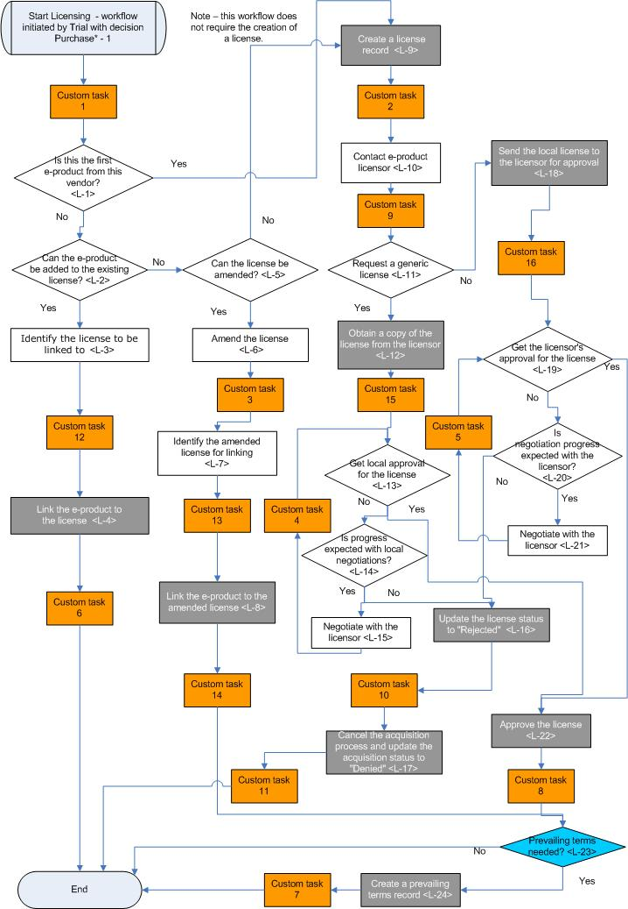
Figure 2. License Workflow
Would you like to use this workflow? Yes No

Workflow Tasks Configuration
Table 2. License Workflow Tasks Configuration
Task ID | Current Values |  |  | Required Values
Task ID | Task  Name | Task Description | Role | Task Name | Task Description | Role | External URL | E-mail Alert on Task Opening  (mailing list) | E-mail Alert on Task Closing  (mailing list) | E-mail Alert  based on role  (YES/NO)
LWP_User_Custom_1 | Site specific task | Site specific task | Licensor |  |  |  |  |  |  | YES
L-1 | Is this the first product from this vendor? | Determine if this is the first product that has been ordered from this vendor, by linking to the e-Product | Selector |  |  |  |  |  |  | YES
L-2 | Can the e-Product be added to the existing license? | Determine if the e-Product can be added to an existing license with the same licensor | Licensor |  |  |  |  |  |  | YES
L-3 | Identify the license to be linked to | Identify the license that the e-Product will be linked to | Licensor |  |  |  |  |  |  | YES
LWP_User_Custom_12 | Site specific task | Site specific task | Licensor |  |  |  |  |  |  | YES
L-4* | Link the e-Product to the license | Use the link license function on the license tab of the e-Product to link the e-Product to the license identified in task L-3 | Licensor |  |  |  |  |  |  | YES
LWP_User_Custom_6 | Site specific task | Site specific task | Licensor |  |  |  |  |  |  | YES
L-5 | Can the license be amended? | Does the license need to be amended? Determine if it can be amended | Licensor |  |  |  |  |  |  | YES
L-6 | Amend the license | Amend the license so that the terms reflect the terms for all the e-Products covered by this license. | Licensor |  |  |  |  |  |  | YES
LWP_User_Custom_3 | Site specific task | Site specific task | Licensor |  |  |  |  |  |  | YES
L-7 | Identify the amended license for linking | Identify the amended license that the e-Product will be linked to | Licensor |  |  |  |  |  |  | YES
LWP_User_Custom_13 | Site specific task | Site specific task | Licensor |  |  |  |  |  |  | YES
L-8* | Link the e-Product to the amended license | Use the link license function on the license tab of the e-Product to link the e-Product to the amended license. | Licensor |  |  |  |  |  |  | YES
LWP_User_Custom_14 | Site specific task | Site specific task | Licensor |  |  |  |  |  |  | YES
L-9* | Create a license record | Create a new license for this e-Product | Licensor |  |  |  |  |  |  | YES
LWP_User_Custom_2 | Site specific task | Site specific task | Licensor |  |  |  |  |  |  | YES
L-10 | Contact e-Product licensor | Contact the licensor and begin negotiating license | Licensor |  |  |  |  |  |  | YES
LWP_User_Custom_9 | Site specific task | Site specific task | Licensor |  |  |  |  |  |  | YES
L-11 | Request a generic license | Does the licensor have a generic license? Request a copy | Licensor |  |  |  |  |  |  | YES
L-12* | Obtain a copy of the license from the licensor | Obtain a copy of the generic license from the licensor. Update the license with the license terms. Update the license by assigning a status “Pending local response” | Licensor |  |  |  |  |  |  | YES
LWP_User_Custom_15 | Site specific task | Site specific task | Licensor |  |  |  |  |  |  | YES
L-13 | Get local approval for the license | Review and approve the vendor license | License_manager |  |  |  |  |  |  | YES
L-14 | Is progress expected with local negotiations? | Is progress expected with local negotiations? | Licensor |  |  |  |  |  |  | YES
L-15 | Negotiate with the licensor | Negotiate license terms with the licensor | Licensor |  |  |  |  |  |  | YES
LWP_User_Custom_4 | Site specific task | Site specific task | Licensor |  |  |  |  |  |  | YES
L-16* | Update the license status to "Rejected" | Update the license status to "Rejected" | Licensor |  |  |  |  |  |  | YES
LWP_User_Custom_10 | Site specific task | Site specific task | Licensor |  |  |  |  |  |  | YES
L-17* | Cancel the acquisition process and update the acquisition status to "Denied" | Cancel the acquisition process and update the acquisition status to "Denied" | Licensor |  |  |  |  |  |  | YES
LWP_User_Custom_11 | Site specific task | Site specific task | Licensor |  |  |  |  |  |  | YES
L-18* | Send the local license to the licensor for approval | Send the licensor a copy of the local generic license. Update the license by assigning a status “Pending licensor response” | Licensor |  |  |  |  |  |  | YES
LWP_User_Custom_16 | Site specific task | Site specific task | Licensor |  |  |  |  |  |  | YES
L-19 | Get the licensor's approval for the license | Has the licensor approved the license? | Licensor |  |  |  |  |  |  | YES
L-20 | Is negotiation progress expected with the licensor? | Is negotiation progress expected with the licensor? | Licensor |  |  |  |  |  |  | YES
L-21 | Negotiate with the licensor | Negotiate license terms with the licensor | Licensor |  |  |  |  |  |  | YES
LWP_User_Custom_5 | Site specific task | Site specific task | Licensor |  |  |  |  |  |  | YES
L-22* | Approve the license | Review and approve the license | License_manager |  |  |  |  |  |  | YES
LWP_User_Custom_8 | Site specific task | Site specific task | Licensor |  |  |  |  |  |  | YES
L-23 | Are prevailing terms needed? | The system checks to see if prevailing terms are needed |  |  |  |  |  |  |  | YES
L-24* | Create a prevailing terms record | If there is more then one active license, create a prevailing terms record for the e-Product. It should contain terms from both licenses | Licensor |  |  |  |  |  |  | YES
LWP_User_Custom_7 | Site specific task | Site specific task | Licensor |  |  |  |  |  |  | YES
*Automatic tasks are highlighted in green

Review and Renewal Workflows

Review E-Product Workflow
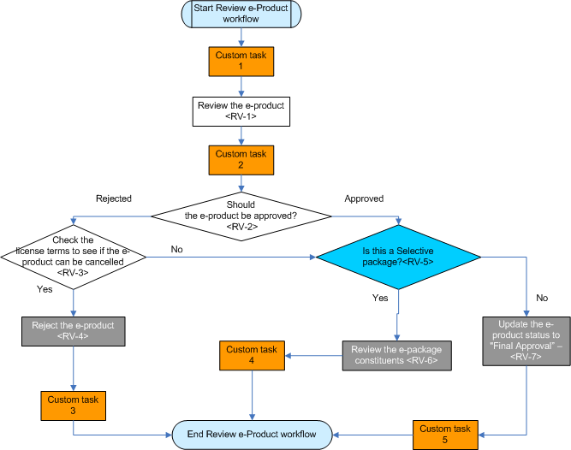
Figure 3. Review e-Product Workflow
Would you like to use this workflow? Yes No

Workflow Tasks Configuration
Table 3. Review e-Product Workflow Tasks Configuration
Task ID | Current Values |  |  | Required Values
Task ID | Task  Name | Task Description | Role | Task Name | Task Description | Role | External URL | E-mail Alert on Task Opening  (mailing list) | E-mail Alert on Task Closing  (mailing list) | E-mail Alert  based on role  (YES/NO)
RWP_User_Custom_1 | Site specific task | Site specific task | Selector |  |  |  |  |  |  | YES
RV-1 | Review the e-Product | Review the e-Product. Consider the usage and cost data. Decide if the e-Product should be renewed | Selector |  |  |  |  |  |  | YES
RWP_User_Custom_2 | Site specific task | Site specific task | Access_Issues |  |  |  |  |  |  | YES
RV-2 | Should the e-Product be approved? | Decide if you want to approve or reject the e-Product | Selector |  |  |  |  |  |  | YES
RV-3 | Check the license terms to see if the e-Product can be cancelled | Look at the termination obligations section of the license to determine if the subscription for the e-Product can be cancelled and by when it has to be cancelled | Licensor |  |  |  |  |  |  | YES
RV-4* | Reject the e-Product | Cancel the e-Product by assigning the selection status of "Rejected" to the e-Product | Selector |  |  |  |  |  |  | YES
RWP_User_Custom_3 | Site specific task | Site specific task | Access_Issues |  |  |  |  |  |  | YES
RV-5 | Is this a Selective package? | Is this a Selective package? | Selector |  |  |  |  |  |  | YES
RV-6* | Review the e-Package constituents | Review the e-Package constituents and decide which ones to include in next year's subscription | Selector |  |  |  |  |  |  | YES
RWP_User_Custom_4 | Site specific task | Site specific task | Access_Issues |  |  |  |  |  |  | YES
RV-7* | Update the e-Product status to "Final Approval” | Update the e-Product status to "Final Approval” | Selector |  |  |  |  |  |  | YES
RWP_User_Custom_5 | Site specific task | Site specific task | Access_Issues |  |  |  |  |  |  | YES
*Automatic tasks are highlighted in green

Acquisition Renewal Workflow
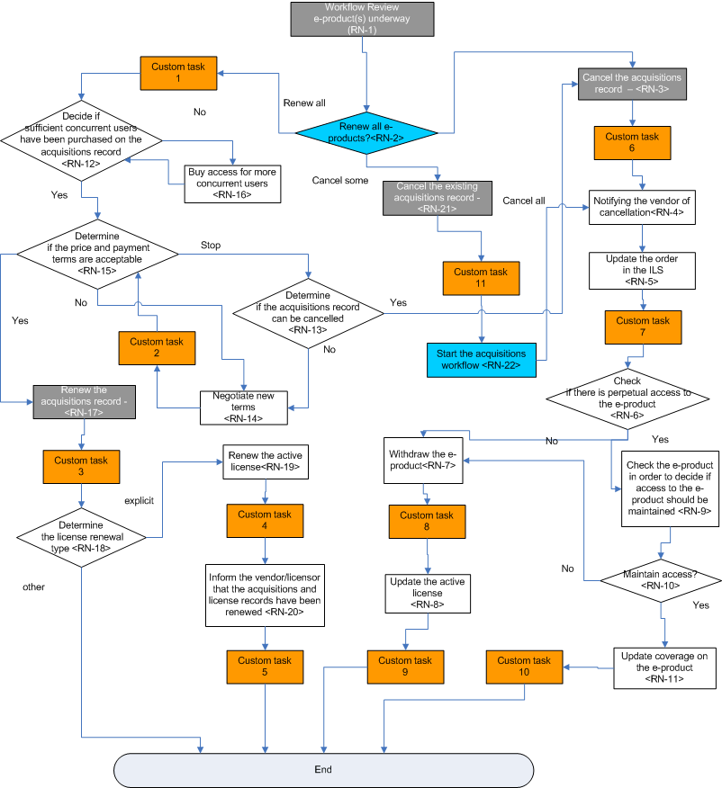
Figure 4. Review e-Product Workflow
Would you like to use this workflow? Yes No

Workflow Tasks Configuration
Table 4. Acquisition Renewal Workflow Tasks Configuration
Task ID | Current Values |  |  | Required Values
Task ID | Task Name | Task Description | Role | Task Name | Task Description | Role | External URL | E-mail Alert on Task Opening  (mailing list) | E-mail Alert on Task Closing  (mailing list) | E-mail Alert  based on role  (YES/NO)
RN-1* | Workflow Review e-Product(s) underway | All e-Products acquired on this acquisitions record are being reviewed. The task ends automatically when all the review workflows are completed. |  |  |  |  |  |  |  | YES
RN-2 | Renew all e-Products? | This task does not display |  |  |  |  |  |  |  | YES
ARWP_User_Custom_1 | Site specific task | Site specific task | Acquisitions |  |  |  |  |  |  | YES
RN-3* | Cancel the acquisitions record | Update the acquisitions record to "Cancelled". | Acquisitions |  |  |  |  |  |  | YES
ARWP_User_Custom_6 | Site specific task | Site specific task | Acquisitions |  |  |  |  |  |  | YES
RN-4 | Notifying the vendor of cancellation | Notify the vendor that the subscription has been cancelled | Acquisitions |  |  |  |  |  |  | YES
RN-5 | Update the order in the ILS | Update the status of the order/acquisitions record in the ILS to “Cancelled” | Acquisitions |  |  |  |  |  |  | YES
ARWP_User_Custom_7 | Site specific task | Site specific task | Acquisitions |  |  |  |  |  |  | YES
RN-6 | Check if there is perpetual access to the e-Product | Check the license terms to see if there is perpetual access to the e-Product | Licensor |  |  |  |  |  |  | YES
RN-7 | Withdraw the e-Product | Update all related e-Products by assigning an "Activation to" date | Selector |  |  |  |  |  |  | YES
ARWP_User_Custom_8 | Site specific task | Site specific task | Acquisitions |  |  |  |  |  |  | YES
RN-8 | Update the active license | Update the active license | Licensor |  |  |  |  |  |  | YES
ARWP_User_Custom_9 | Site specific task | Site specific task | Acquisitions |  |  |  |  |  |  | YES
RN-9 | Check the e-Product in order to decide if access to the e-Product should be maintained | Decide if access to the e-Product should be maintained even though the e-Product is not currently received | Selector |  |  |  |  |  |  | YES
RN-10 | Maintain Access? | Maintain Access to the e-Product for the years that are available under the perpetual access agreement | Selector |  |  |  |  |  |  | YES
RN-11 | Update coverage on the e-Product | Update coverage on the e-Product so that it shows only those years that are available | Selector |  |  |  |  |  |  | YES
ARWP_User_Custom_10 | Site specific task | Site specific task | Acquisitions |  |  |  |  |  |  | YES
RN-12 | Decide if sufficient concurrent users have been purchased on the acquisitions record | Check the usage statistics and the incident log and determine if there are enough concurrent user licenses | Selector |  |  |  |  |  |  | YES
RN-13 | Determine if the acquisitions record can be cancelled | Check the termination obligations section of the license to confirm that the acquisitions record can be cancelled | Acquisitions |  |  |  |  |  |  | YES
RN-14 | Negotiate new terms | Negotiate new terms with the vendor | Acquisitions |  |  |  |  |  |  | YES
ARWP_User_Custom_2 | Site specific task | Site specific task | Acquisitions |  |  |  |  |  |  | YES
RN-15 | Determine if the price and payment terms are acceptable | Get approval for the price and payment terms | Acquisitions Manager |  |  |  |  |  |  | YES
RN-16 | Buy access for more concurrent users | Purchase access for more concurrent users. Update the acquisition record to reflect the change | Acquisitions |  |  |  |  |  |  | YES
RN-17* | Renew the acquisitions record | Link to the acquisitions record and renew it using the renew function that displays above the acquisitions details screen | Acquisitions |  |  |  |  |  |  | YES
ARWP_User_Custom_3 | Site specific task | Site specific task | Acquisitions |  |  |  |  |  |  | YES
RN-18 | Determine the license renewal type | Identify the appropriate license and determine the license renewal type - is it explicit or not? | Licensor |  |  |  |  |  |  | YES
RN-19 | Renew the active license | Manually renew the active license using the renew function that displays above the license details screen | Licensor |  |  |  |  |  |  | YES
ARWP_User_Custom_4 | Site specific task | Site specific task | Acquisitions |  |  |  |  |  |  | YES
RN-20 | Inform the vendor/licensor that the acquisitions and license records have been renewed | Contact the vendor and the licensor and inform them that the acquisitions record and license record have both been renewed | Acquisitions |  |  |  |  |  |  | YES
ARWP_User_Custom_5 | Site specific task | Site specific task | Acquisitions |  |  |  |  |  |  | YES
RN-21* | Cancel the existing acquisitions record | Cancel the existing acquisitions record by updating the status of the record to “Cancelled”. Acquisitions workflows start for all approved e-Products | Acquisitions |  |  |  |  |  |  | YES
ARWP_User_Custom_11 | Site specific task | Site specific task | Acquisitions |  |  |  |  |  |  | YES
RN-22 | Start the acquisitions workflow | Start the acquisitions workflow | Acquisitions |  |  |  |  |  |  | YES

*Automatic tasks are highlighted in green

