

Yoel Kortick

Problem solving with the TXT ADAM full text field

Problem:

I have defined TXT as a “Full Text Index” for ADAM digital objects.
But, for some reason, when I search for it in GUI and web it does not work.
When trying to figure out why it is not working I noticed that in the GUI Aleph “thinks” I am looking for “Words = TXT whatever” instead of “Full Text = whatever”.

On a server where it does work it states “Full Text = whatever”:

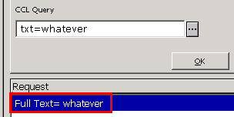

On my server (where it does not work) it states “Words = txt whatever”:

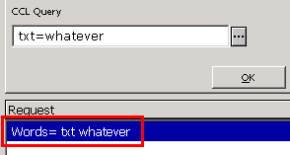

I have defined the TXT field it according to the document “How_to_set_up_and_use_full_text_search_for_ADAM_yk.doc” on the Doc Portal under directory “How to > ADAM”.

Resolution:

When you do the ADAM full text search the system uses, among other tables, $alephe_unicode/unicode_to_word_gen.

If this table changes the equals sign (=) to a space (0020) then it will also change it in the search in the web or GUI when “TXT = whatever” is done. In your specific case, you were changing the equals sign to a space.

We removed the sign as follows:

exltst-18(2_exl) EXL01-ALEPH>>cd $alephe_unicode
exltst-18(2_exl) EXL01-ALEPH>>diff unicode_to_word_gen unicode_to_word_gen.before
149c149
< !* 003D 0020 #EQUALS SIGN
---
> 003D 0020 #EQUALS SIGN

And now it works correctly:

