


ALEPH Version 18.01
How to make a fix procedure
which will replace
d with ^ in position 5 of LDR

Yoel Kortick


© Ex Libris Ltd., 2007
CONFIDENTIAL INFORMATION
The information herein is the property of Ex Libris Ltd. or its affiliates and any misuse or abuse will result in economic loss. DO NOT COPY UNLESS YOU HAVE BEEN GIVEN SPECIFIC WRITTEN AUTHORIZATION FROM EX LIBRIS LTD.
This document is provided for limited and restricted purposes in accordance with a binding contract with Ex Libris Ltd. or an affiliate. The information herein includes trade secrets and is confidential.
DISCLAIMER
The information in this document will be subject to periodic change and updating. Please confirm that you have the most current documentation. There are no warranties of any kind, express or implied, provided in this documentation, other than those expressly agreed upon in the applicable Ex Libris contract.
Any references in this document to non-Ex Libris Web sites are provided for convenience only and do not in any manner serve as an endorsement of those Web sites. The materials at those Web sites are not part of the materials for this Ex Libris product and Ex Libris has no liability for materials on those Web sites.

Copyright Ex Libris Limited, 2006. All rights reserved.
Documentation produced August 2006
Document version 1.3
Web address: http://www.exlibrisgroup.com

Yoel Kortick
How to make a fix procedure which will
replace d with ^ in position 5 of LDR

This document will describe how to make a fix procedure which will change position 5 of the LDR from “d” to “^” on cataloging records both in the database and in input file. For more information on the creation of home made fix procedures see the accompanying files “How_to_make_home_made_fix_procedures_parameters.ppt” and “How_to_make_home_made_fix_procedures_examples.ppt”.

This record has a “d” in position 5 of the LDR field:

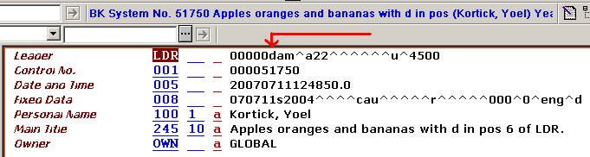

This is position 5 when counting from zero (when counting from one it is position 6).

This means that the record has been deleted. For more information see the Library of Congress MARC explanation of this position at http://www.loc.gov/marc/bibliographic/ecbdldrd.html .

If for whatever reason you wish to remove the d from position 5 you can make a home made fix procedure to do this.

We will want to change this:

LDR L 00000dam^a22^^^^^^u^4500

To this:

LDR L 00000^am^a22^^^^^^u^4500

To do so:

ONE

In the directory $data_tab/import make a fix procedure as follows:

! 2 3 4 5 6 7 8 9
!-!!!!!-!!-!-!!!-!!!-!!!!!-!!!!!!!!!!!!!!!!!!!!!!!!!!!!!!-!!!!!!!!!!!!!!!
1 LDR 005 005 FIXED-CHANGE-VAL d,^

The above file name is called “change_pos_5_of_ldr”. It means “in field LDR from position 5 to position 5 change d to ^”.
For more information on the creation of home made fix procedures see the accompanying files “How_to_make_home_made_fix_procedures_parameters.ppt” and “How_to_make_home_made_fix_procedures_examples.ppt”.

TWO

Add this fix procedure to the “edit > fix record” menu in the cataloging module of the GUI. First add it to $data_tab/tab_fix as follows:

! 1 2 3
!!!!!-!!!!!!!!!!!!!!!!!!!!!!!!!!!!!!-!!!!!!!!!!!!!!!!!!!!!!!!!!!!!>
YOEL1 fix_doc_do_file_08 change_pos_5_of_ldr

Above the routine name is YOEL1

THREE

Add the routine name to the file which creates the menu. It is $data_root/pc_tab/catalog/fix_doc.lng and added as follows:

! 1 2 3 4
!!!!!-!-!-!!!!!!!!!!!!!!!!!!!!!!!!!!!!!!!!!!!!>
YOEL1 N L Change pos. 5 of LDR from d to ^ (Yoel's special)

FOUR

Run UTIL M 7 and reconnect to GUI. Retrieve record with a d in pos. 5 of the LDR and invoke menu.

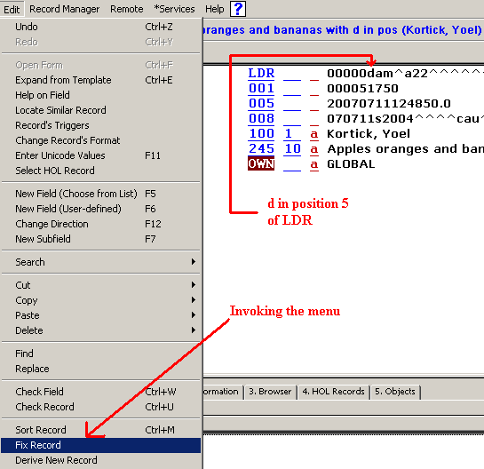

FIVE

Choose the new option to change the d to ^

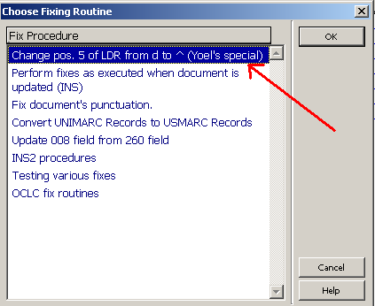

SIX

See the change occur

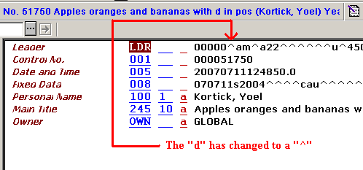

SEVEN

The script made in $data_tab/import can be used via service file-08 to change an ALEPH sequential file in $data_scratch:

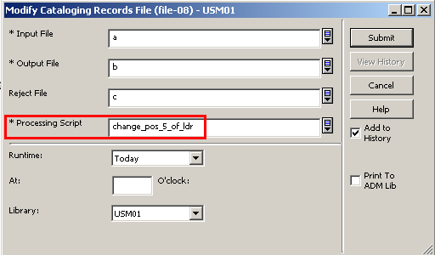

EIGHT

The fix routine YOEL1 can be used when uploading records via manage-18:

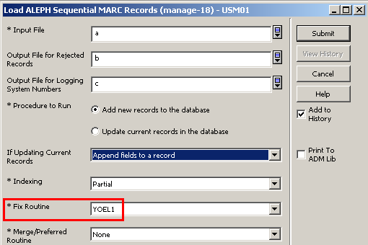

NINE

Via manage-37 the fix-routine can be used to fix existing records in the database.



