

How to add a condition a condition to an xsl template

Yoel Kortick

Question
How can we change an xsl form so that it will be different depending on the data which is printed in it?

Example one:
How can I have one version of the form loan-receipt.xsl if the item is status 02 “Two days” and another form if it is not status 02 “Two days”?

Example two:
How can I have one version of the form hold-request-wait.xsl for ILL partner libraries and another form for all other regular patrons?

Answer
It is possible to have different versions of the same form depending on data content, but it is not possible to have different versions of the form be used depending on data content.
For example, it is not possible to say:

Use template loan-receipt-01.xsl for item status 02
Use template loan-receipt-02.xsl for all other item statuses

However, it is possible to change loan-receipt.xsl so that in one case certain fields will print in certain ways and in other cases other fields will print in certain ways.

It is important to note that what will be done here is not specifically an Aleph function, rather it is a standard xsl function. Details may be obtained at http://www.w3schools.com/xsl/xsl_if.asp .

Example one

We will change here the template loan-receipt.xsl so that if the item being printed on the form is item status 02 “Two Days” then the form will include the Due Hour, and in all other cases it will not include the due hour.

This form is printed if we choose in the circulation module the menu
Aleph > Options > Set Up Loan options > Loan Receipt Printing > Per Single Loan

Here is the default form from the “out of the box” version:

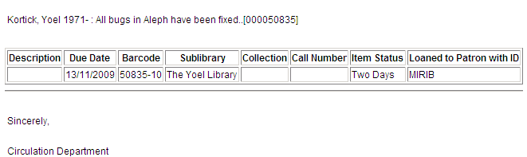

If we change the form as follows then the due hour will always appear in the form:

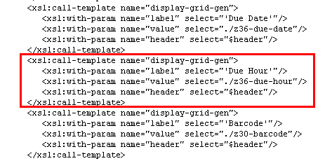

Now here is the due hour:

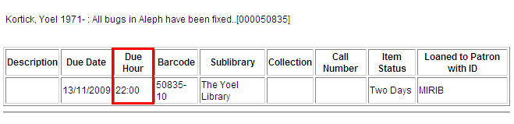

At this stage, we want to make a condition. We want to state that if the z30-item-status is “Two Days” then print the Due Hour. If it is not “Two Days” then don’t print the Due Hour.

Below we add an “if” condition for the field:

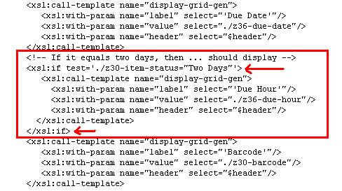

Now when the z30-item-status is “Two Days” we have the Due Hour:

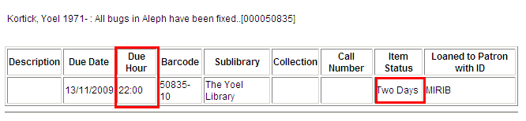

But, when the z30-item-status is not “Two Days” we do not have the Due Hour:

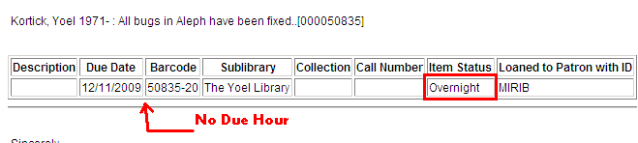

Note #1:

It is also possible to use "!=" instead of "=" .

Thus it would be
<xsl:if test='./z30-item-status!="Two Days"'>

The above means “If the z30-item-status is not “Two Days””

Note #2:

Above we knew that “Two Days” is in the field “z30-item-status” because that is what is in the template and because we can see it if we print the form in raw xml:

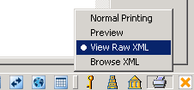

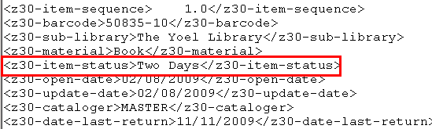

Example two

We will change here the template hold-request-wait.xsl so that if the patron record being printed on the form has a note in z302-field-1, for example like “ILL”, then the form will have a specific title and specific text. In all other cases it will have the regular title and text.

Note: While in most cases a dedicated patron status specifically for ILL partners exists, the z305 data is not included in the letter. Therefore here we will be using the text "ILL" in a note field.

The form hold-request-wait.xsl is printed by p-cir-12, by ue_06 or if we choose in the circulation module the menu
Requests > Hold Requests > Print Letter – Hold Request Not Filled

Here is the default form from the “out of the box” version:

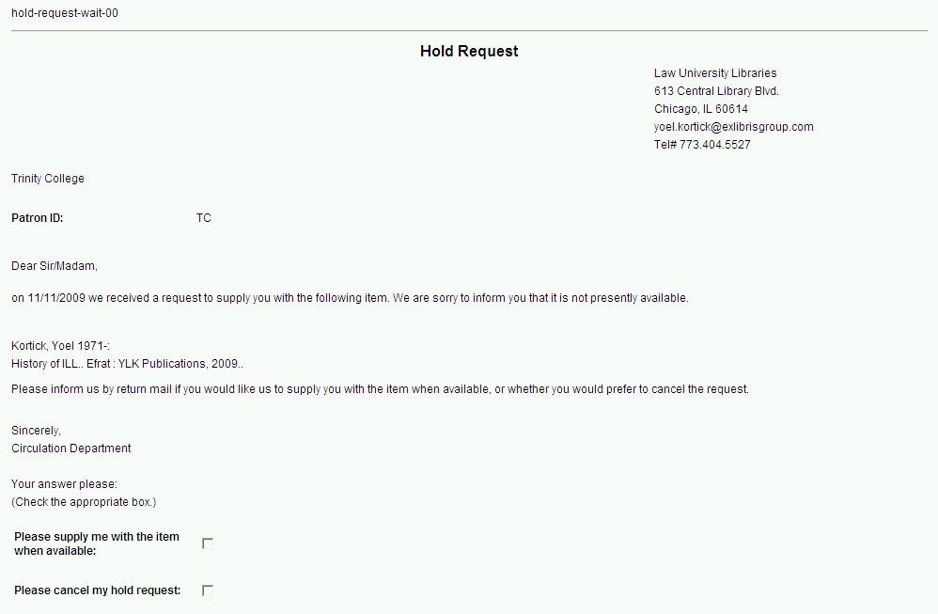

If we change the form as follows then the remark regarding the patron account in the OPAC will always appear in the form (the yellow highlight bold is the addition):

<xsl:call-template name="generic-line">
<xsl:with-param name="line" select='concat("salutation_string##on ", //z37-request-date, " we received a request to supply you with the following item. We are sorry to inform you that it is not presently available.")'/>
</xsl:call-template>
<xsl:call-template name="salutation-end"/>
<xsl:call-template name="bib-info-hdr"/>
<xsl:call-template name="generic-line">
<xsl:with-param name="line" select="'Please inform us by return mail if you would like us to supply you with the item when available, or whether you would prefer to cancel the request.'"/>
</xsl:call-template>
<xsl:call-template name="generic-line">
<xsl:with-param name="line" select="'Please note that you can also delete the request yourself via your patron account in the OPAC.'"/>
</xsl:call-template>
<xsl:call-template name="table-open"/>
<xsl:call-template name="display-gen">
<xsl:with-param name="label" select="'Author of Part:'"/>
<xsl:with-param name="value" select="./z37-author"/>
</xsl:call-template>

Now here is the remark in addition to the note asking the customer to inform the library by return mail:

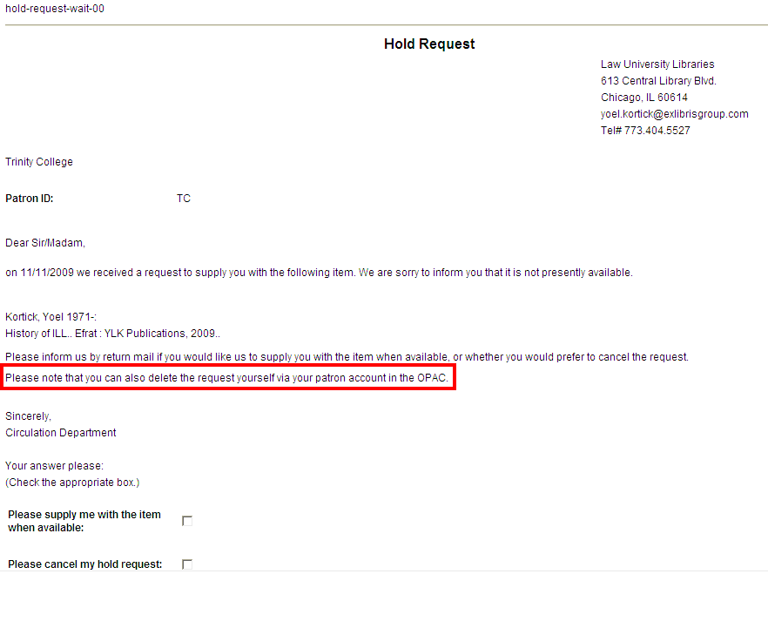

At this stage, we want to make a condition:

We want to state that if the z302-field-1 has “ILL” then do not print the remark “Please note that you can also delete the request yourself via the patron account in the OPAC”. This is because e ILL partners are not using it. They have never received a login from the library and don’t even know that it exists. ILL partners should use the checkboxes at the bottom or reply by mail.

Here is the condition:
If z302-field-1 doesn’t have “ILL” then only the remark “Please note that you can also delete the request yourself via the patron account in the OPAC” is printed and the checkboxes at the bottom should not be printed. This is because if the patrons delete any unwanted requests themselves instead of replying by mail, it saves the library a lot of work.

Below we add a “choose” condition for the field:

<xsl:choose>
<xsl:when test="z302-field-1='ILL'">
<xsl:call-template name="generic-line">
<xsl:with-param name="line" select="'Please inform us by return mail if you would like us to supply you with the item when available, or whether you would prefer to cancel the request.'"/>
</xsl:call-template>
</xsl:when>
<xsl:otherwise>
<xsl:call-template name="generic-line">
<xsl:with-param name="line" select="'Please note that you can also delete the request yourself via your patron account in the OPAC.'"/>
</xsl:call-template>
</xsl:otherwise>
</xsl:choose>
..

<xsl:choose>
<xsl:when test="z302-field-1='ILL'">
<xsl:call-template name="signature">
<xsl:with-param name="text" select="'##Sincerely,##Circulation Department####Your answer please:##(Check the appropriate box.)'"/>
</xsl:call-template>
<xsl:call-template name="checkbox">
<xsl:with-param name="text" select="'Please supply me with the item when available:'"/>
</xsl:call-template>
<xsl:call-template name="checkbox">
<xsl:with-param name="text" select="'Please cancel my hold request:'"/>
</xsl:call-template>
</xsl:when>
<xsl:otherwise>
<xsl:call-template name="signature">
<xsl:with-param name="text" select="'##Sincerely,##Circulation Department'"/>
</xsl:call-template>
</xsl:otherwise>
</xsl:choose>

</xsl:template>
<xsl:template name="signature">
<xsl:param name="text"/>
<xsl:call-template name="generic-line">
<xsl:with-param name="line" select="$text"/>
</xsl:call-template>
</xsl:template>

</xsl:stylesheet>

Now when the z302-field-1 has “ILL” we have the checkboxes and the note asking to reply by return mail:

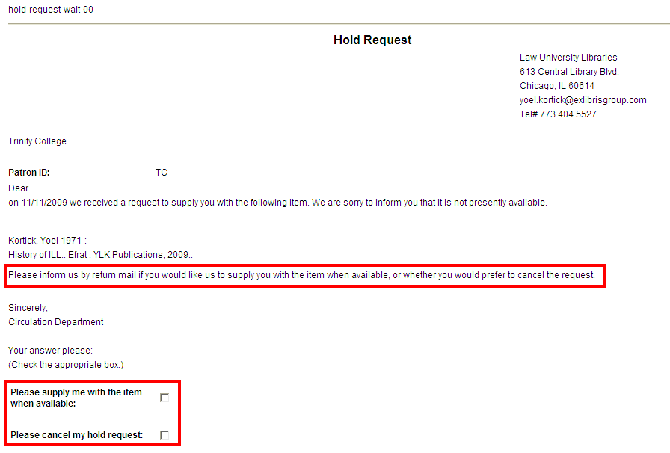

But, when the z302-field-1 does not have “ILL” we do not have the checkboxes but we do have the note regarding the patron account:

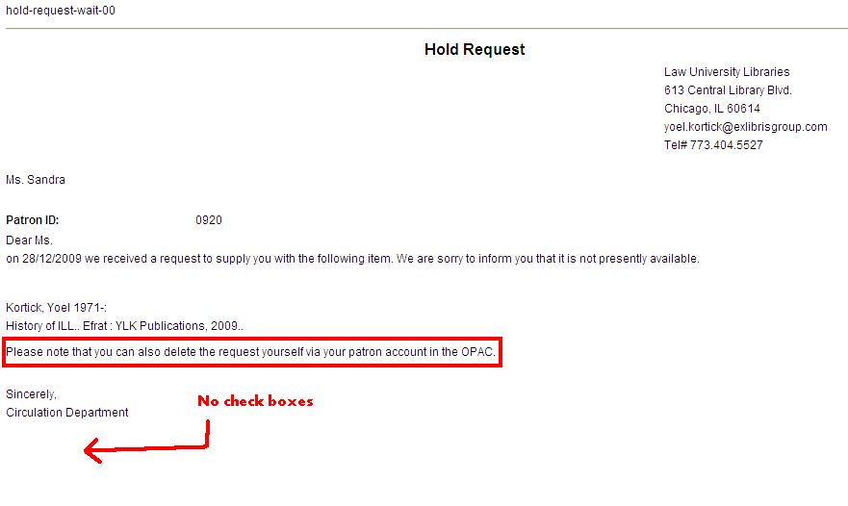

Note #1:

Above we knew that “ILL” is in the field “z302-field-1” because that is what is in the template and because we can see it if we print the form in raw xml:

Note #2:

As z302-field-1 appears in the section-01 of the xml, it can only be used in the section-01 of the xsl template, too!

<?xml version="1.0"?>
<printout>
<form-name>hold-request-wait</form-name>
<form-language>ENG</form-language>
<form-format>00</form-format>
<subject>Hold Request Waiting Letter</subject>

<section-01>

..

<z302-ill-library>ILL_L</z302-ill-library>
<z302-home-library>Law Library</z302-home-library>
<z302-field-1>ILL</z302-field-1>
<z302-field-2></z302-field-2>
<z302-field-3></z302-field-3>
<z302-note-1></z302-note-1>
<z302-note-2></z302-note-2>

..

</section-01>

</printout>

Example three

The cash-03 service prints a report including several lines of cash transactions (baby blue below), as well as a line with the summary, a line with the balance and a line with the total (red below). For example:

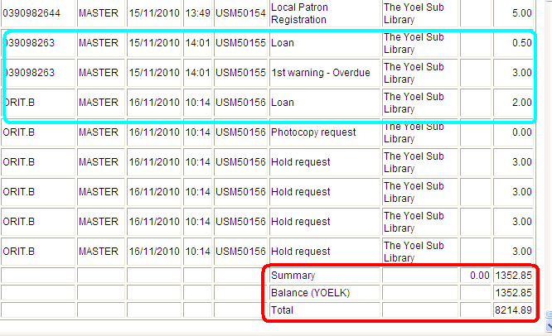

Now we want to only print the lines with Summary, Balance and Total.

This we can copy the existing form “payment-received-report.xsl” to a new format, for example 89 and then edit “payment-received-report-89.xsl” so that there will be a condition to only print the desired lines:

<xsl:for-each select="//section-02">
<xsl:if test="position() = 1">
<xsl:call-template name="section-02">
<xsl:with-param name="header" select="'header'"/>
</xsl:call-template>
</xsl:if>
<xsl:if test="contains(z31-description,'Summary') or contains(z31-description,'Balance') or contains(z31-description,'Total')">
<xsl:call-template name="section-02"/>
</xsl:if>
</xsl:for-each>

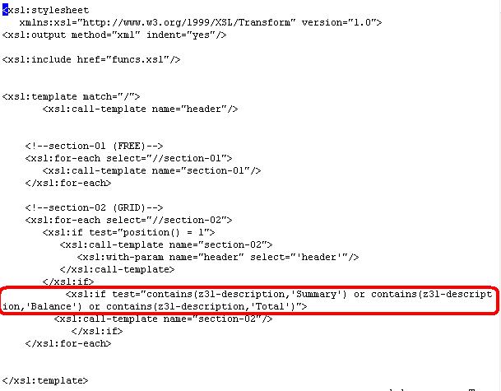

Then we linked to it in the cash-03 xml:

aleph@viola(a20_1) NTU01> cd $alephe_root/pc_b_eng
aleph@viola(a20_1) NTU01> ls -lrt p-cash-03.xml
-rw-r--r-- 1 aleph exlibris 6372 Nov 16 13:37 p-cash-03.xml
aleph@viola(a20_1) NTU01>
<cbitem>
<value>89</value>
<display> Yoel’s format (payment-received-report-89.xsl) </display>
</cbitem>

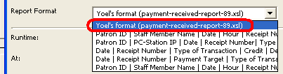

So now you can run this by using cash-03 and choose the format “Yoel’s format (payment-received-report-89.xsl)".

It will then include only lines which have Balance, Summary or Total:



