Sample sites:

University of Utah https://na02.alma.exlibrisgroup.com/mng/login?institute=01UTAH_INST&auth=local
Loyola University – Chicago https://na01.alma.exlibrisgroup.com/mng/login?institute=01LUC_INST&auth=local

Load Electronic Collections for existing purchased services – include vendor in name
Ex: CCC Get It Now Springer below.

This is documented in Alma September 2014 Release Notes.
If collections were not loaded, use Repository - advanced search CZ for electronic collections where electronic collection name contains CCC Get it Now
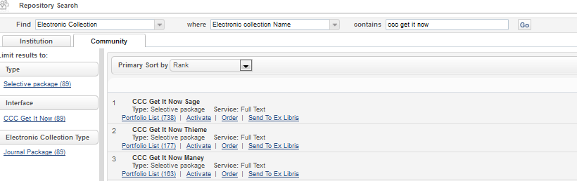
***Required: For each CCC service you wish to offer, Activate the collection****
***Required: Activate all portfolios which should be available for patrons to request articles from.
Once activated, EDIT the record to alter any data needed. In particular, Description and Public Note.
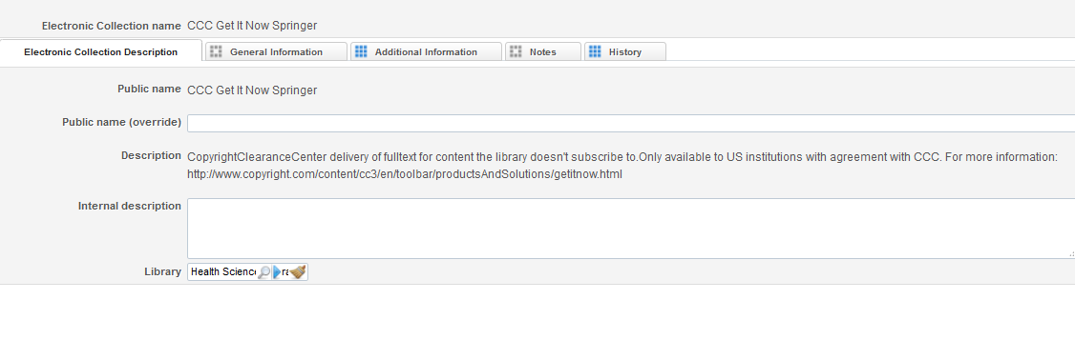
Note: CZ Electronic Collection Description tab already includes:
CopyrightClearanceCenter delivery of fulltext for content the library doesn't subscribe to. Only available to US institutions with agreement with CCC. For more information: http://www.copyright.com/content/cc3/en/toolbar/productsAndSolutions/getitnow.html
General Information Tab: Verify Interface Name for all collections (CCC Get It Now). If it does not exist on standalone portfolio, add via Information Update job.
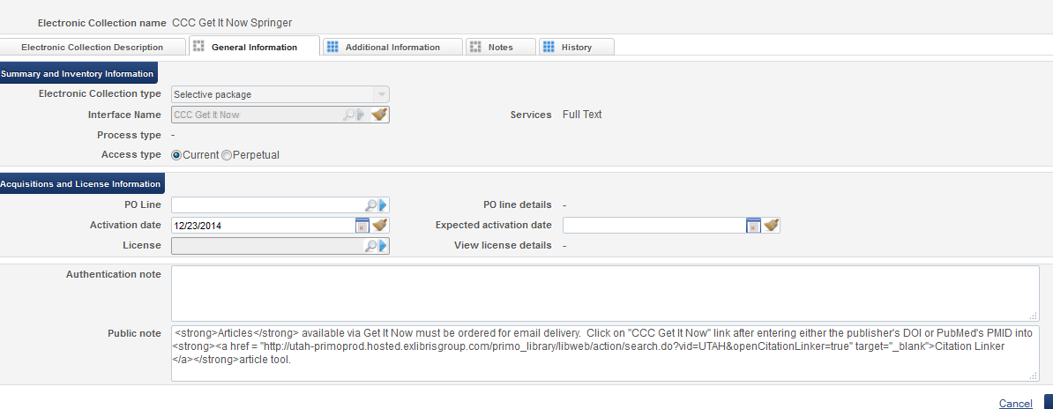
Add Activations dates as appropriate
Public note (not required) sample: <strong>Articles</strong> available via Get It Now must be ordered for email delivery. Click on "CCC Get It Now" link after entering either the publisher's DOI or PubMed's PMID into <strong><a href = "http://loyola-primo.hosted.exlibrisgroup.com/primo_library/libweb/action/search.do?vid=LUC&openCitationLinker=true" target="_blank">Citation Linker </a></strong>article tool.

If a citation linker address is included on the journal level, http and vid must be changed to match institution specific information. Update: Primo citation linker address with the http: and view name. Public note is useful only on the Journal record. On the article record, following the instructions brings the user back to the same article.

SAVE changes

‘EDIT SERVICE’ - Linking tab
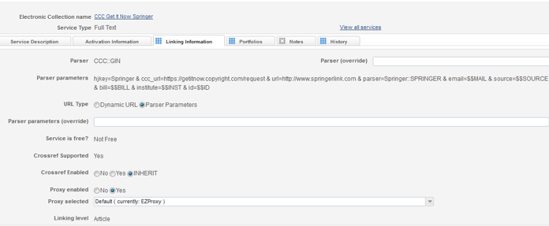
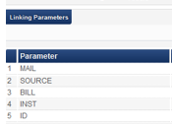
Enable and select Proxy
Add Parameters (CCC parameters for your institution).
- Mail & Bill : usually the email contact for your institution; same email address should go into both Mail and Bill fields.
- Source & INST: usually code for your institution with CCC; both values will match
- ID is blank – used only if institution is using EZproxy instead of parameters.

Common errors:
Mail and Bill values do not match
Source and INST do not match

Activation Tab
*May need to Activate resources upon save and add activation date. This depends upon the site’s use of resources from this vendor.
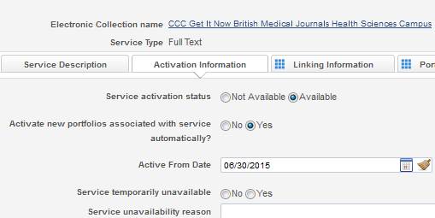
PRIMO Settings in Alma (Online Services Order and Display Logic Rules)

Online Services Order
Alma > Fulfillment > Discovery interface display logic > Online Services Order
– allows prioritization of display of e-collections based on Interface Name (see below)

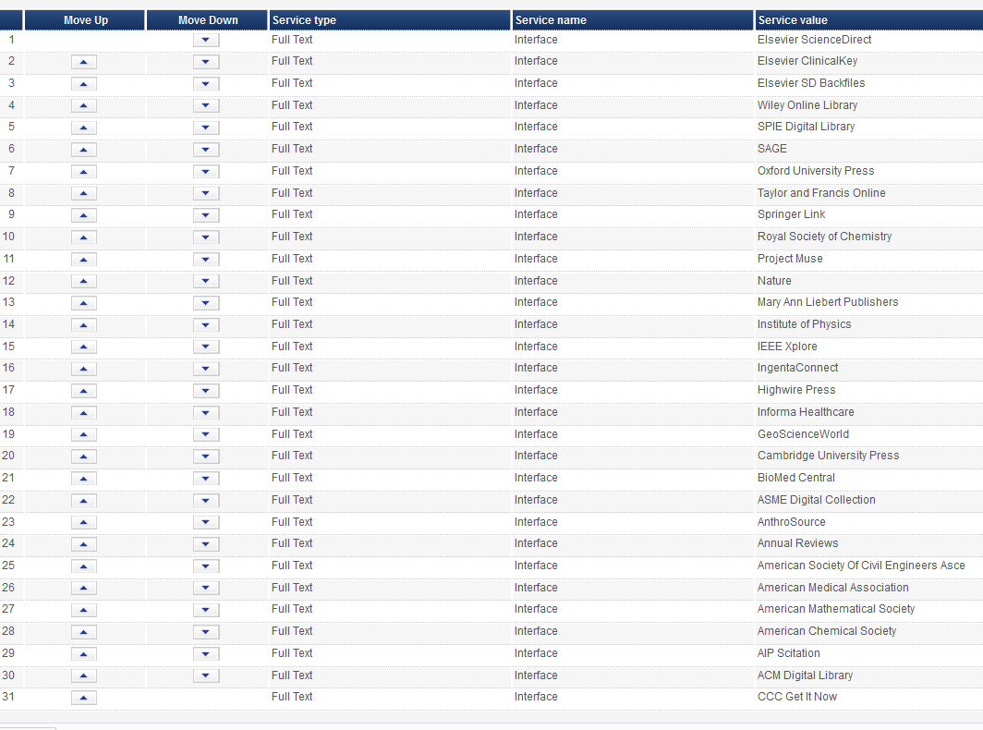

Display Logic Rules
Alma > Fulfillment > Discovery Interface Display Logic > Display Logic Rules
Example: hide CCC Get It Now from all user groups except Faculty and Staff

PRIMO > test configuration
From Alma: Find Electronic Collection “CCC Get It Now”;
Find Activated Collections > Choose an activated Portfolio (journal title) to search in Primo
Search site’s Primo FE:
(Loyola) http://primo-pmtna02.hosted.exlibrisgroup.com/primo_library/libweb/action/search.do?menuitem=0&fromTop=true&fromPreferences=false&fromEshelf=false&vid=01LUC

Test 1) Search for that journal title “Tobacco Control”
- Click View It
- Click the link for CCC Get It Now
**Note: This journal is also in Free e-journals.
May want to de-activate this title in CCC Get It Now sources and/or add “Free e-journals” to Alma > Fulfillment > Discovery interface display logic > Online Services Order prior to “CCC Get It Now”
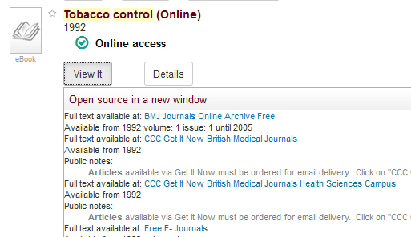
- Enter Proxy Information as required
- No Article found (because you’re on the journal title) but proves CCC access is configured
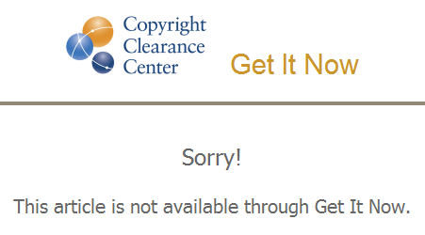
Test 2) Find articles in that title – Search for “tobacco control” ; limit to Journal “tobacco control”
- Click View It
- Click the link for CCC Get It Now

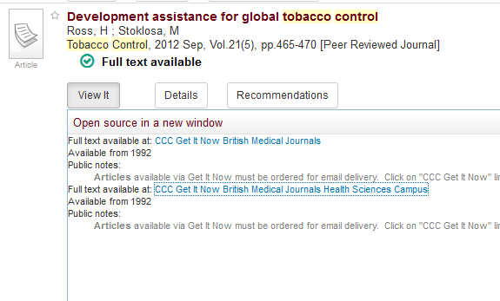

- Enter Proxy Information as required
- CCC confirmation page for ordering appears. Requests email address and ‘I agree’ to terms
  - If not, configuration is incorrect (likely parameters for site)
