In Opac after searching the following brief list is displayed:

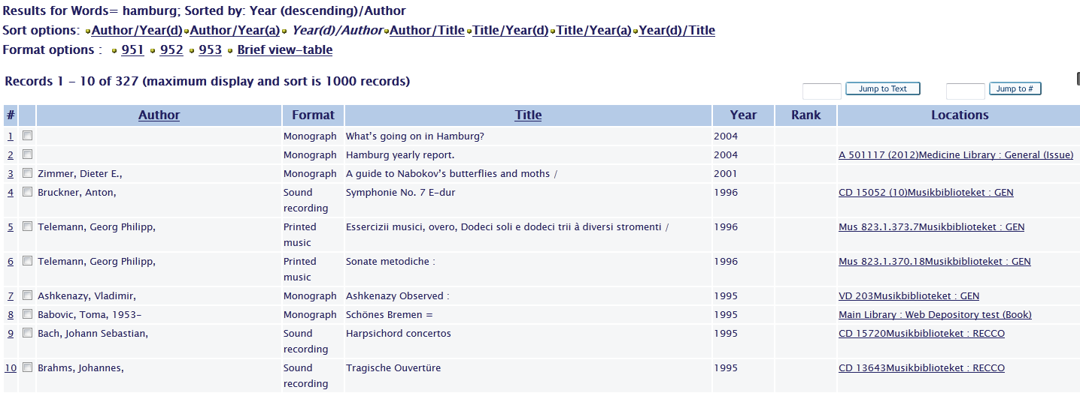

It is possible to sort by column Author or by column Title when you click on the according underlined entry.

How to add a sort option also for column Locations?

In xxx01/tab/tab_sort you see that the sort code for locations is 04:

!1 2 3 4 5 6 7 8 9 10 1 12 13 4 15 16 7 18 9
!!-!!-!!!!!-!!!!!-!-!!!!!-!!!!!-!-!!!!!-!!!!!-!-!!!!!-!!!!!-!-!!!!!-!!!!!-!-!!-!!
01 95 008 260## c 08 04
02 01 1#### a 700## a 00 00
03 11 245## a 2 240## 2 00 00
04 22 050## LOC## hjl 084## a 00 00
05 11 440## av 2 00 00
06 TYP## FMT## 00 00
07 01 BND 245## a 2 00 00

In xxx01/tab/www_tab_short.lng you see the active sort options in column 4 for Author, Title, Year:
! 2 3 4 5 6 7 8 9 10 11 12 13
!-!-!!!!!!!!!!!!!!!!!!!!-!!!!!!!!!!!!-!!-!!-!!!!-!-!-!!!!!!!!!!-!!-!!!!!-!!!!!-!!!!!-!!!!!-!!!!!
1 L Author 02---A01---A 00 00 0100 S 9 - ## 1#### 700##

2 L Format S ## TYP## FMT##

3 L Title 03---A01---A 00 00 0100 S ## 245##

4 L Year 01---D02---A 00 00 S ## YR

5 L Rank L ## RANK

!6 L Lib/Items 00 00 2000 L ## ITM+

7 L Locations 00 00 0100 L ## LOC+

Add a sort option like the following also for the Locations line in all required language files:

7 L Locations 04---A01---D 00 00 0100 L ## LOC+

Restart the WEB Server

