We have an example dashboard here. Let’s assume that we want to rename the middle section (“Inactive loans”) to a different name, for example “Test report of inactive loans”.
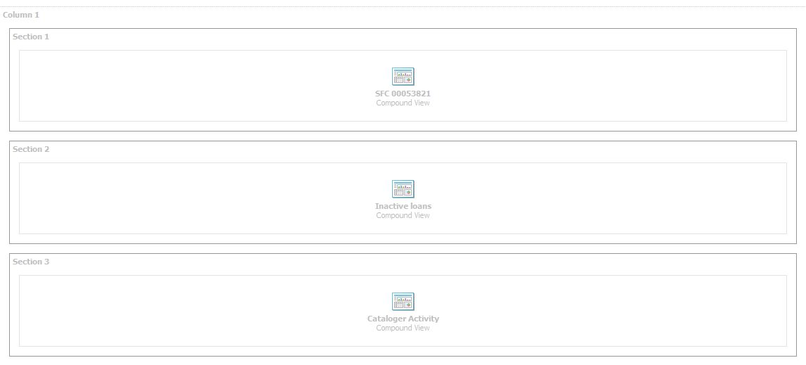
You can’t rename the report but you can rename the section. Currently it is called “Section 2”. So the steps are:
- Rename “Section 2” to “Test report of inactive loans”.
- By default the section title is suppressed, it needs to be unsuppressed.
- The report title needs to be suppressed then.

STEP 1: Rename the section title:
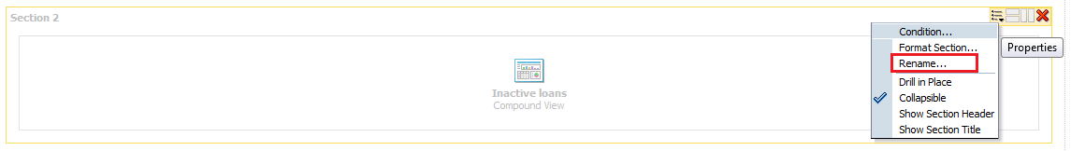
(Click Rename and enter the new section title, here: “Test report of inactive loans”.)

STEP 2: Unsuppress the section title:
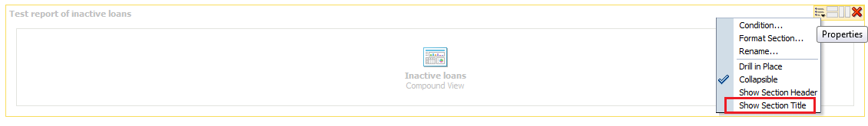
(Click in order to add a checkmark.)

STEP 3: Suppress the report title:
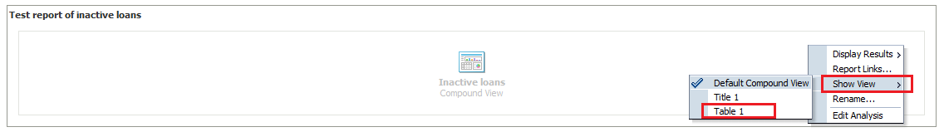
Instead of “Default Compound View”, select “Table 1” which will only display the table and not the report title (which is still “Inactive loans”).

Don’t forget to save your changes!

