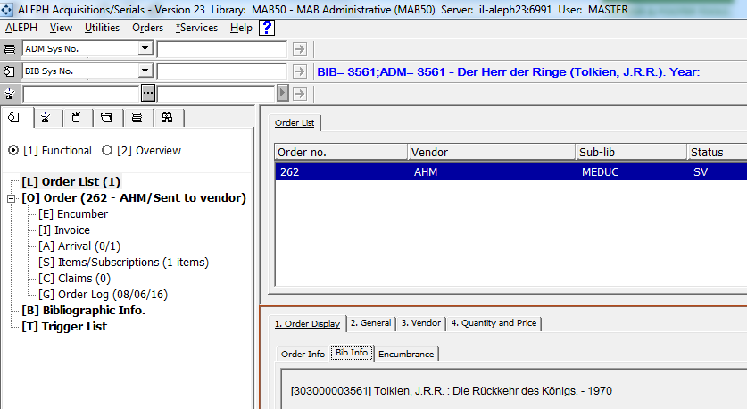
Where does this information come from?

xxx50/pc_display_eng/bib-info
!
! Bib information
! section-01 - dependent on existence of bib-info
!

SECTION-01

CONDITION bib-info

##LABEL Bib Info##

<include>html-head
Bib-info is a paragraph within bib_format
<div class="table-bib-info">
./bib-info
</div>
</table>

<include>html-tail

END-CONDITION

END-SECTION-01

xxx50/tab/bib_format
bib-info 303

xxx01/tab/edit_paragraph.eng
303 SYS## D [303 ]
303 100## D ^ :
The fields to display are added here. Please note that this table is in the bibliographic library and not in the ADM library
303 200## D :
303 331## D ^
303 410## D .^-^
303 412## D ^:^
303 415## D ;^
303 425## D .^-^
303 540## D .^-^ISBN:^

