Usm01/tab/tab100
ACC-COUNT-LIMIT=1200
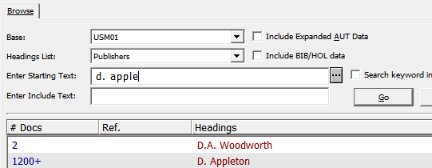

For the display in brief list parameter “set-result-set-limit” in $alephe_root/pc_server_defaults is relevant. Currently it’s not set (default=1000). This leads to the following result:
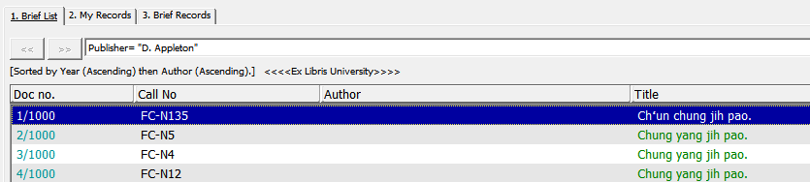

Parameter in $alephe_root/pc_server_defaults changed:
setenv set_result_set_limit 2000

View in brief list afterwards:
