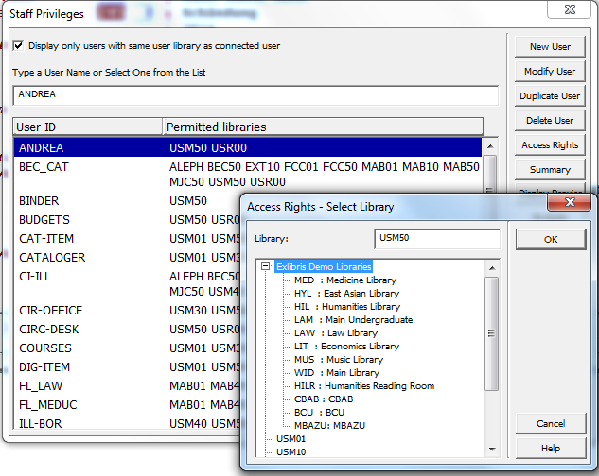

Add here privileges for a specific sublibrary or for the complete ADM library

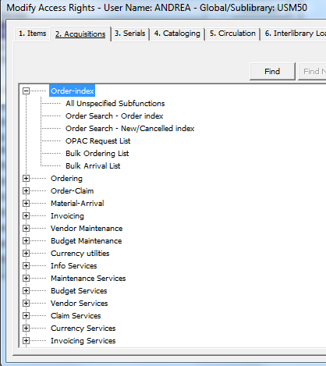

Check in the Acquisitions tab which access rights are already stored and maybe modify or enhance them