How to change the email subject for courtesy notices incl. renew

(loan-notice-renew-letter)

Product: Aleph
Version: 21, 22, 23
Relevant for Installation Type: Dedicated-Direct, Direct, Local, Total Care

Goal: Add a subject line for loan-notice-renew-letter mails

1) Add the relevant line to ./xxx50/tab/form_description.eng

Example:
! 1 2 3
!!!!!!!!!!!!!!!!!!!!!!!!!!!!!!-!!-!!!!!!!!!!!!!!!!!!!!!!!!>
[…]
loan-receipt Loan Receipt
loan-notice-renew-letter Loan Notice Renew Letter - Test
note:
a) that the text needs to be aligned with the header
b) A form number in col. 2 is not required when there are no different form numbers
2) Restart the PC server (util w/3/3)
Testing the results
3) Run service Courtesy notices (p-cir-10) with renew option
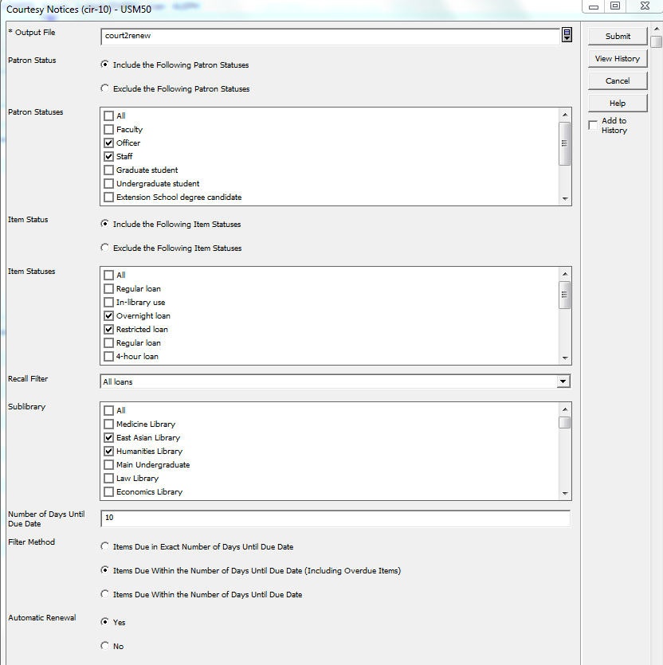

4) Print one of the forms in 'Preview'
5) Used the print history to change to option 'Mail' to send it to my mail address.
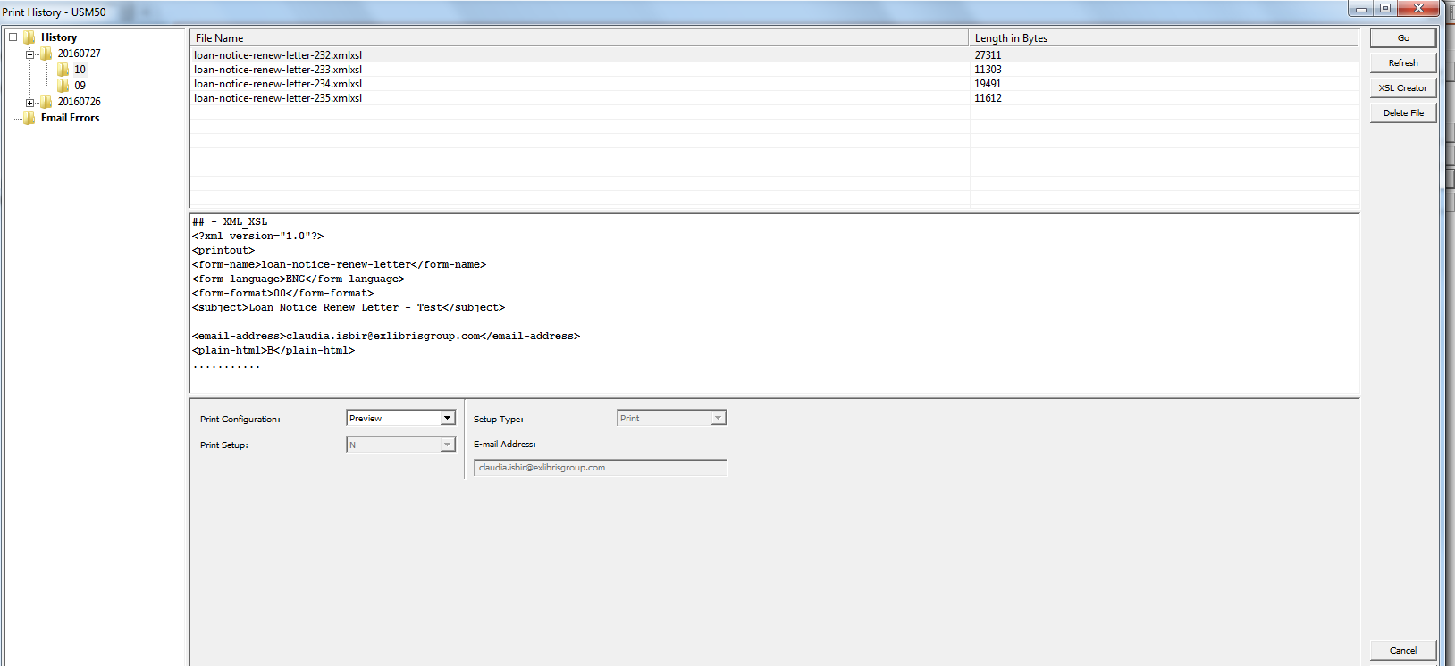

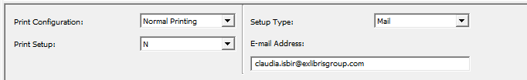

Results

