Customizing Summon: Branding and Header Options

1. Summon Branding and Header Options

1.1 Summon Administration Console:
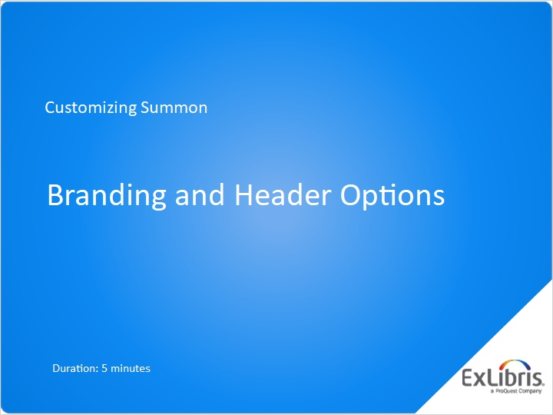
Notes:
Welcome to this session on customizing Summon, where we will discuss options for branding your Summon interface.

1.2 Agenda
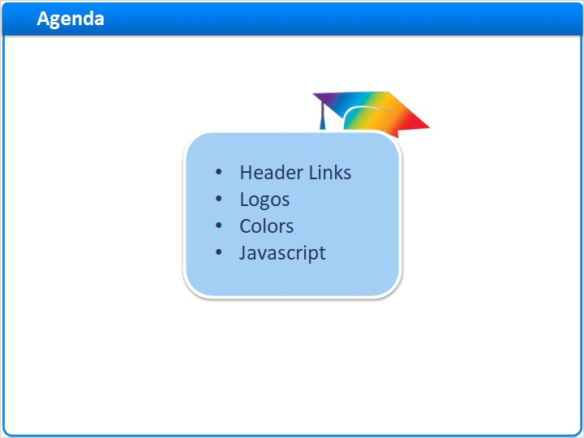
Notes:
In this short session, we’ll cover how to change some of the links in the Header, add institutional logos, change the colors of links, and even add javascript to the Summon interface.

1.3 Choose Page Title and Header Links
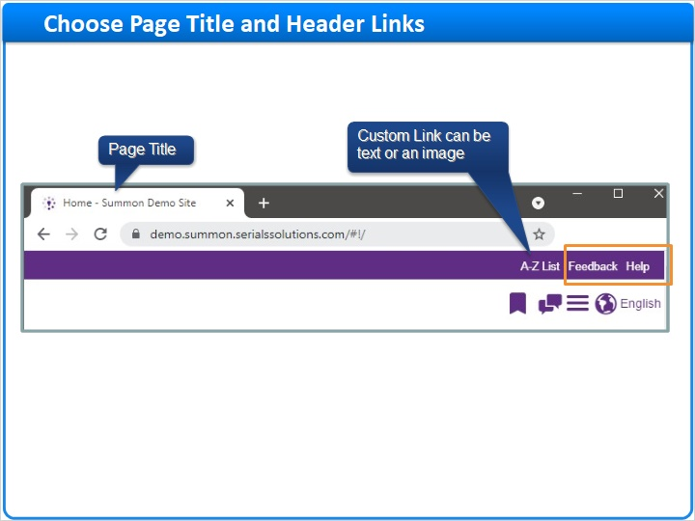
Notes:
Here is the top part of the Summon interface.

The page title is what appears in the researcher’s browser tab, and is what will display if the researcher bookmarks the page.

The custom link can be any piece of text you like, or even a small image, and can link anywhere you want. In this example, the link goes to the library’s A-to-Z list, for title discovery.

Also available in the header section are the Feedback link and the Help link.

1.4 Settings for Page Title and Header Links
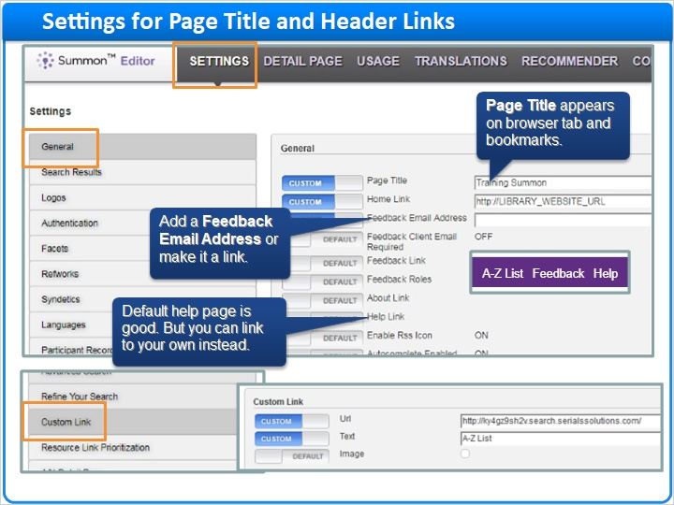
Notes:
To change these items in the header, go to the Settings tab of the Summon Administration Console, in the General section.

The page title can be customized here with the Page Title field.

When the researcher clicks on the Feedback link and fills out the feedback form, Summon will send an email with their information to the email address you include in that field here.

A default help page is available for researchers who click the Help link on the Summon page; but if you create your own help page, you can put the URL here and the Help link will go to your help page.

And you can make your own custom link by filling out the fields in the Custom Links section of the Settings tab.

1.5 Spruce Up Logos
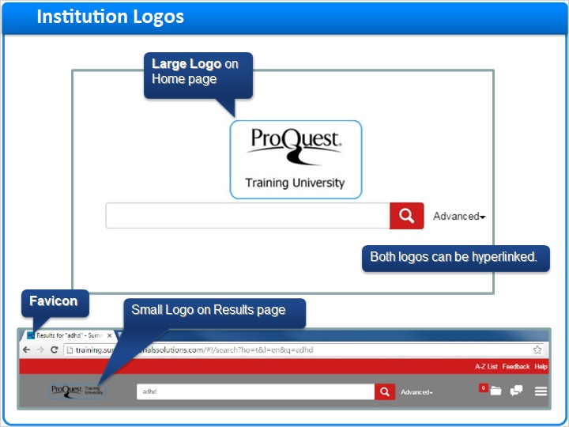
Notes:
There are three logos you will want to add to Summon:

The large logo appears on the Summon home page.

The small logo appears on the results page.

Both of these logos can link to another web page, such as your library home page.

The FAV-ee-con, or FAVE-eye-con, is the tiny image that appears at the top of the browser, and also appears on a bookmark list.

1.6 Settings for Logos
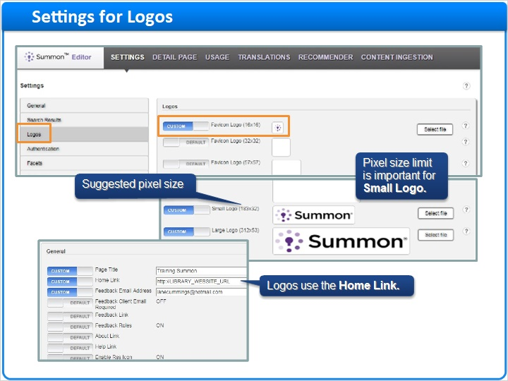
Notes:
On the Settings tab in the Summon Administration Console, choose the Logos section. There are quite a few Favicon sizes, due to all the mobile devices that can take advantage of Favicons, but the one for browsers is the first one, 16x16 pixels. Way down the page are the Small and Large Logos. It is especially important that the Small Logo be no larger than the pixel size specified, otherwise your Summon results page won’t display correctly.

Back in the General section is the Home link, which is the web page that will open when the patron clicks on either the small or large logo.

1.7 Color Your Summon Links
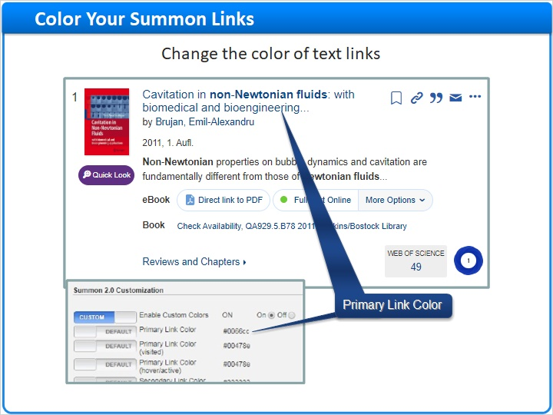
Notes:
By default, primary links are a medium blue color. To change colors, select the Summon 2.0 Customization section in the Settings Tab. You need to enter the hexidecimal code of the link color you would like.

1.8 Color Your Summon Authentication Banner
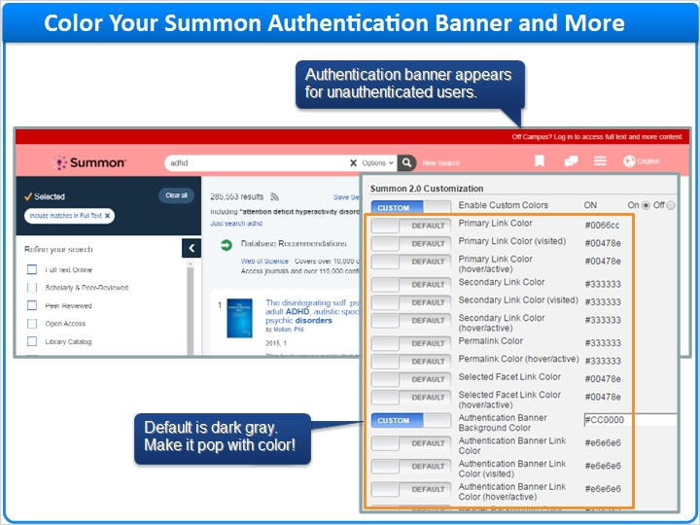
Notes:
Summon researchers who are not authenticated will see the authentication banner at the top of your Summon page. Unauthenticated researchers won’t be able to access very much full-text content, and in fact the Summon results may be slightly different for them. Therefore, it’s important that they know they are not yet authenticated.

The default color for the authentication banner is a dark grey, which researchers don’t seem to notice. It might be better if it is a more eye-catching color, like red, or perhaps a school color.

There are many other colors you can change on your Summon interface, including the background behind the small logo, the color of text items when you hover your mouse over them, and more.

1.9 Really Customize Your Summon with Javascript
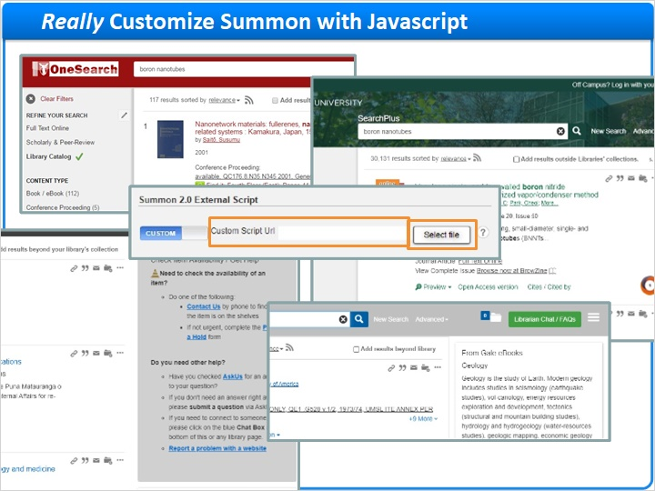
Notes:
You can make some sophisticated changes to Summon if you are able to create javascript code at your library. Examples shown here include Find It buttons, link to chat with a librarian, and more. But you can really do many things with javascript code.

Your institution’s staff will need to create and maintain the code.

To add javascript to your Summon page, select the Summon 2.0 External Script section and change the slider to Custom. If you want to store the javascript file on Summon’s servers, click Select file and upload the javascript file from your computer. Or, if a server at your institution will host the javascript file, then enter the full URL of the file on your server. By the way, if you do host the javascript file at your institution, your servers need to be very stable and always available: If Summon can’t access the javascript file, then the Summon page will not appear at all for your patrons and researchers.

1.10 Session Review
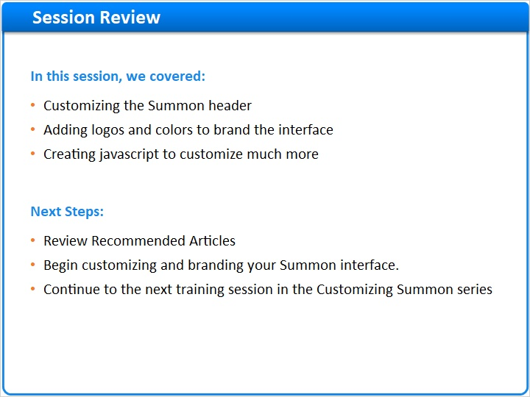
Notes:
That concludes this “Branding and Header Options” training session.

In this session, you learned how to:
- Customize the Summon header;
- Add logos and colors to incorporate your institution’s brand into the interface; and
- Create javascript to customize other elements of the Summon page.

Much more information is available in the online documentation, and there are links to that documentation in the Recommended Articles section where you launched this training session.

Next you can begin customizing Summon and adding your institutional branding, and then continue with the next training session in the Customizing Summon series.

1.11 Thank You!

Notes:
Thank you for joining this session!

1.12 About this Training
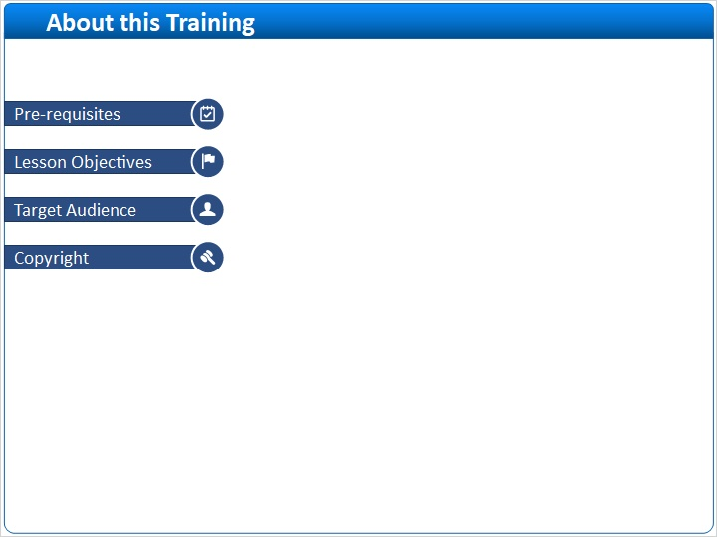
Notes:

1 (Slide Layer)
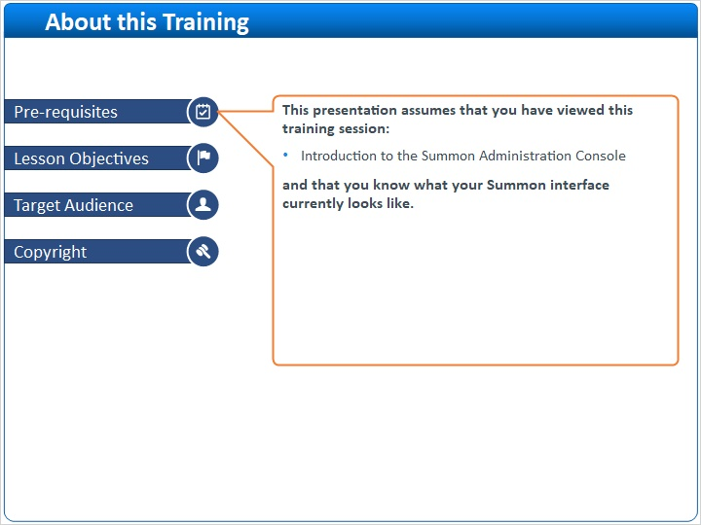

2 (Slide Layer)
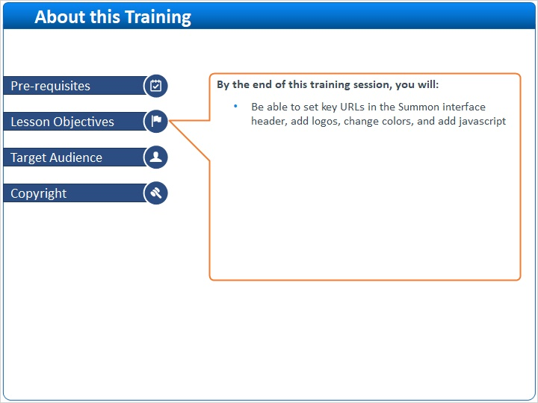

3 (Slide Layer)
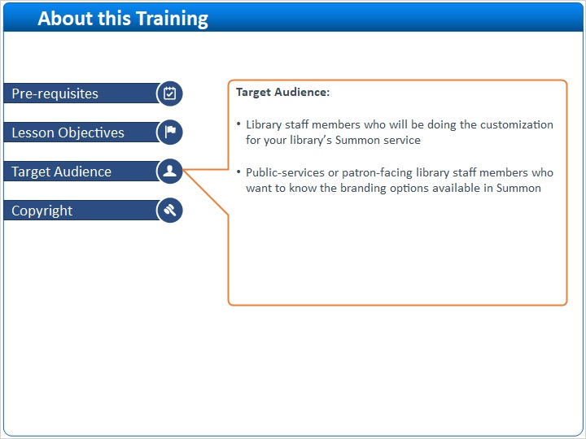

4 (Slide Layer)


