Customizing Summon: Refinements and Facets

1. Summon Refinements and Facets

1.1 Summon Refinements and Facets
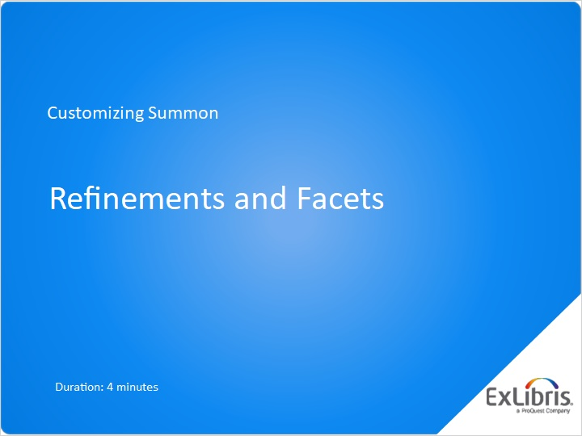
Notes:
Welcome to this session on Customizing Summon, where we will discuss options for refinements and facets in the Summon interface.

1.2 Agenda
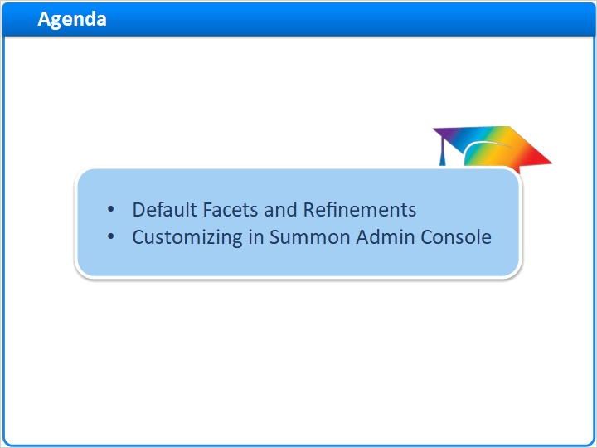
Notes:
In this short session, we’ll cover the default settings for the various facets and refinements your Summon researchers can use, and how to change those settings to ones customized for your library.

1.3 Refinements and Facets to Filter Summon Results
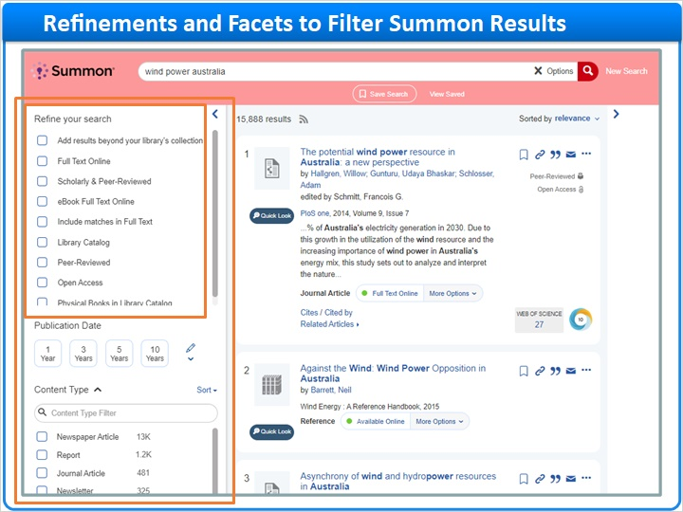
Notes:
When your library’s researchers use Summon, they can filter their searches using many different tools in the interface. The Results page, shown here, is sometimes called the Basic Search page.

Most of the filter tools are found in the left column. Let’s start with the first group: Refine your Search.

1.4 Choose Results Page Refinements
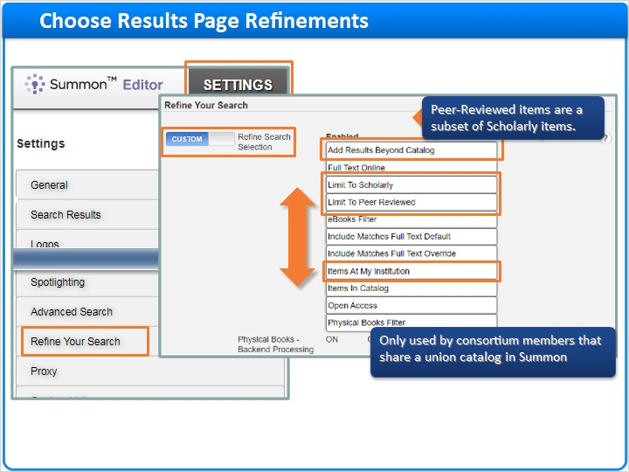
Notes:
To enable and disable tools in the Refinements group, go to the Summon Administration Console on the Settings tab, and select the Refine Your Search section.

Select Custom, and then move the refinement tools to the Enabled column or the Disabled column as desired. You can also drag enabled tools up and down to change the order they appear in Summon.

The refinement here called ”Add Results Beyond Catalog” gives the researcher the option to display results from the entire Summon Index.

Scholarly and peer-reviewed items are defined as such by the Ulrich’s service. Peer-reviewed items are a subset of scholarly items.

The refinement called “Items at my Institution” only has an effect for libraries that are part of a Summon Consortium who share a union catalog.

1.5 Refinements on Advanced Search Page
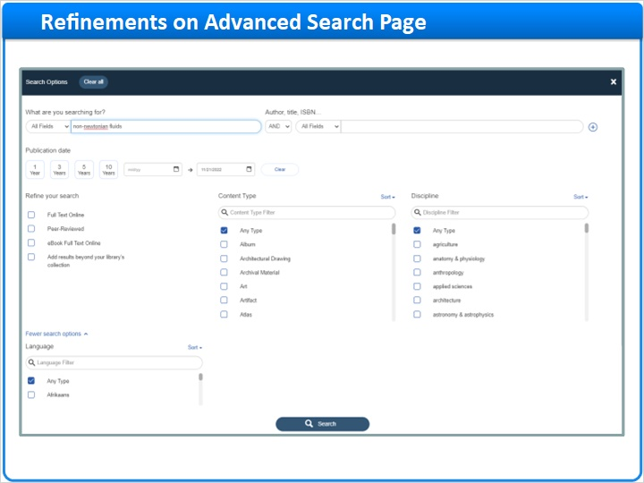
Notes:
The Advanced Search page gives researchers a much more precise way to search for results, as well as some of the refinements found on the Basic Search page.

1.6 Choose Advanced Search Page Refinements
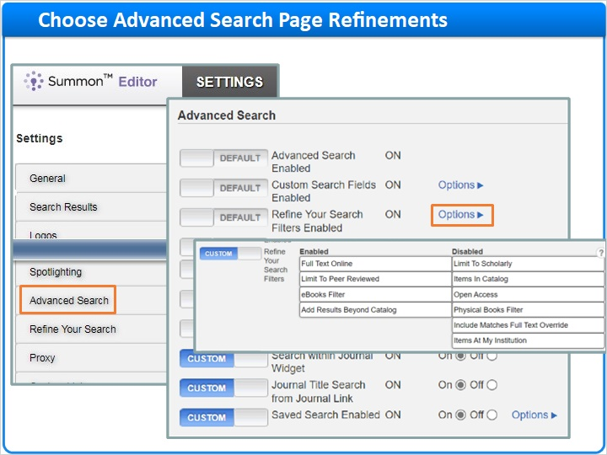
Notes:
To change which refinements appear on the Advanced Search page, go to the Summon Administration Console on the Settings tab, and select the Advanced Search section.

Refinement options here are mostly the same as in the Refine Your Search section, although you will need to open the Options to see all of them.

1.7 Default Order of Facets
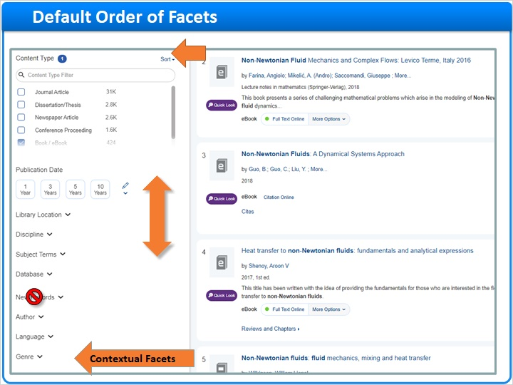
Notes:
Down the left side of the Summon page are the rest of the targeted facets.

In addition, there are contextual facets that only appear when search results are filtered either by book and e-book, or by Library Catalog. They are based on citation information in your MARC records, which is only available if Summon has indexed your library catalog.

All facet groups, whether targeted or contextual, can be moved up or down on the facets column, or even deleted from the facets column, using the Summon Administration Console.

1.8 Reorder or Remove Facets
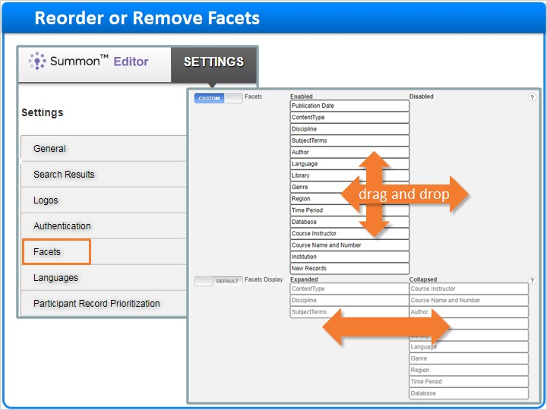
Notes:
Go to the Settings tab, and then choose the Facets section. Drag-and-drop facets to enable or disable, or move up and down to change the order they appear in the Summon facets column.

In the second section, you can change whether these facets are expanded or collapsed by default. Of course, Summon researchers can expand or collapse facets as needed.

1.9 Publication Date Facet
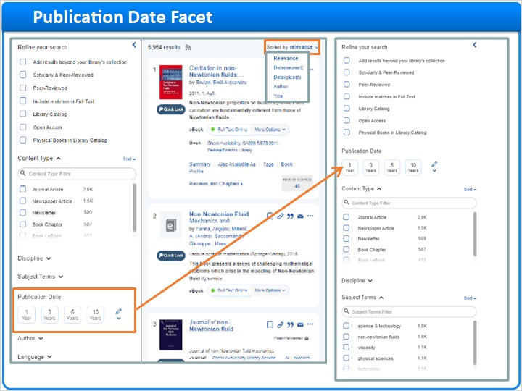
Notes:
One important change is to move the Publication Date facet up higher than it is by default … perhaps even above the Content Type facet. This is because researchers tend to overlook the Publication Date facet, and instead choose to sort by date, which turns off relevance ranking in their results list.

1.10 Thank You!

Notes:
That’s it for refinements and facets. Thank you for joining this session!

1.11 About this Training
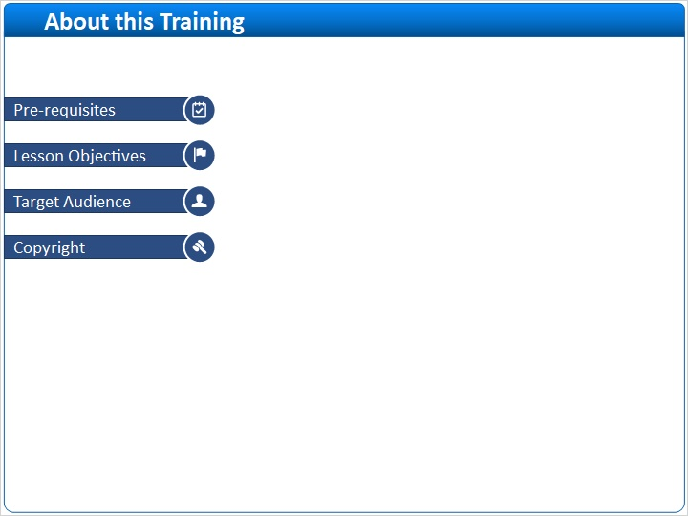
Notes:

1 (Slide Layer)
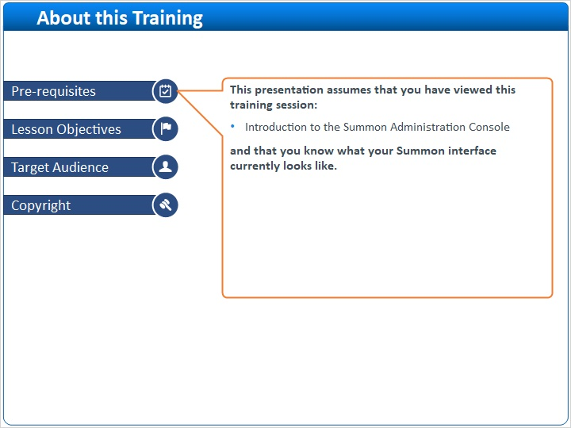

2 (Slide Layer)
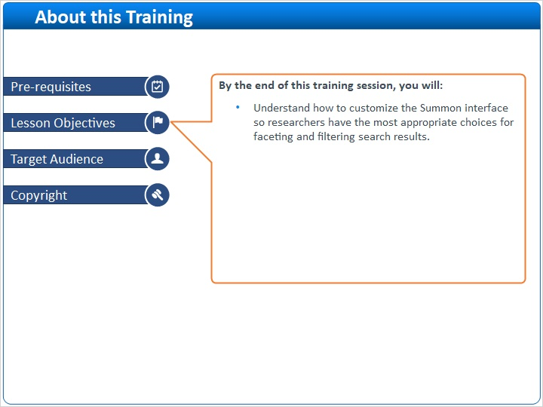

3 (Slide Layer)
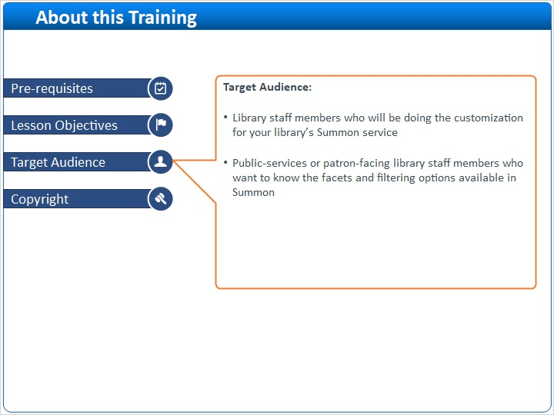

4 (Slide Layer)


