Sample record which has 2 items
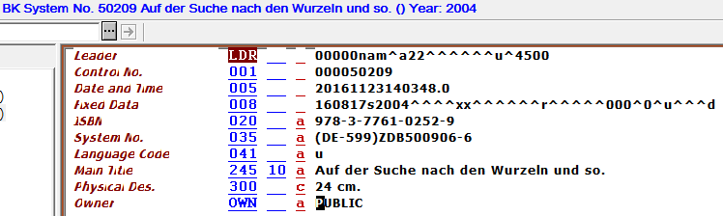
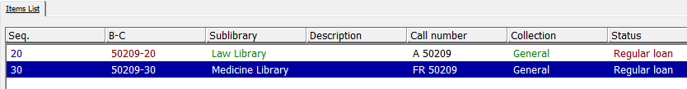

In xxx01/tab/tab_expand add expand routine expand_doc_bib_z30

ITEMS expand_doc_bib_z30 CONF=expand_doc_bib_z30_exp
You may add a specific table when you want to decide which fields from the items should be expanded.

In table expand_doc_bib_z30_exp you can decide which fields should be expanded into the BIB record. This is an example:
! 2 3 4 5
!-!!!!!!!!!!!!!!!!!!!!!!!!!!!!!!!!!!!-!-!!!!!!!!!!-!
# z30-material m space X
# z30-sub-library 1 space N
# z30-collection 2 space N
# z30-call-no 3 space X
# z30-inventory-number 6 space X
# z30-barcode 5 space X

For more information read the table header.

When running print-03 in order to export records assign routine ITEMS in field “Expand Routine”:

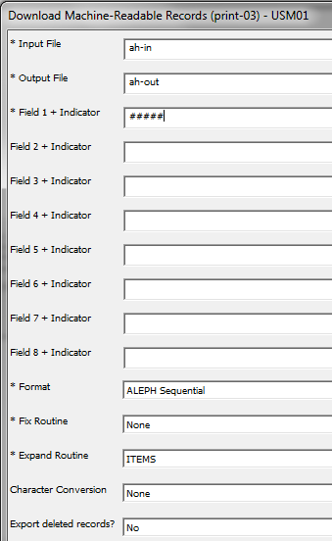

This is how the fields look in the output of print-03:

000050209 Z30-1 L $$mBOOK$$1LAW$$2GEN$$3A 50209$$550209-20
000050209 Z30-1 L $$mBOOK$$1MED$$2GEN$$3FR 50209$$550209-30

