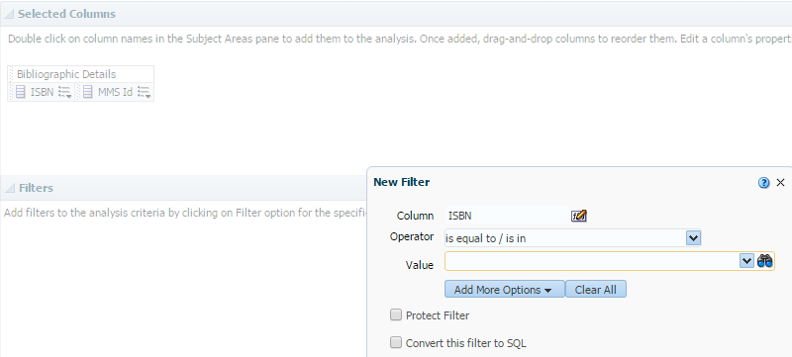
Click here

Select single lines and move them to the right or move all lines using

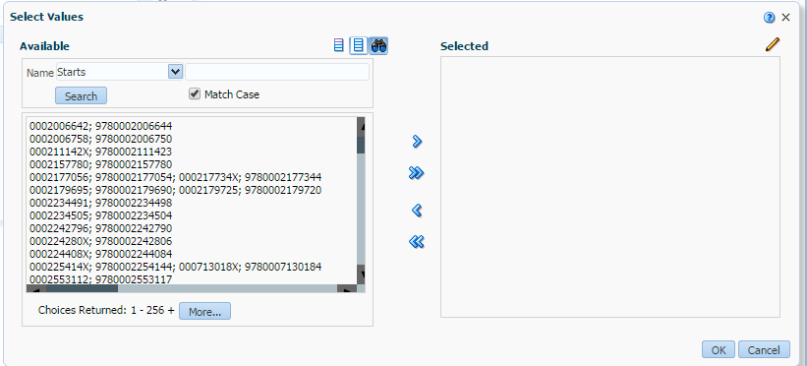

Click OK until you come back to your selection criteria > the ISBN is filled in

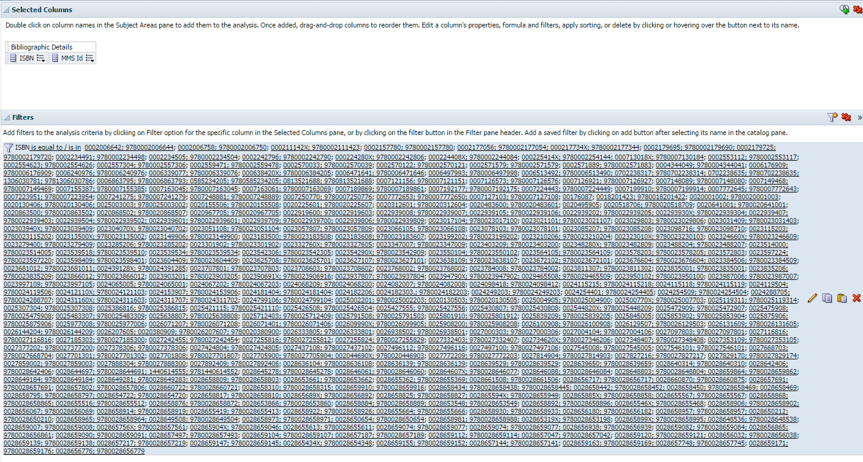

You can now click on Results and you’ll get a proper report

