|  |  |
| --- | --- |
| **How to move one of several ordered items to a new location and maintain link to order** |  |
|  | |

**Question**

“*When we order two identical copies, both are linked to the same holding; but in the process of cataloging is necessary to move one of them to a new holding (because one of them goes to a different location). How can we do this moving while keeping intact the link with the order?”*

**Answer**

This can be done via the “Manage Items” and “Edit Inventory” option from the “Receiving Workbench”.

See below for details.

**ONE**

POL-44239 has been created for title “Global perspectives on gender equality” and includes two items, both of which are in the same library and location: Main Library, Middle Eastern Studies location

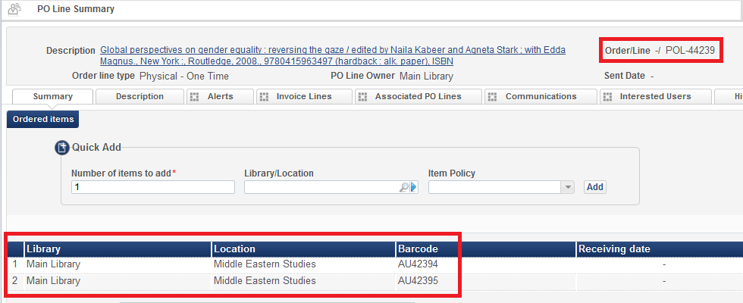

**TWO**

At a later stage, for example before or while receiving the items, it is decided that

1. One item will remain in the Main Library, Middle Eastern Studies location
2. One item will move to the Main Library, General location

From the receiving workbench (Acquisitions menu > Receiving and Invoicing > Receive) the POL is retrieved and the staff user clicks “Manage Items”

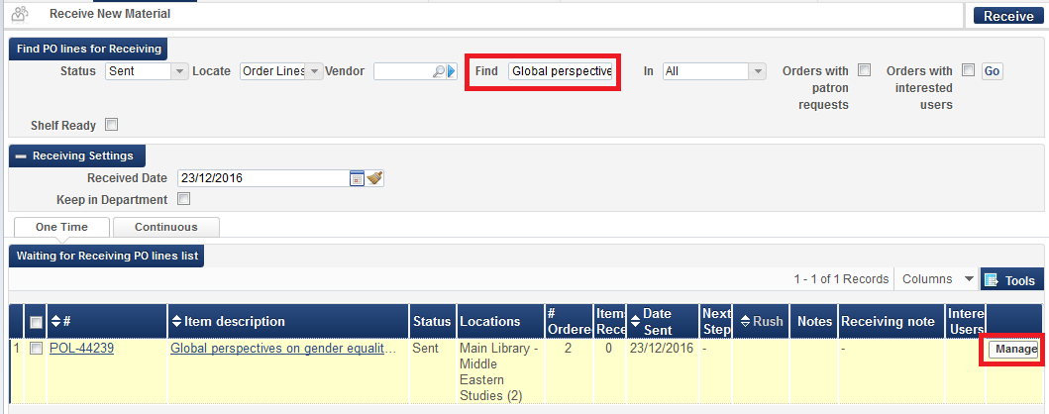

**THREE**

For the item which will move to a different location click “edit inventory”. Here we do it for barcode AU42394

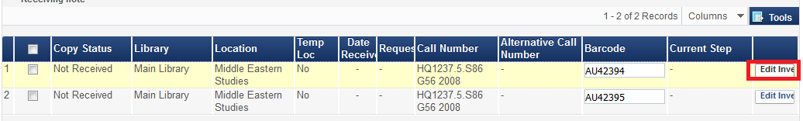

**FOUR**

In the “Permanent Location” section choose a desired new location, here we choose “General” even though the linked holding record still has “Middle Eastern Studies”. Moving the permanent location will automatically create a new holding record.

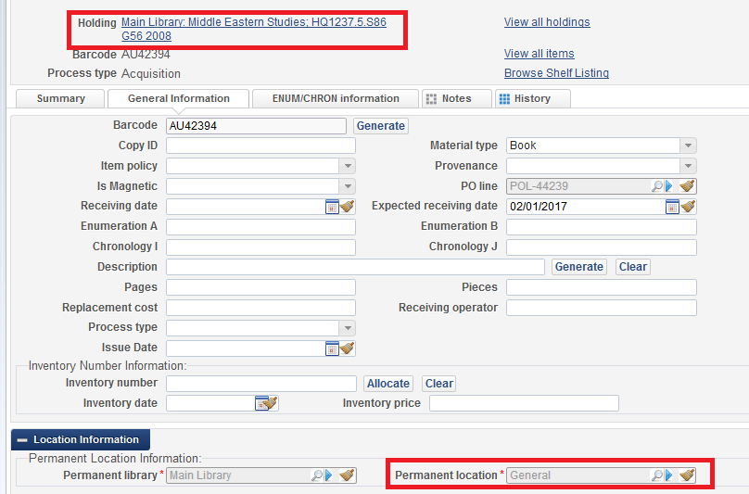

**FIVE**

Receive warning that this item will move to new location while there are still other items. Confirm the message.

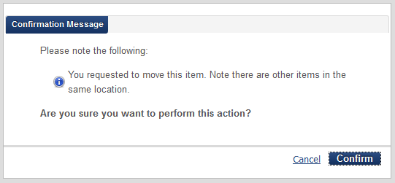

**SIX**

Now see that there are still two items connected to the order and they are in different locations

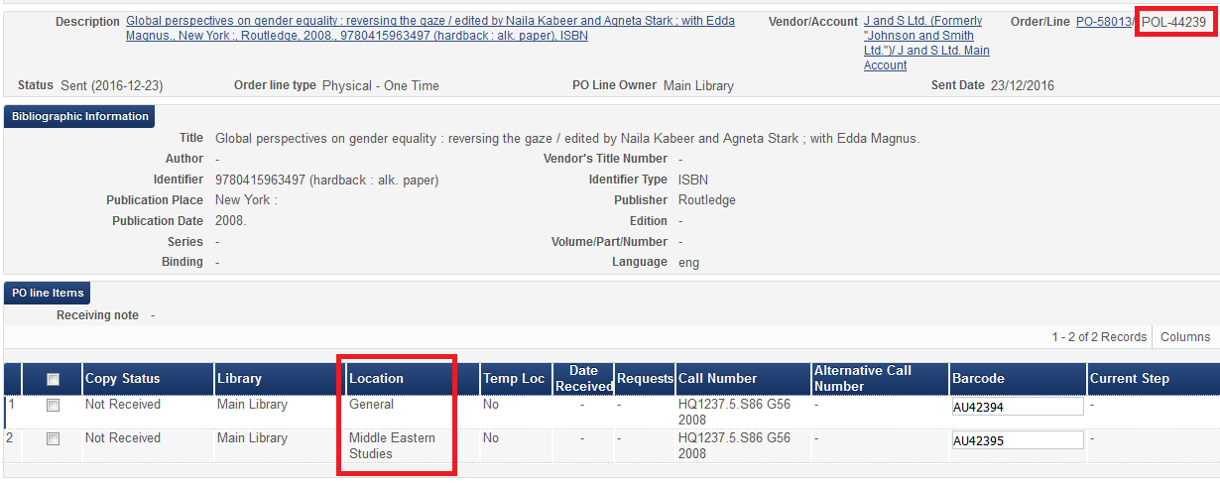

**SEVEN**

You can see that each item has its own holding record and both are still connected to the order.

