|  |  |
| --- | --- |
| **The ability to “un-receive” an item via the “un-receive” button** |  |
|  | |

The “un-receive” button appears in the receiving workbench list of items for both ‘One Time’ and ‘Continuous’ orders if

1. The item is still in the acquisitions department
2. There are no requests on the item
3. The staff user is at the receiving desk or acquisitions dept.
4. There is a work order on the item

First example (for “continuous” type order)

1. User is at the acquisitions desk  
   
2. User does “receive”  
     
   
3. User switches to tab “Continuous”  
     
   
4. User clicks “Manage Items” on the desired POL to arrive to the “Received Items List  
     
     
     
   
5. See for example that both barcode AU38056 and AU37990 have arrived  
     
   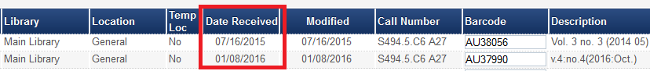
6. See that AU37990 **does** have option to un-receive from the actions button and AU38056 does not have an option to un-receive  
     
   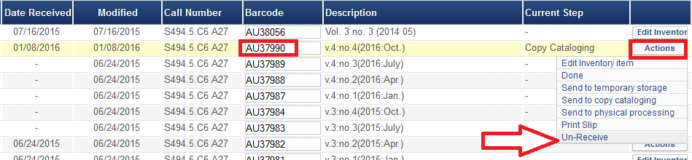
7. The reason AU37990 **does** have option to un-receive is because it has a work order. A work order was automatically created for the item because before it arrived the staff user did “actions > receive” from the “Received Items List”  
     
     
     
   while “Keep in department” and “Next step” copy cataloging was chosen in the “Receive new material” page  
     
      
     
   This causes a work order to be created for the item  
     
   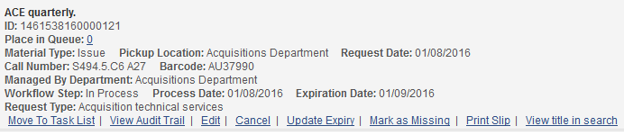
8. And if we choose “un-receive”  
     
     
     
   We are prompted for confirmation  
     
   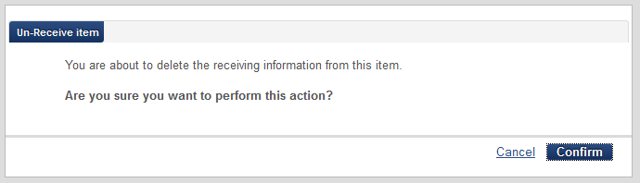  
     
   And the item is no longer arrived  
     
   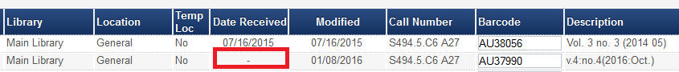

Second example (for “one time” type order)

1. User is at the acquisitions desk  
   
2. User does “receive”  
     
   
3. User switches to tab “One Time”
4. ‘Flame Thrower’ will be received. A work order will be created because we have “Keep in department” and “Next step” copy cataloging chosen in the “Receive new material” page  
     
     
   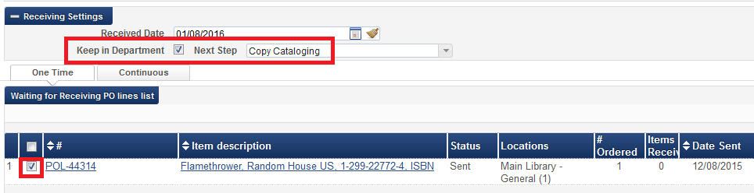
5. A work order was created  
     
   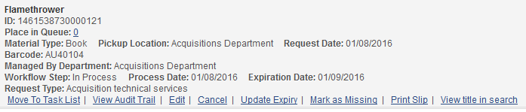
6. Now if staff user retrieves this POL in the receiving workbench and click “Manage Items” he will see an “Un-Receive” option  
     
   