|  |  |
| --- | --- |
| **How to change invoices to status “Sent to ERP” without using the “Export to ERP” job** |  |
|  | |



**How to change invoices to status “Sent to ERP” without using the “Export to ERP” job**

**Question:**

How can we pay our invoices (change them to status “Sent to ERP”) without actually sending them to the ERP?

We do not want to use a “dummy” (fictitious) ERP account just to get the workflow to get them to change to this status.

**Note:**

This does not relate to using the “Prepaid” checkbox which has always existed. The “prepaid” option will move POL to “Closed” after “save and continue”.

New March feature described below is about **all** (not “prepaid”) invoices. After “save and continue” is clicked the invoices will skip the “ready to be paid” status and change to “sent to ERP” status.

This will occur if the new “invoice_skip_erp” parameter will be “true”.

In other words:

1. In order for invoices to move to "closed" without exporting to ERP the user needs to click the “prepaid” checkbox in the invoice.
2. If “invoice_skip_erp” parameter  is set to true and "prepaid" is not checked in the invoice then the invoice will move straight to status "sent to ERP" without really exporting the invoice to ERP.   The job to export to ERP does not need to run and the resulting xml file of the job will not be created.

**Answer:**

As of the March 2014 release this can be done via a new parameter “invoice_skip_erp”.

This parameter may be found under the general configuration menu > general > other settings.

In order to move invoices to "closed" without exporting the invoice to ERP customize this parameter as "true":

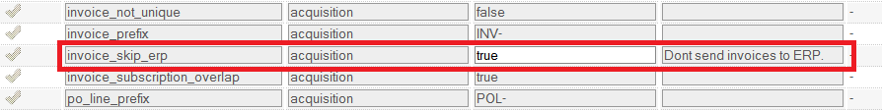

In the invoice “Payment” section we do not click the "Prepaid" checkbox.

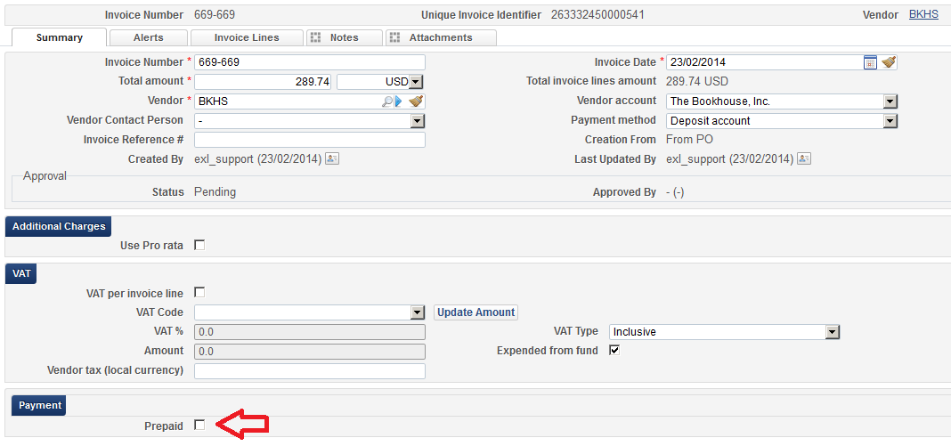

Add invoice line(s) and save

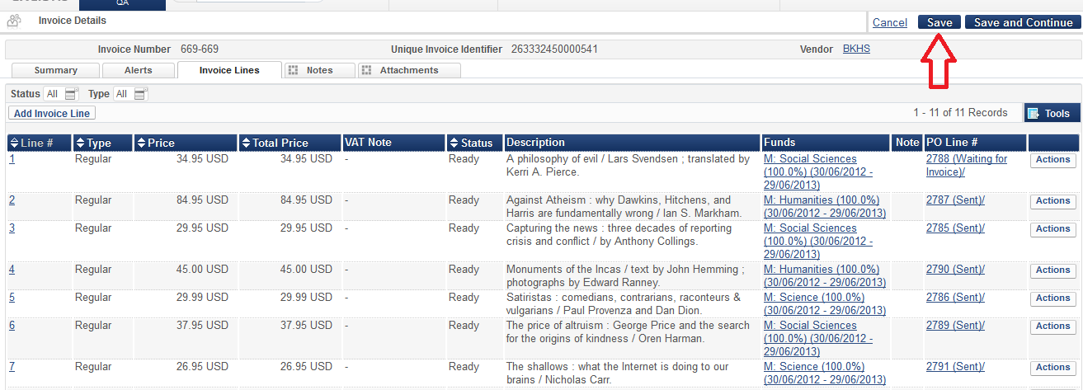

The invoice will change to status “Sent to ERP” instead f “Waiting to be paid” and there is no need to run the job “ERP export”

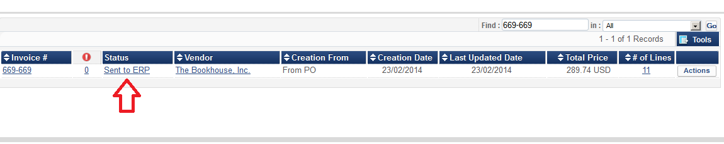

URM-23436