|  |  |
| --- | --- |
| **How to control if a sum is rounded up in an Analytics report** |  |
|  | |



**Question:**

We have made a report called  “Fines and Fees Report” in directory “Shared Folders > University of XXXXXX > Reports”

It works but the “original amount” is rounding off.  We do not want it to round off.

For example in the second case below it states “29” in Analytics but should state “28.50” which is the real total from Alma.

**How can we prevent Analytics from rounding to the nearest whole number?**

Here is the 29 in Analytics and other rounded numbers:

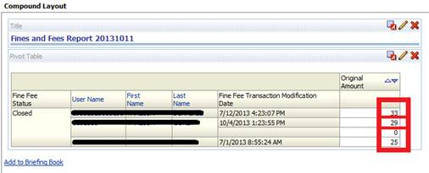

**Answer:**

**ONE**

In the criteria tab of the report edit the “original amount” column and then choose “column properties”

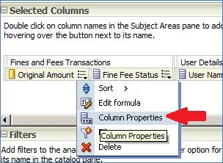

**TWO**

In the “Data format” column see that the “Decimal Places” is defined as “0”

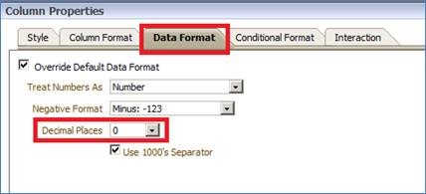

**THREE**

Change the “Decimal places” to “2”

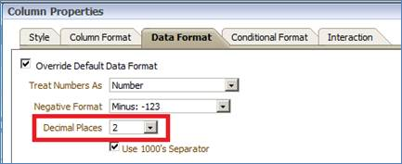

**FOUR**

Save the report and check results now, numbers are not rounded and it states 28.50 instead of 29:

