|  |  |
| --- | --- |
| **How to create an Alma Analytics report which identifies items returned 30 days or more after the due date** |  |
|  | |



**Yoel Kortick**

**Senior Librarian**

**Question**

We are trying to create a report that identifies items returned 30 days or more after the due date. How do we set up a query based on comparing data in two separate columns? e.g. return date >30 days than due date.

**Answer**

In order to make a report of this nature it is possible to use the measurement “Return Due Days” in the “Fulfillment” subject area under the Fact “Loan”.

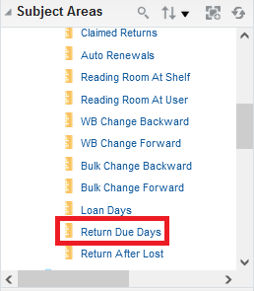

As described in the On Line Help under “Analytics > Fulfillment > Field Descriptions > Guidelines for Using Filters Based on Loan and Renewal Dates”, the “Return Due Days” “Stores the number of days between the return date and the due date”.

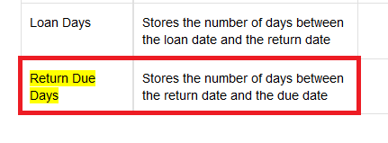

In other words, the “Return Due Days” is the difference between the “Return Date” and the “Due Date”. If the item was returned late it will be a positive number, and if the item was returned early it will be a negative number (because the “Return Date” would be less than the “Due Date”.

As a test to see and check what this field is, we can make a simple report in the “Fulfillment” subject area and include the following

* Loan . Return Due Days
* Loan Date . Loan Date
* Due Date . Due Date
* Return Date . Return Date

Filter by “Return Date Filter” equals the last 3 months

Filter by “Return Due Days” < 0 (this will give all items returned on time)

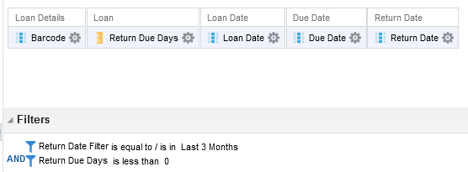

Check results and see that the “Return Due Days” really is the difference between the “Return Date” and the “Due Date”. See screenshot below of the results of this report. Here is an evaluation:

* In the first case below (barcode 1049307) the return date was May 14. The Due Date was May 19. It was return 5 days before the due date. The “Return Dues Days” is therefore “-5”

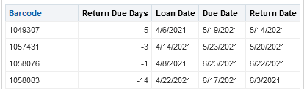

Now if we want to get only items which were returned 30 or more days late then we can change the filter to state “‘Loan . Return Due Days’ >= 30”

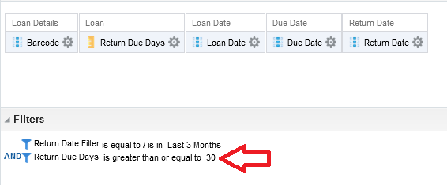

Now all items in the report were returned 30 or more days after the due date.

In the first case, barcode 390300033692890, the item was due May 28, 202301 and returned August 9, 2021. August 9, 2021 is 73 days later than May 28, 2021 and therefore the “Return Due Days” is 73.

