|  |  |
| --- | --- |
| **How to conditionally change the text format in an Alma Analytics report** |  |
|  | |

**Question**

Hi;

I have a report which includes the PO Line invoice status. Most are “Fully invoiced” but there are some that are “Partially invoiced”. How can I make the text “Partially Invoiced” be red bold so that I can more quickly identify them.

Here it is now:

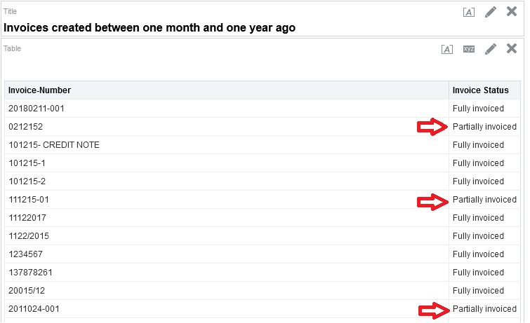

**Answer**

From the Criteria tab chose “Column Properties” on the field you want to change

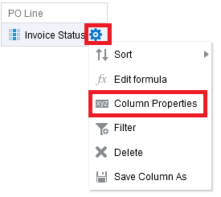

In the “Conditional Format” tab add a condition on the Invoice Status

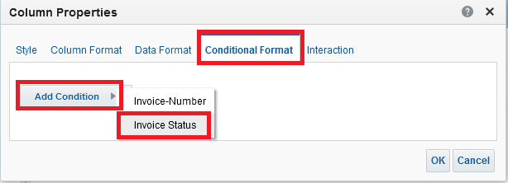

Choose what to do when the Invoice Payment Status is equal to “Partially invoiced”.

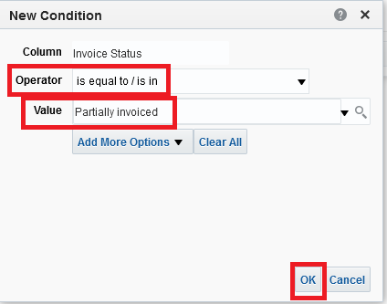

Make the font be red and the style be bold

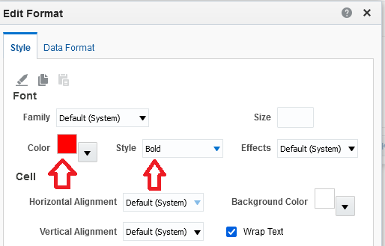

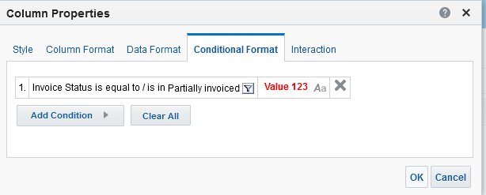

See results:

