|  |  |
| --- | --- |
| **How to filter by a string for both uppercase and lowercase with one filter** |  |



**Question:**

I am making a report and filtering by all titles with the word ‘Feminism’ or ‘feminism’ (capital F and lowercase f at beginning of word). I must do the filter twice with an OR in the middle, because ‘Feminism’ will not find ‘feminism’ and ‘feminism’ will not find ‘Feminism’. Is there an easier way to do it than this?

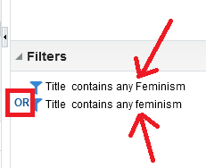

**Answer:**

The easier way to do this would be to first convert the string to all uppercase or all lowercase and then search for it in whatever case you convert it to.

**ONE**

On the field which you are filtering do “edit formula” and then change it to lower case.

This can be done on any text field. For example here in this example we will do it on the title from bibliographic details dimension.

"Bibliographic Details"."Title"

To

LOWER("Bibliographic Details"."Title")

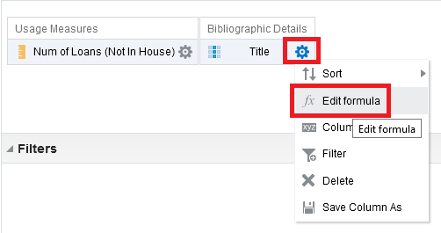

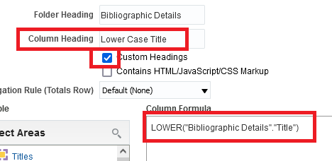

**TWO**

Now in this field the entire title is lowercase. So now if you filter by ‘feminism’ with lowercase on this lowercase title you will find records for which the actual title may have Feminism or feminism.

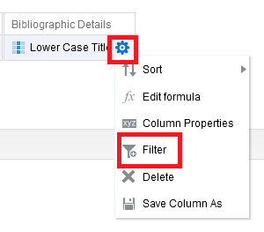

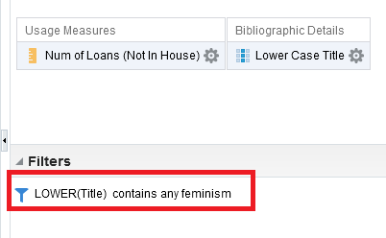

**THREE**

Now take note that if you look at the results everything is lowercase

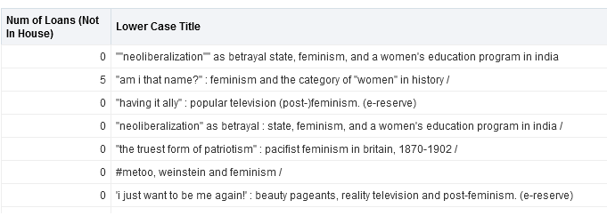

**FOUR**

So what we really want to do is display the real title and filter by the lowercase title.

So … add now the real title to the report, and delete the lowercase title from the display but leave it in the filter

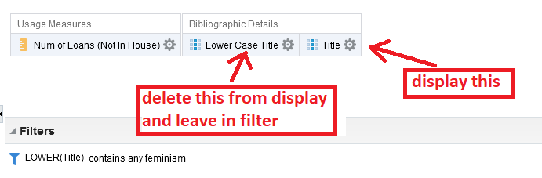

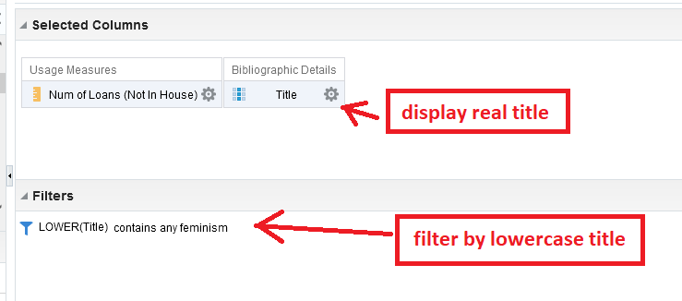

**FIVE**

Results are as desired. The filter finds “Feminism” and “feminism”.

