|  |  |
| --- | --- |
| **How to separate the date time field to date, time and hour** |  |
|  | |

**Question:**

Sometimes the date in analytics has the full calendar date plus the time. For example the ‘Last Loan Date’ in the ‘Physical Item Details’ dimension of the ‘Physical Items’ subject area. How can we get just the date (without the time) to filter or display? Sometimes we also need just the time, or hour.

Here is how it appears now:

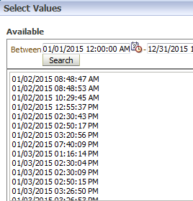

**Short answer:**

In ‘edit formula’:

The date: CAST("Physical Item Details"."Last Loan Date" AS DATE)

The time: CAST("Physical Item Details"."Last Loan Date" AS TIME)

The hour: HOUR(CAST("Physical Item Details"."Last Loan Date" AS TIME))

**Full answer:**

**ONE**

The CAST function (among other methods) can be used for this.

First choose ‘edit formula’ on the desired field from the criteria tab

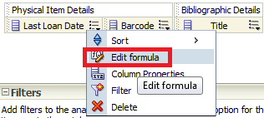

**TWO**

Click ‘Insert Function’

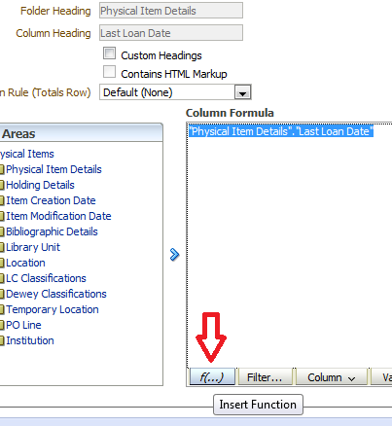

**THREE**

Choose “Conversion > Cast’

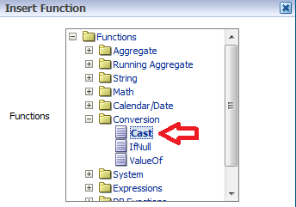

**FOUR**

Get this:

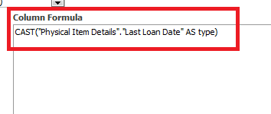

**FIVE**

To get the time change

CAST("Physical Item Details"."Last Loan Date" AS type)

To

CAST("Physical Item Details"."Last Loan Date" AS TIME)



And if desired change header

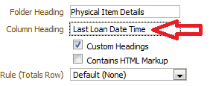

**SIX**

Now it appears as follows:

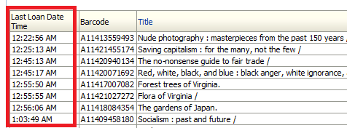

**SEVEN**

To get just the date do

CAST("Physical Item Details"."Last Loan Date" AS DATE)

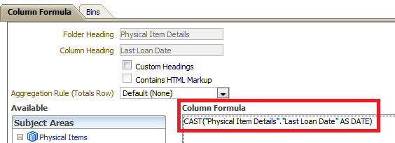

**EIGHT**

It now appears like this:

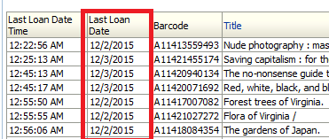

**NINE**

To get just the hour do

HOUR(CAST("Physical Item Details"."Last Loan Date" AS TIME))

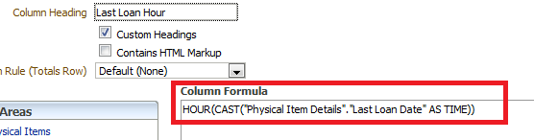

**TEN**

It now appears as follows:

