|  |  |
| --- | --- |
| **How to concatenate two or more fields in an Alma Analytics report** |  |
|  | |

**Question:**

I want to make a report which will put two fields together and have a text between them. Now I have library code and item ID in two separate columns. I want it to be library code, space, dash, space, and then item ID. All of this should be in one column. How can I do this?

**Answer:**

There are multiple ways to do this. Here is a recommended way:

**ONE**

First create the table with the columns which you will eventually want to combine:

Here is a report of items created within the last month displaying Item ID, Barcode, Creation Date, and Library Code.

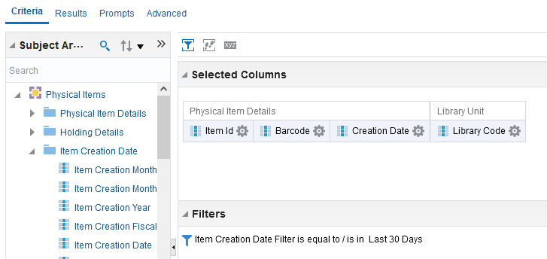

**TWO**

Go to results tab and see that results have the columns you want to concatenate

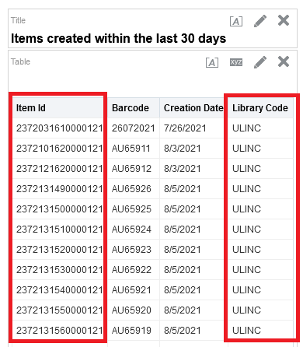

**THREE**

In criteria tab for each column you want to concatenate do “edit formula” to see the actual formula of the column

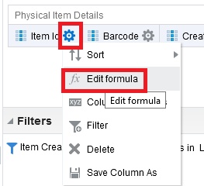

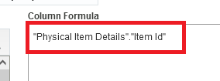

**FOUR**

See that:

The Item ID is "Physical Item Details"."Item Id"

The Library Code is "Location"."Library Code"

**FIVE**

Do “Edit formula” on one of the fields which you will concatenate. Here we do it on “Library Code”

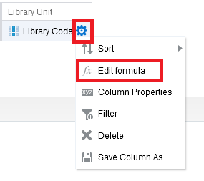

**SIX**

Leave the field you want, and add another field (or fields) which you want to appear. Divide the fields with the double pipe button:

"Location"."Library Code"||"Physical Item Details"."Item Id"

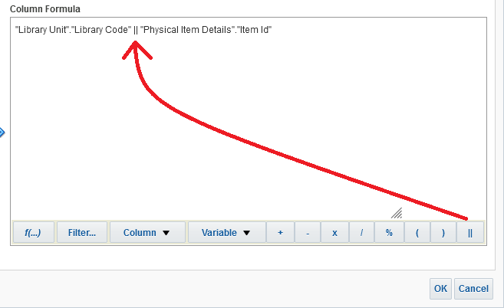

**Note:**

We left "Library Unit"."Library Code" as it was

We added the double pipe with the button on the bottom right. It could have been typed in manually

We added the "Physical Item Details"."Item Id" by pasting it, after copying it by doing “edit formula” on the field. It could have been added from the “Column” button on the bottom (third from left). It also could have been added by choosing the field from the left pane as follows:

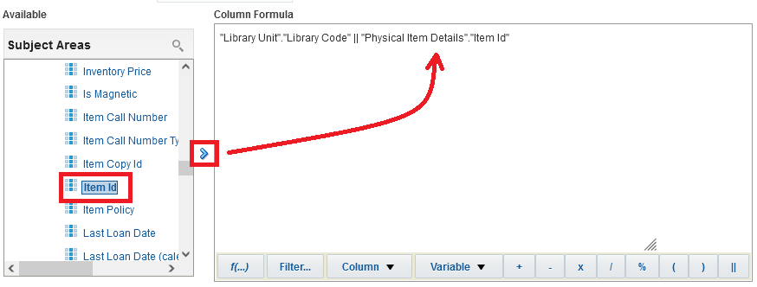

**SEVEN**

See now in results tab that the column contains both the library code and the item ID

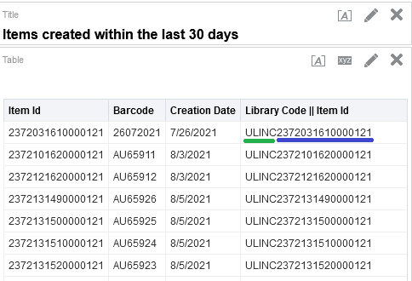

**EIGHT**

Now add the “space dash space” between the library code and Item ID.

Text can be added by putting it in single quotes, and again use the double pipe between the parts of the column.

So again do “edit formula” and have this as the formula:

Instead of this

"Location"."Library Code"||"Physical Item Details"."Item Id"

Have this

"Location"."Library Code"|| ' - ' ||"Physical Item Details"."Item Id"

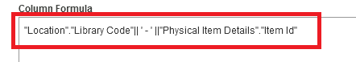

**NINE**

Now in results tab see that the field is concatenated with a space dash space between each part

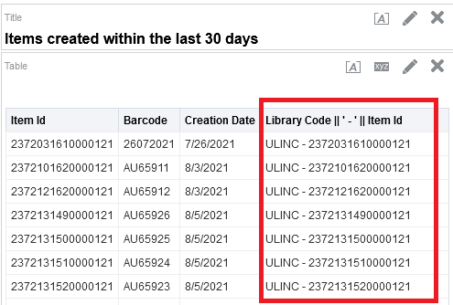

**TEN**

You will probably want now to delete the non-desired field and rename the concatenated field

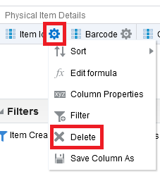

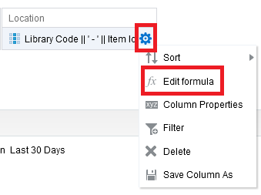

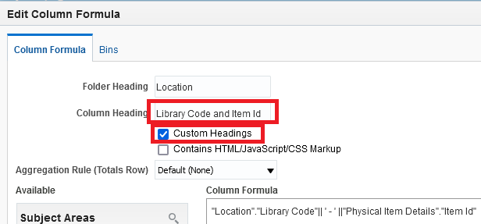

**ELEVEN**

See final results

