|  |  |
| --- | --- |
| **How to use multiple filters per column in an Alma analytics report** |  |
|  | |



**Question**

I am trying to make a report comparing the amount of fines and fees we took from patrons in 2020 as compared to 2019. I want 4 different columns:

1. Year 2019 fines for overdue fine
2. Year 2019 fines for lost item replacement fee
3. Year 2020 fines for overdue fine
4. Year 2020 fines for lost item replacement fee

I want them in four different columns so it will be easy to compare (and not four different reports).

The problem I am having now is that when I choose a filter for “transaction” year is equal to 2019 and 2020 (and it appears on the bottom of the criteria tab) then I get one column for both years. The same happens when I filter for “Fine Fee Type” is equal to Overdue fine and lost item replacement fee. They both appear in the same column

**High level answer (followed by detailed answer)**

Note that there are multiple methods to do this. The method described here is the easiest to explain to a wide variety of analytics user levels. Further, it is possible to do this only on a field which is a measure.

In order to do this the filter cannot be made on the level of the report, but rather on the level of the columns. Thus instead of making the filter from the column in the criteria tab, it should be made from the window which appears after doing “edit formula”.

Do not filter like this:

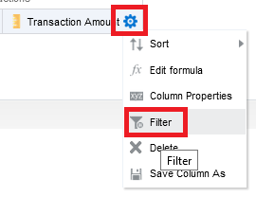

Filter like this:

First click ‘Edit formula’, then in the “Edit Column Formula window click “Filter” on the bottom

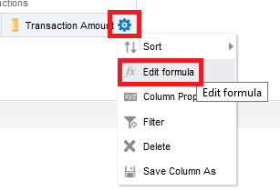

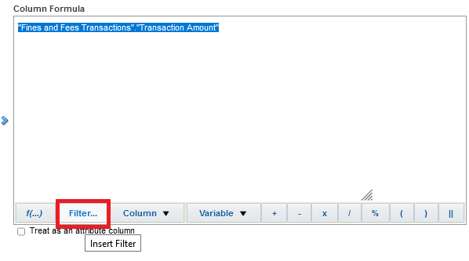

It is easiest to make two separate columns and then combine them using the clear instructions for combining the syntax in step 12 below

**Detailed answer**

Based on what is written above we will do as follows

**ONE**

In a new Alma Analytics report add the column “Fines and Fees Transactions > Transaction Amount” twice.

The reason we will add it twice is because on the first one we will filter by “Transaction Year” and on the second one we will filter by “Fine Fee Type”. Then we will clearly see the syntax of each and then combine them into the first column and rename it accordingly

We are starting like this:

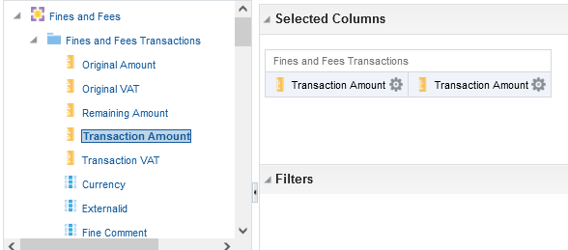

**TWO**

Now we will make the first column be “Transaction Year = 2019”

On the first column do “edit formula” then with the text selected click the “filter” button on the bottom:

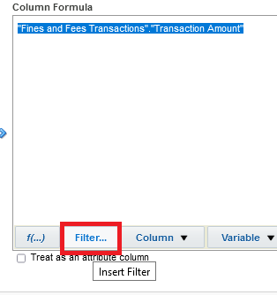

**THREE**

In the left column choose “Transaction Date > Year” and double click it.

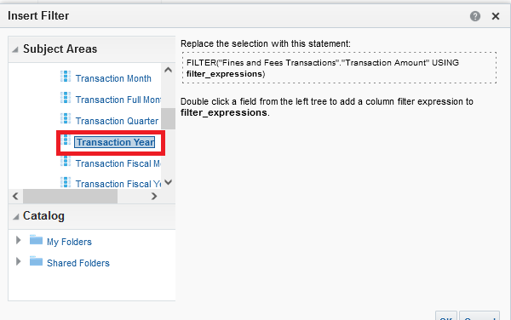

**FOUR**

A new window opens, filter by year 2019 then click ‘OK” in the two windows which appear

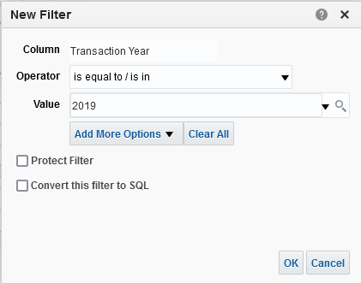

**FIVE**

You now have this syntax:

FILTER("Fines and Fees Transactions"."Transaction Amount" USING ("Transaction Date"."Transaction Year" = 2019))

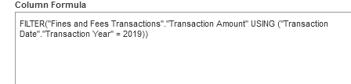

**SIX**

In the results tab this column shows only 2019, while the other column shows all years

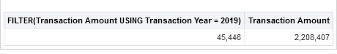

**SEVEN**

Now on the second “untouched” “Transaction Amount” column filter it by “Fine Fee Type”

Again, like on the previous column, choose “edit formula” and “filter”

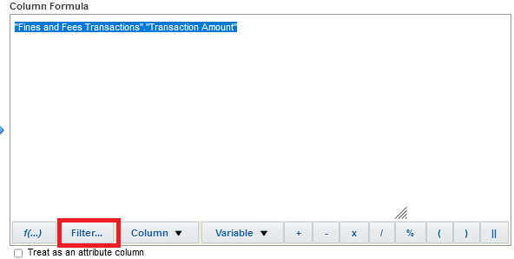

**EIGHT**

Choose “Fine Fee Type” in left column and double click

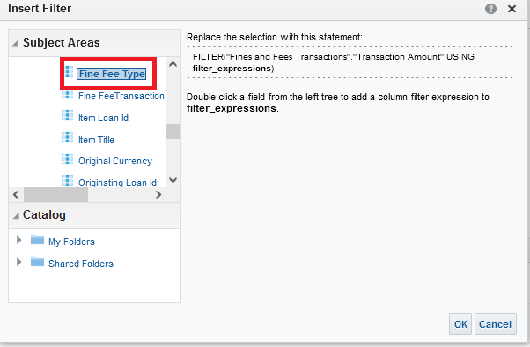

**NINE**

Filter by “Overdue fine”

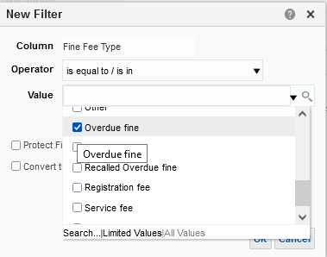

**TEN**

Get this formula

FILTER("Fines and Fees Transactions"."Transaction Amount" USING ("Fines and Fees Transactions"."Fine Fee Type" = 'Overdue fine'))

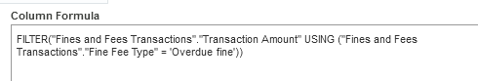

**ELEVEN**

Now in the results tab we have a column filtered by transaction year = 2019 and another column filtered by fine fee type = Overdue fine

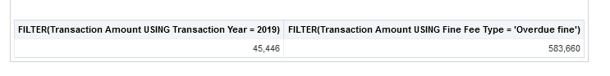

**TWELVE**

Now we will combine them. These are the two existing filters

**FILTER("Fines and Fees Transactions"."Transaction Amount" USING ("Transaction Date"."Transaction Year" = 2019))**

**FILTER("Fines and Fees Transactions"."Transaction Amount" USING ("Fines and Fees Transactions"."Fine Fee Type" = 'Overdue fine'))**

To combine them:

Before the closure of the last parentheses in the first filter

1. Type a Boolean operator. In this case we want AND
2. Add everything which is in the second filter between the word USING and the last parentheses. Combined, we will have this:

**FILTER("Fines and Fees Transactions"."Transaction Amount" USING ("Transaction Date"."Transaction Year" = 2019) AND ("Fines and Fees Transactions"."Fine Fee Type" = 'Overdue fine'))**

On the first column (or whatever column you want) do “edit formula” and use this new text and change the header accordingly

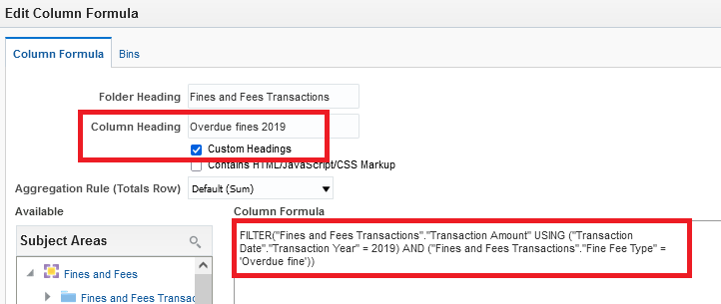

Delete the extra column.

We now have this:

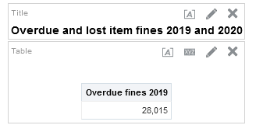

**THIRTEEN**

At this stage either:

1. Do the same steps as above for the additional columns with different year and different fine fee type.
2. Take the existing text and just change it accordingly by column name and values.

Option 2 is much easier and faster

If using option 2 the four column formulas will be:

For 2019

**FILTER("Fines and Fees Transactions"."Transaction Amount" USING ("Transaction Date"."Transaction Year" = 2019) AND ("Fines and Fees Transactions"."Fine Fee Type" = 'Overdue fine'))**

**FILTER("Fines and Fees Transactions"."Transaction Amount" USING ("Transaction Date"."Transaction Year" = 2019) AND ("Fines and Fees Transactions"."Fine Fee Type" = 'Lost item replacement fee'))**

For 2020

**FILTER("Fines and Fees Transactions"."Transaction Amount" USING ("Transaction Date"."Transaction Year" = 2020) AND ("Fines and Fees Transactions"."Fine Fee Type" = 'Overdue fine'))**

**FILTER("Fines and Fees Transactions"."Transaction Amount" USING ("Transaction Date"."Transaction Year" = 2020) AND ("Fines and Fees Transactions"."Fine Fee Type" = 'Lost item replacement fee'))**

**FOURTEEN**

Add the measure “Transaction Amount” three more times and on each one do “edit formula” and replace the existing text with the text above, and change the column header accordingly.

For example here is the edit formula and column heading for transaction amounts for 2020 Lost item replacement fee:

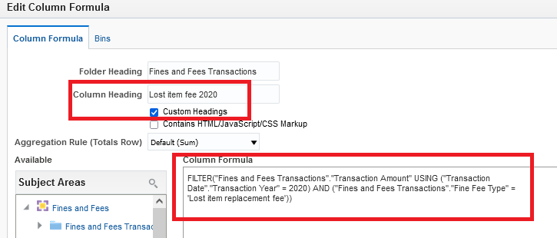

**FIFTEEN**

Here are results in table format

