|  |  |
| --- | --- |
| **Defining the ‘Validation of Order Information’ in the Integration Profile for ‘New Order API’** |  |



The “New Order API” integration profile contains a section “Validation of Order Information”. It defines the conditions by which an order should not be created via the API, and includes the following options:

1. Do not create order in case of:
   1. Order is not fully funded
   2. Invalid fund code
   3. Fund balance insufficient to cover encumbrance

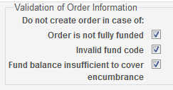

1. When “Order is not fully funded” is checked the order will not be created if:  
    The sum of the <fund_distributions> section of the xml is   
    less than the sum of the <price> section of the xml.  
   The error message which will be returned in the xml is:   
   **The PO line is not fully funded.**
2. When “Invalid fund code” is checked the order will not be created if:  
    The fund code used in the xml does not exist in the institution.  
   The error message which will be returned in the xml is:  
   **Fund code {fund code} is invalid.**
3. When “Fund balance insufficient to cover encumbrance” is checked the order will not be created if:  
    One of the funds used in the <fund_distributions> section of the xml   
    has less available balance than the corresponding “sum” in the “amount” section of xml.   
   The error message which will be returned in the xml is:   
   **Fund {fund code} does not have enough money for executing the desired transaction.**

**Case One**

In this case we check the first box “Order is not fully funded”

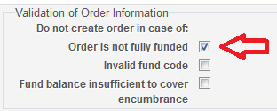

The fund code YLK has 100 Euro and according to the rules of the fund it cannot over-encumber or over-expend.

Note that the price of 26.00 and the fund distribution totals 25.00.

So the price does not exceed what we have in the fund, but the total fund distributions are less than the price.

I have this in my xml payload for the API

<price>

**<sum>26.00</sum>**

<currency>EUR</currency>

</price>

…

<fund_distributions>

<fund_distribution>

<fund_code>YLK</fund_code>

<amount>

**<sum>25.00</sum>**

<currency>EUR</currency>

</amount>

</fund_distribution>

</fund_distributions>

We get this error

<errorsExist>true</errorsExist>

<errorList>

<error>

<errorCode>300012</errorCode>

<errorMessage>The PO line is not fully funded.</errorMessage>

<trackingId>E01-3101132648-GKFRP-AWAE1254065358</trackingId>

</error>

</errorList>

And the order is not created.

**Case Two**

We check that we have a valid fund code

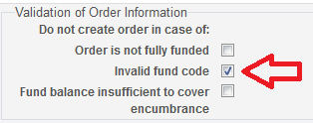

In the xml we use an invalid fund code.

<fund_distributions>

<fund_distribution>

<fund_code>OZ</fund_code>

<amount>

<sum>25.00</sum>

<currency>EUR</currency>

</amount>

</fund_distribution>

</fund_distributions>

We get this message

<errorsExist>true</errorsExist>

<errorList>

<error>

<errorCode>40188612</errorCode>

<errorMessage>Fund code OZ is invalid.</errorMessage>

<trackingId>E01-3101134025-9E4TI-AWAE1959145621</trackingId>

</error>

</errorList>

And the order is not created.

**Case Three A**

In this case we will check “Fund balance insufficient to cover encumbrance”

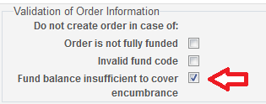

The fund code YLK has 100 Euro and according to the rules of the fund it cannot over-encumber or over-expend.

We have this in the xml payload for the API

<price>

**<sum>26.00</sum>**

<currency>EUR</currency>

</price>

…

<fund_distributions>

<fund_distribution>

<fund_code>YLK</fund_code>

<amount>

**<sum>25.00</sum>**

<currency>EUR</currency>

</amount>

</fund_distribution>

</fund_distributions>

The order is created. This is because we have enough money in the funds and we did not check to make sure that the order is fully funded. We only checked if the fund balance is insufficient.

**Case Three B**

Again we will check “Fund balance insufficient to cover encumbrance”



The fund code YLK has 100 Euro and according to the rules of the fund it cannot over-encumber or over-expend.

We make an order for 101 Euro (which is more than I have in the fund).

We have this in the xml payload for the API

<price>

**<sum>101.00</sum>**

<currency>EUR</currency>

</price>

…

<fund_distributions>

<fund_distribution>

<fund_code>YLK</fund_code>

<amount>

**<sum>101.00</sum>**

<currency>EUR</currency>

</amount>

</fund_distribution>

</fund_distributions>

In the API response we receive this message

<errorsExist>true</errorsExist>

<errorList>

<error>

<errorCode>301014</errorCode>

<errorMessage>Fund YLK does not have enough money for executing the desired transaction</errorMessage>

<trackingId>E01-3101131737-NCN3E-AWAE1611800384</trackingId>

</error>

</errorList>

And the order is not created.