|  |  |
| --- | --- |
| **How to define and add a local authority file for JULAC** |  |



**ONE**

In order to add a new local authority vocabulary do as follows:

“Resource management configuration menu > cataloging > metadata configuration > manage local vocabularies > Add vocabulary”

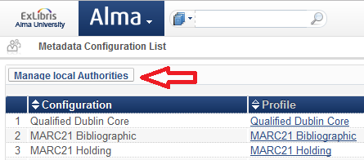

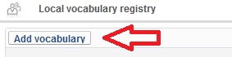

**TWO**

For each desired vocabulary fill in the form.

For example here is local vocabulary JULAC Names:

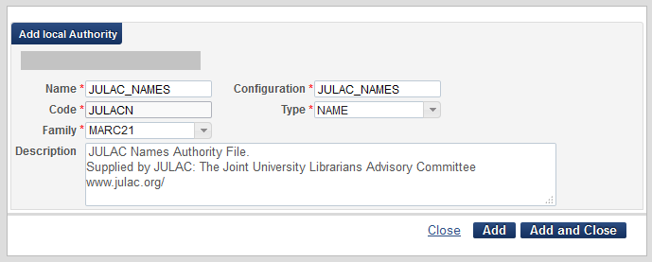

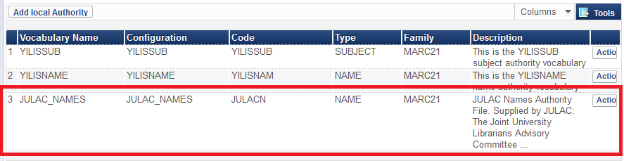

**THREE**

Take note that now you can add authority records manually for these files in the metadata editor

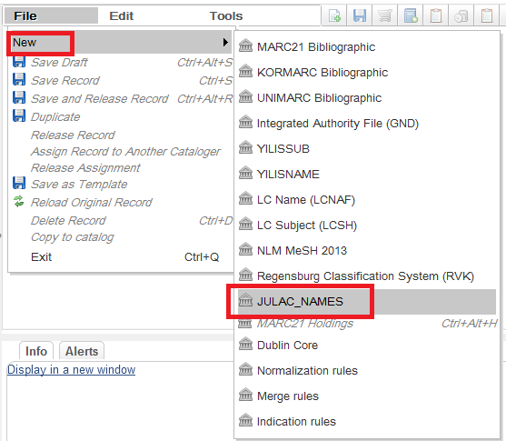

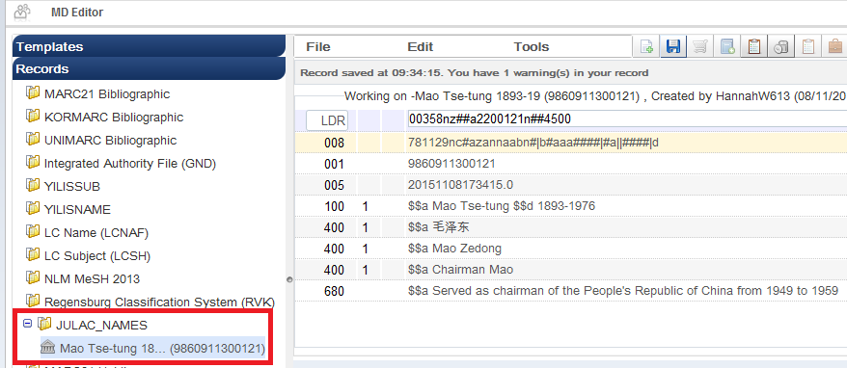

**FOUR**

The record exists in the repository

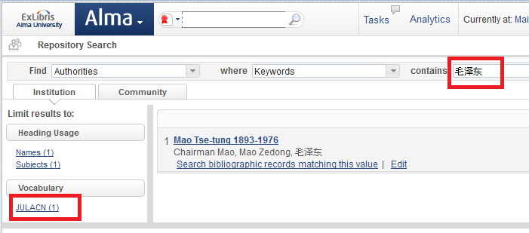

**FIVE**

Take note that now you can add authority records via an import profile for these records. We choose code “JULACN” which is the code we gave for this type of authority record above.

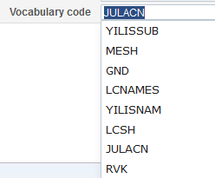

**SIX**

Here we have created an import profile for type “Authority” for JULAC Names

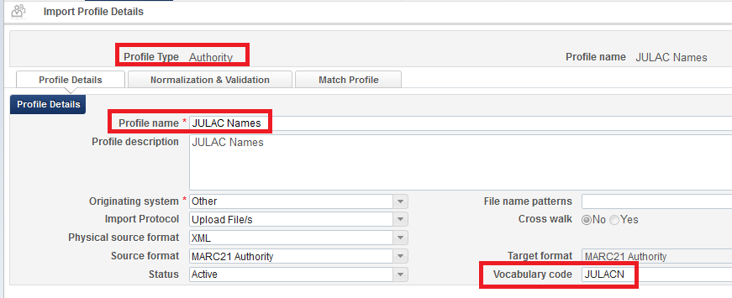

**SEVEN**

Now we import the file

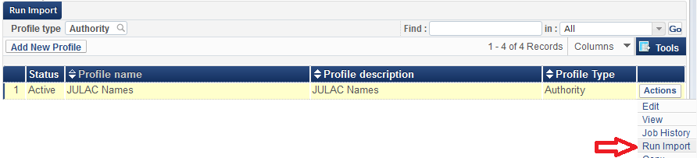

**EIGHT**

The job completed successfully

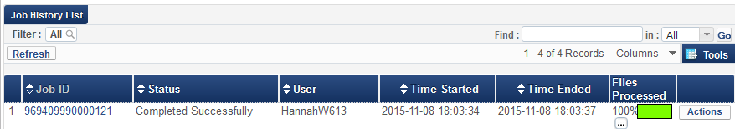

NINE

Three records were imported and we will preview them

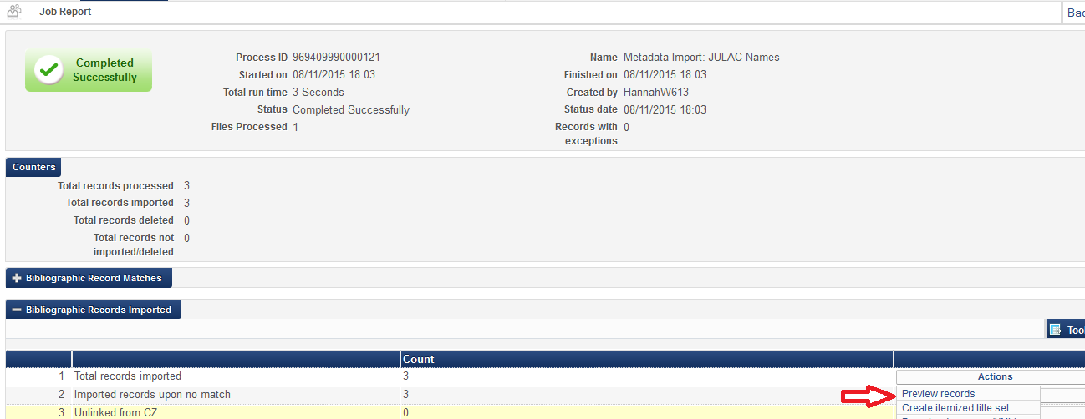

TEN

Here are the imported records:

