|  |  |
| --- | --- |
| **How to remove a portfolio from a local electronic collection** |  |
|  | |

**ONE**

Local Collection ‘Project Gutenberg Free E Books’ has 16 portfolios.

We want to remove title “Why Worry” from the collection.

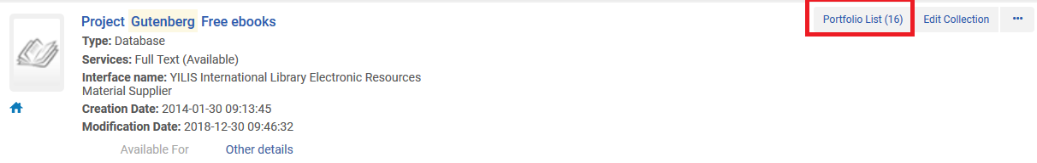

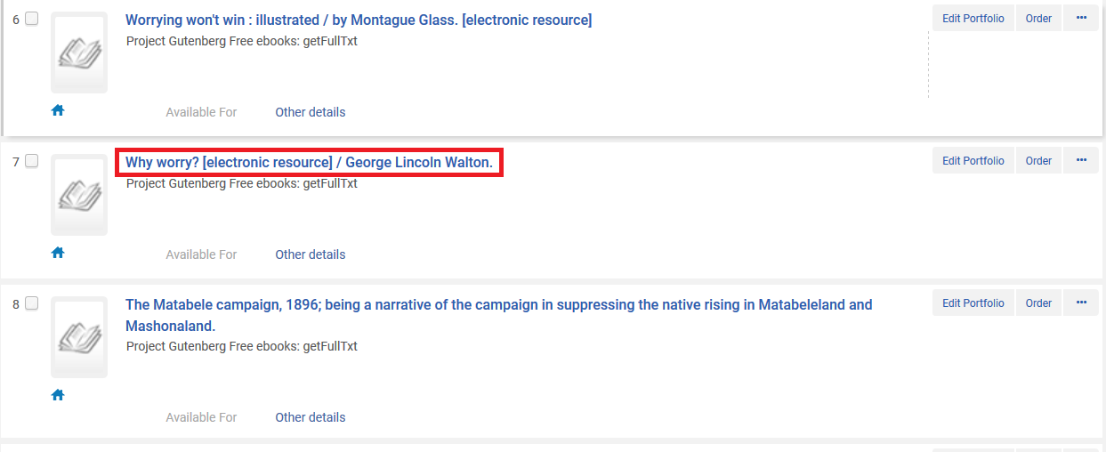

**TWO**

From the electronic collection repository search results click “edit service” and then switch to the “portfolios” tab.

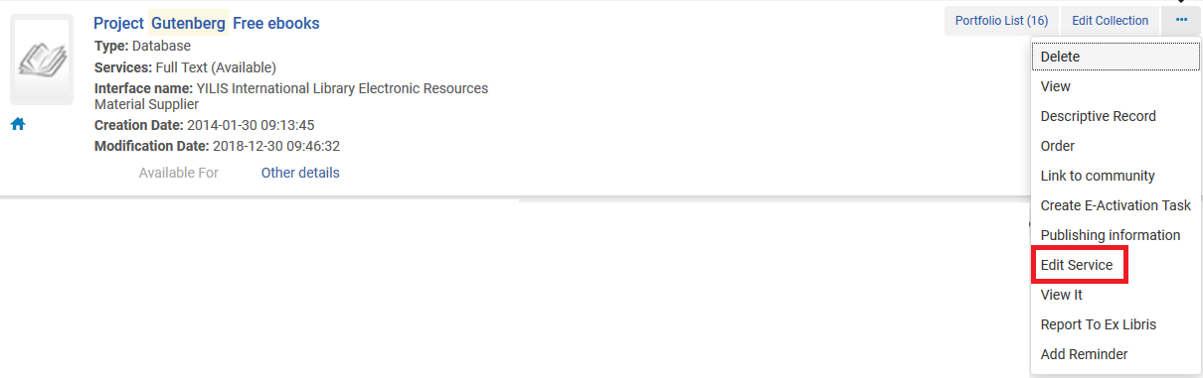

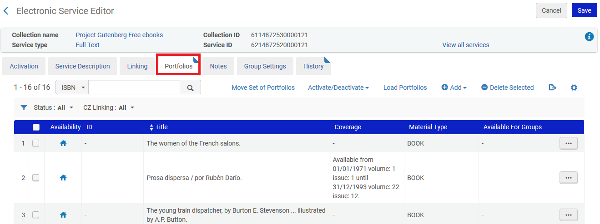

**THREE**

Find the title you want to remove and then click “actions > remove”. You will receive confirmation that the portfolio has been removed.

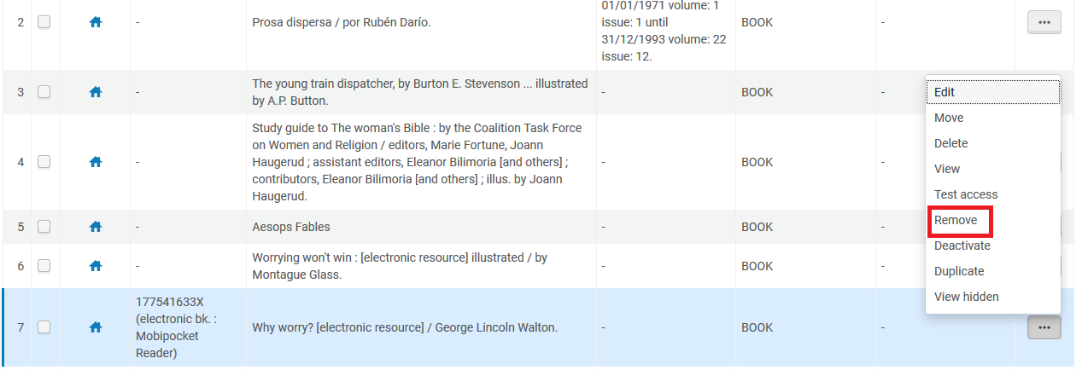



**FOUR**

Now you will see that the electronic collection has one less portfolio.

Previously there were 16 portfolios, now there are 15.

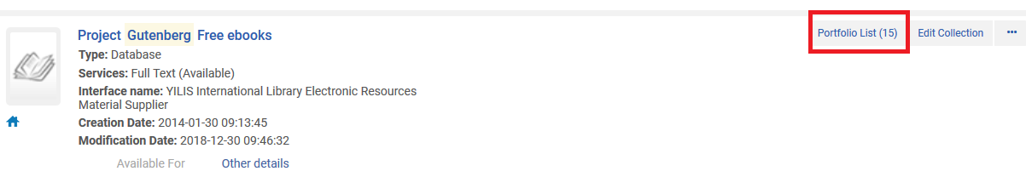

You will also see that the bibliographic record and portfolio still exist for the title which was removed from the collection. It is now a standalone portfolio.

