|  |  |
| --- | --- |
| **How to print a barcode to be a scannable barcode instead of numbers** |  |
|  | |

**Yoel Kortick**

**Senior Librarian**

**Question:**

I have defined in FulUserBorrowingActivityLetter to have the barcode print. But it prints as numbers and I need to be able to scan it.

I added it as follows:

<td>Barcode:&#160;</td>

<td>

<xsl:value-of select="notification_data/user_for_printing/identifiers/code_value[2]/value"/></td>

</td>

But it prints as a number, like this:

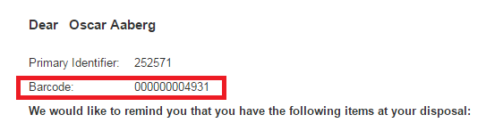

**Preliminary comment to answer below:** One of the examples below uses font 'CarolinaBar-B39-2.5-22x158x720'.

This is just an example and other fonts can be used. For example, at the time of the creation of this document there is an example a free barcode font provided by Google: <https://fonts.google.com/specimen/Libre+Barcode+39+Extended+Text>

**Answer:**

When you print the barcode you can define that you want it to print in barcode fonts, for example Code39 or Carolina Bar.

Note that different browsers may behave differently for various font definitions in the xsl, and may also depend on the presence of the font on the PC.

To define the font to be Code39 change

<td>Barcode:&#160;</td>

<td>

<xsl:value-of select="notification_data/user_for_printing/identifiers/code_value[2]/value"/></td>

</td>

To

<td>Barcode:&#160;</td>

<td> **<span style="font-family:'Code39'">**

<xsl:value-of select="notification_data/user_for_printing/identifiers/code_value[2]/value"/>

**</span>** </td>

That will print like this, which can be scanned by a barcode scanner:

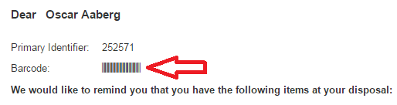

And it will use this font:

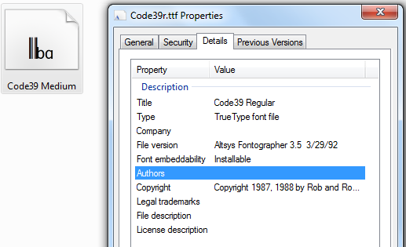

Note that in other cases the following may also be preferred which uses Carolina Bar font:

<td>Barcode:&#160;</td>

<td> **<span style="font-family:'CarolinaBar-B39-2.5-22x158x720'">**

<xsl:value-of select="notification_data/user_for_printing/identifiers/code_value[2]/value"/>

**</span>** </td>