|  |  |
| --- | --- |
| **How to print the second of two repeating identical field codes in a letter** |  |
|  | |

**Question:**

I am trying to print the patron barcode in the Borrowing Activity Letter (Patron Circulation Summary). I have defined in “XML Letter to Admin” that FulUserBorrowingActivityLetter will be sent to me, and I see in the raw xml that the patron primary identifier **and** the barcode **both** appear as

/notification_data/user_for_printing/identifiers/code_value/value

When I put it in the xsl the first one prints. How can I get the second one to print?

The first one is the primary identifier and the second one is the Barcode. I want the barcode.

Here they are in the raw xml

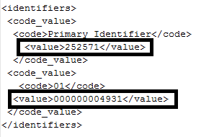

**Short Answer:**

Add the occurrence of the field you want to print in square brackets after the field, for example:

"notification_data/user_for_printing/identifiers/code_value**[2]**/value"/

**Full Answer:**

As you state, if the identifier is added “as normal” as follows:

<table cellspacing="0" cellpadding="5" border="0">

<tr>

<td>Primary Identifier:&#160;</td>

<td><xsl:value-of select="notification_data/user_for_printing/identifiers/code_value/value"/></td>

</tr>

</table>

Then by default the first one will print:

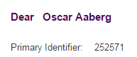

If you want the second one to print then add a 2 in square brackets after the field.

This is the case for all fields which will occur multiple times.

For example this:

<table cellspacing="0" cellpadding="5" border="0">

<tr>

<td>Barcode:&#160;</td>

<td><xsl:value-of select="notification_data/user_for_printing/identifiers/code_value[2]/value"/></td>

</tr>

</table>

Will print:

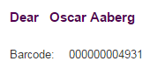

If you want them both to print then you could do this:

<table cellspacing="0" cellpadding="5" border="0">

<tr>

<td>Primary Identifier:&#160;</td>

<td><xsl:value-of select="notification_data/user_for_printing/identifiers/code_value/value"/></td>

</tr>

<tr>

<td>Barcode:&#160;</td>

<td><xsl:value-of select="notification_data/user_for_printing/identifiers/code_value[2]/value"/></td>

</tr>

</table>

OR

<table cellspacing="0" cellpadding="5" border="0">

<tr>

<td>Primary Identifier:&#160;</td>

<td><xsl:value-of select="notification_data/user_for_printing/identifiers/code_value[1]/value"/></td>

</tr>

<tr>

<td>Barcode:&#160;</td>

<td><xsl:value-of select="notification_data/user_for_printing/identifiers/code_value[2]/value"/></td>

</tr>

</table>

Now this will print:

