|  |  |
| --- | --- |
| **How to fix the strange appearance of numeric fields in a csv file which is opened in Excel** |  |
|  | |



There may be cases where an analytics report is exported to a csv format and then when opening the report certain numeric fields such as MMSID appear strangely.

For example we will export the report ‘Bibliographic records and physical items with subject feminism or feminist’ to csv format:

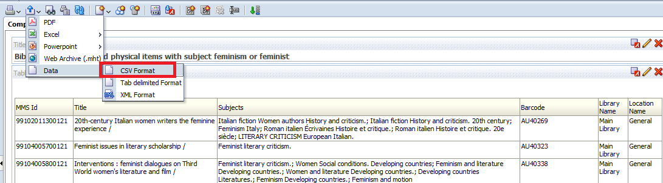

We open the csv report in Excel

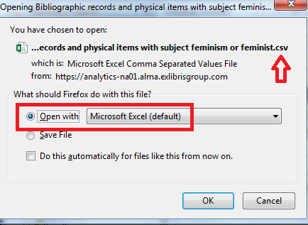

And the MMSID appears strangely. It begins with 9.9 and includes an E+

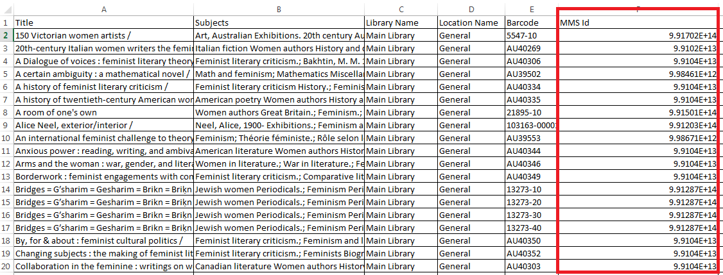

To fix the appearance of the column select the column, right click it and choose ‘Format Cells’

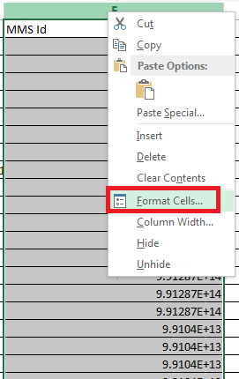

In the ‘Number’ tab choose category ‘Number’

In the Decimal places choose 0

In the ‘Use 1000s separator’ do not check it

Click OK

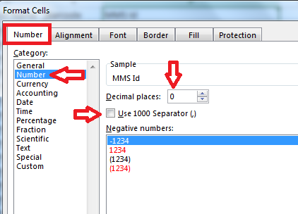

See that now the number appears correctly

