|  |  |
| --- | --- |
| **How to make the enumeration level b numeric value appear as text in the item description** |  |



**Question:**

If the journal issue has for example:

* Enumeration level a = ‘2’
* Enumeration level b = ‘10’
* Chronology level i = ‘2012’

Then the description is generated with numbers rather than words: Vol.2, **10** 2012

How can it be generated as words instead? For example: Vol.2, **October** 2012'

**Answer:**

This can be done by making 12 description template rules: one for each month.

Description templates are accessible from the resource management configuration menu under ‘General > Description Templates’.

The example below shows rules for January and February.

Remaining months can use same methodology (and it can be done quickly because each rule can be duplicated and just change the month)

**ONE**

For each rule (which is a month) state “if enumeration a is not empty” and “enumeration b = [whatever month]” and “chronology level i is not empty” then display enumeration level a with prefix Vol. and suffix [whatever month]

**TWO**

For example here is January. The input parameters say for this to work only if

* Enumeration b = 01
* Enumeration a is not empty
* Chronology level i is not empty

Then it states to make the prefix for Enumeration a ‘Vol. ‘ and the suffix be ‘, January ‘

At the end display chronology level i.

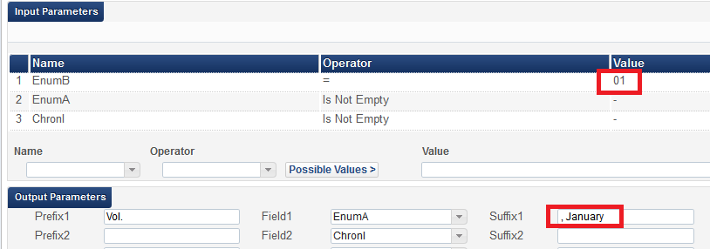

**THREE**

For example here is February. The input parameters say for this to work only if

* Enumeration b = 02
* Enumeration a is not empty
* Chronology level i is not empty

Then it states to make the prefix for Enumeration a ‘Vol. ‘ and the suffix be ‘, February ‘

At the end display chronology level I with no prefix or suffix.

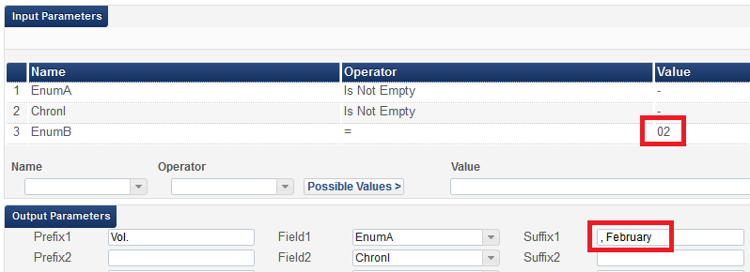

**FOUR**

Here is an example with

* Enumeration level a = ‘2’
* Enumeration level b = ‘01’
* Chronology level i = ‘2012’



After clicking “generate” for the description it returns “Vol. 2, January 2012”

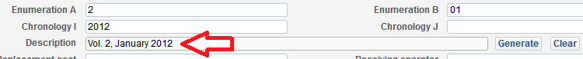

**FIVE**

Here is an example with

* Enumeration level a = ‘2’
* Enumeration level b = ‘02’
* Chronology level i = ‘2012’



After clicking “generate” for the description is returns “Vol. 2, February 2012”

