|  |  |
| --- | --- |
| **How to make a merge rule and routine which will save the 9XX fields of record already in Alma** |  |
|  | |



**Question**

How can I make and use a merge routine so that when I copy and merge from WorldCat it will save the 9XX fields of record already in Alma?

**Note:**

In addition to what appears below please also see the following to presentations in the “Rules” section of <https://knowledge.exlibrisgroup.com/Alma/Training/Extended_Training/Presentations_and_Documents>

1. Rules - Merge rules and routines.pptx
2. Rules - Merge rules syntax for copy cataloging.docx

See especially slide 26 of “Rules - Merge rules and routines.pptx”. This gives the specific syntax to do what is desired here

**Here is what happens now:**

* The record in Alma has a 900, 950 and 951.
* The record in WorldCat has a 938, 948 and 994.

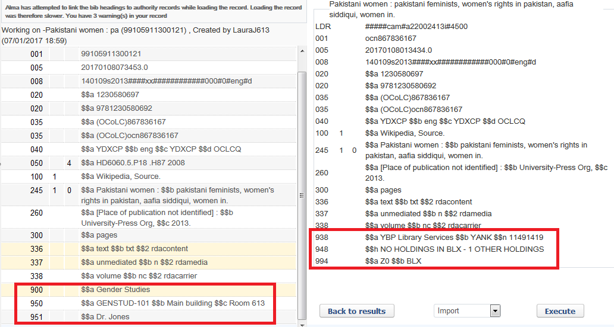

If we do “merge preview” we see that we get only the 938, 948 and 994 from the WorldCat record.

The 900, 950 and 951 from the record in Alma disappear.

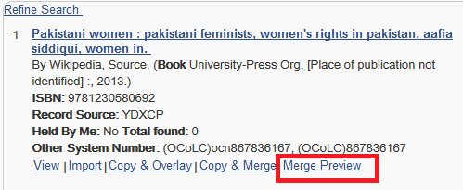

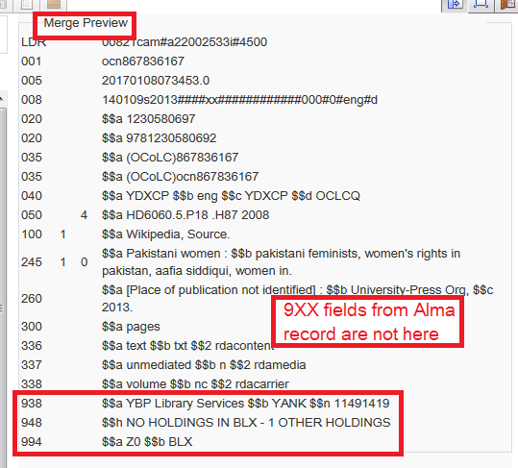

**To make it so that the merge will keep the 9XX fields which are already in the Alma record do as follows:**

**ONE**

Create a merge rule called “Keep all 9XX fields of Alma record during merge”.

Make this rule include the following syntax (note that there is a rule like this in the community folder called EXL - Keep all 9XX fields of Alma record during merge):

**rule "Keep all 9XX fields of Alma record during merge"**

**when**

**merge**

**then**

**add MARC."9XX"**

**end**

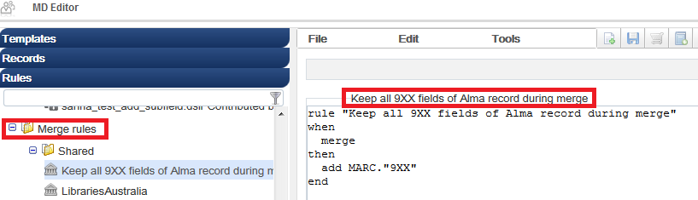

**TWO**

Note that the only activity the above rule does is add the 9XX fields from the existing Alma record to the record with which it is being merged. The syntax used is explained on slide 26 of “Rules - Merge rules and routines.pptx”. The result will be the “The record from WorldCat + the 9XX fields of the Alma record.”

**THREE**

Add this rule to the WorldCat search profile.

Navigate to “Alma > Resource Management > Resource Configuration > Configuration Menu > Search Configuration > External Search Resources > WorldCat > Edit > Merge Method”

Add the merge rule made above.

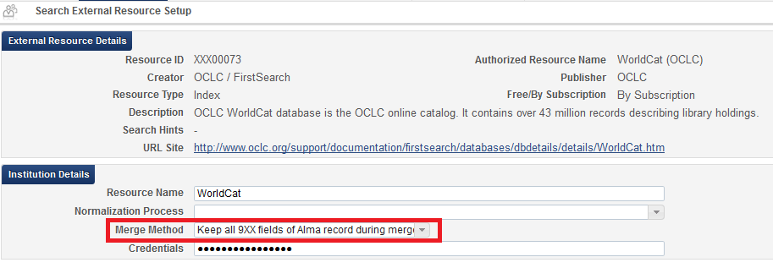

**FOUR**

Give it a test.

Before the merge:

The Alma record has a 650_4 field as well as a 900, 950 and a 951.

The WorldCat record has a 938, 948 and 994

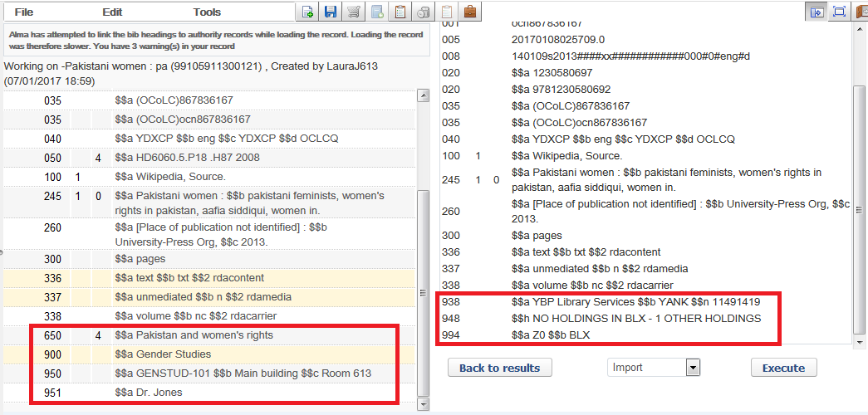

**FIVE**

We do “Merge Preview”.

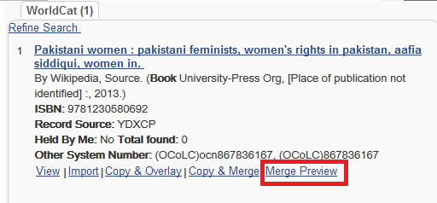

**SIX**

The result is “The record from WorldCat + the 9XX fields of the Alma record.”

We do not have the 650_4 that was in the Alma record.

We do have the 900, 950 and 951 which was in the Alma record.

We also have all of the fields from the WorldCat record including the 9XX fields.

