|  |  |
| --- | --- |
| **How to create a normalization rule to move all contents in angled brackets of 852 subfield h to 852 subfield k** |  |



Introductory note:

After performing the following activities see also presentation “Rules - Normalization rules - How to run a rule on a set of holding records”.

**ONE**

We have a holding record like this

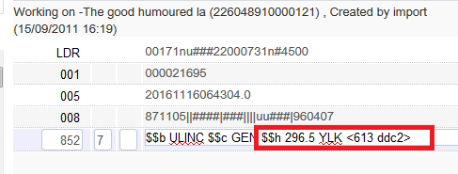

**TWO**

We see that the 852 subfield h has the following text

$$h 296.5 YLK <613 ddc2>

**THREE**

We want to move everything in the angled brackets to subfield k to that instead oif this

$$b ULINC $$c GEN $$h 296.5 YLK <613 ddc2>

We will have this

$$b ULINC $$c GEN $$h 296.5 YLK $$k 613 ddc2

**FOUR**

We will use a normalization rule to change the < to $$k and then change the > to nothing:

rule "Move all contents in angled brackets of subfield h to subfield k"

when

(TRUE)

then

replaceContents "852.h.<" with "$$k "

replaceContents "852.h.>" with ""

changeSubField "852.k" to "k"

end

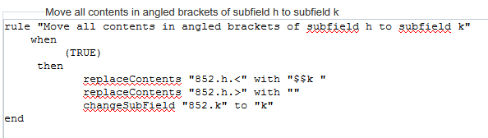

**FIVE**

Test the rule as follows from split editor mode of the metadata editor

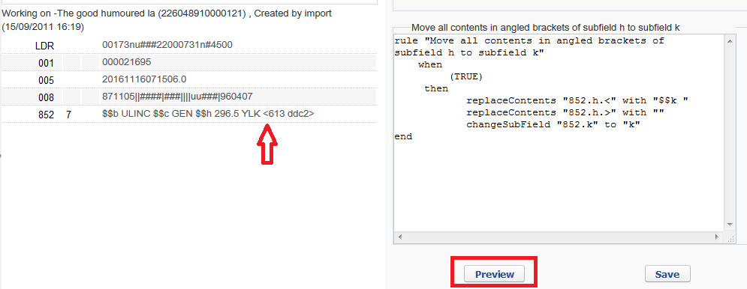

**SIX**

See successful results

