|  |  |
| --- | --- |
| **Merge rules syntax for copy cataloging** |  |



Introduction

The three main commands

Sample data

What we want to happen in the rule

The sample rule explained

The sample rule

The results and data

The case of “Merge and combine inventory”

**Introduction**

In addition to the information below see also the On Line Help.

In this document we will show how to make a merge routine which will be used for “copy cataloging”. When we state “copy cataloging” we mean the following actions:

* A bibliographic record is open in the metadata editor
* The ‘search external resource’ function is invoked
* A record is found
* The ‘copy and merge’ action is done

Note that the syntax of this routine will differ for a merge which is performed as part of an import profile. The import profile and the copy cataloging differ on which record is considered the preferred record and therefore the merge routine syntax also differs.

**The three main commands**

The three main commands in the merge routine are replace, remove and add.

The **replace** really means “keep”. Or, in other words, “replace the value in the incoming record with the value I already have”. This is the case however when no other parameters are used.

The **remove** command removes fields from the incoming library record

The **add** command will add the field you already have to the final results together with what came from the incoming record. The **add** cannot be done on a field which was already removed.

Summary:

* To remove a field you have in the existing library record and replace it with the field in the incoming record use no commands
* To keep the field you have in the existing library record and also get the field from the incoming record use **add**
* To keep the field you have in the existing library record and not also get the field from the incoming record use **remove**

**The sample data**

* In the library catalog we have existing record “Lean In” by “Sandberg, Sheryl”, OCLC number 813526963.
* This record is also present at Library of Congress (Record Source: DLC) and retrievable in Alma via “Search External resources” for “World Cat”.

The record in the library has:

082 $$a 658.4

948 $$a Reviewed by consortial cataloger

994 $$a 248-365-613

The record in WorldCat has:

035 $$a (OCoLC)813526963 $$z (OCoLC)812406870 $$z (OCoLC)838389356 $$z (OCoLC)880953998

035 $$a (OCoLC)ocn81352696305000 $$a HD6054.3 $$b .S265 2013

05000 $$a HD6054.3 $$b .S265 2013

08200 $$a 658.4/092082 $$2 23

994 $$a Z0 $$b WAU

938 $$a Brodart $$b BROD $$n 103471650

938 $$a Baker and Taylor $$b BTCP $$n BK0012284646

938 $$a Coutts Information Services $$b COUT $$n 24032307

938 $$a YBP Library Services $$b YANK $$n 9801050

948 $$h HELD BY WAU - 3077 OTHER HOLDINGS

**What we want to happen in the rule**

The library wants

1. The 082 they already have to be replaced by the 082 of the incoming records. They do not want both the 082 they already have plus the one from the incoming record. They want only the one from the incoming record.
2. The 948 they already have to remain and also get the new 948 from the incoming record.
3. The 994 they already have to remain and not also take the 994 from the incoming

So:

Case 1 is “replace what I have with the incoming”.

This will use **replace**

Case 2 is “keep what I have and also take the incoming”.

This will use **replace** and **add**

Case 3 is “keep what I have and do not take the incoming”.

**The sample rule explained**

Regarding case 1:

We replace the 082 in the library record with the 082 from WorldCat

We state:

remove MARC."0"XX excluding "001,035,082"

Then later we state

replace MARC.XXX excluding "001,035,082,59X,9XX"

So we are doing nothing (it is excluded both times)

Regarding case 2:

We keep the 948 in the library record and also get the one from WorldCat

We state:

remove MARC."9"XX excluding "901,902,940,948,950,952,953,954,956,989,998"

Then later we state

replace MARC.XXX excluding "001,035,082,59X,9XX"

Then later we state

add MARC."9"XX

So we are doing add

Regarding case 3:

We keep the 994 we have and do not take the incoming 994.

We state

remove MARC."9"XX excluding "901,902,940,948,950,952,953,954,956,989,998"

Then later we state

add MARC."9"XX

The second “add” is irrelevant because we already removed the 994.

Only 9XX fields which have not been removed can be added.

So we are only doing remove

**The sample rule**

rule "Merge rule for WorldCatYLK"

when

merge

then

remove MARC."0"XX excluding "001,035,082"

remove MARC."1"XX

remove MARC."2"XX

remove MARC."3"XX

remove MARC."4"XX

remove MARC."50"X

remove MARC."51"X

remove MARC."52"X

remove MARC."53"X

remove MARC."54"X

remove MARC."55"X

remove MARC."56"X

remove MARC."57"X

remove MARC."58"X

remove MARC."59"X excluding "590,599"

remove MARC."6"XX

remove MARC."7"XX

remove MARC."8"XX

remove MARC."9"XX excluding "901,902,940,948,950,952,953,954,956,989,998"

replace MARC.XXX excluding "001,035,082,59X,9XX"

replace MARC."035" when MARC."035"."a" does not contain "[aA]leph" excluding MARC."035"("9"," ")

add MARC."59"X

add MARC."9"XX

end

**The results and data**

Library record before the merge

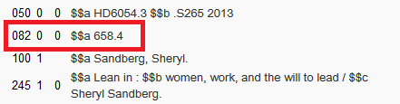

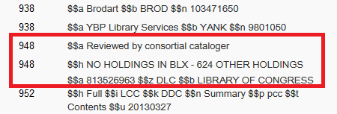

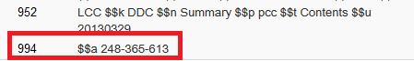

In incoming record

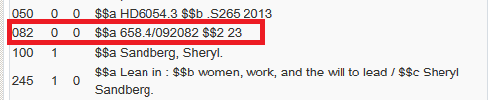

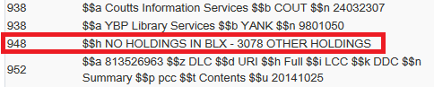

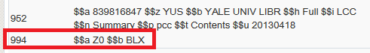

The merge result

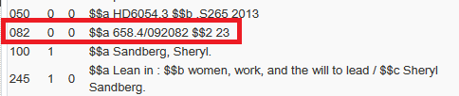

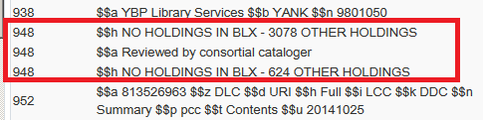

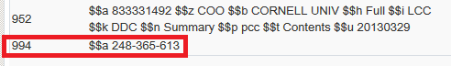

Note that in the case of "Merge and combine inventory" the preferred record is on left side.

