|  |  |
| --- | --- |
| **How to run a normalization rule on a set of holding records** |  |



Below we show how to take a normalization rule created in the metadata editor and add it to a process and then run the process on a set of holding records

**ONE**

In metadata editor create a normalization routine. No need here to specify if it is for a bibliographic or holding record. For example here is one which adds an 866 field with specific text. The normalization routine below is called “YK - add field 866 subfield a Vol. 1-10”. It is written like any other normalization routine:  
  
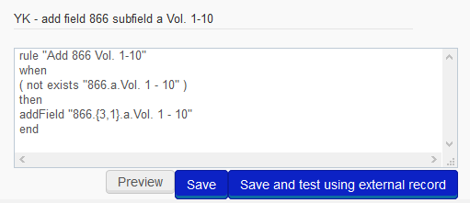

**TWO**

You can then open a holding record in the left pane, and in the right pane edit the normalization routine and run it with “Preview” and see that it works.

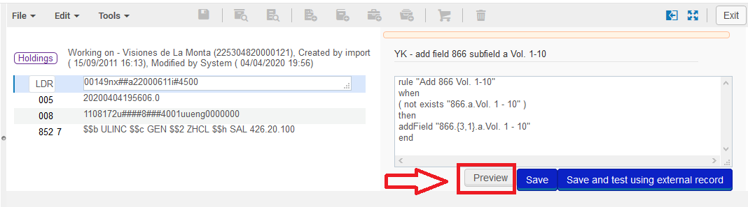

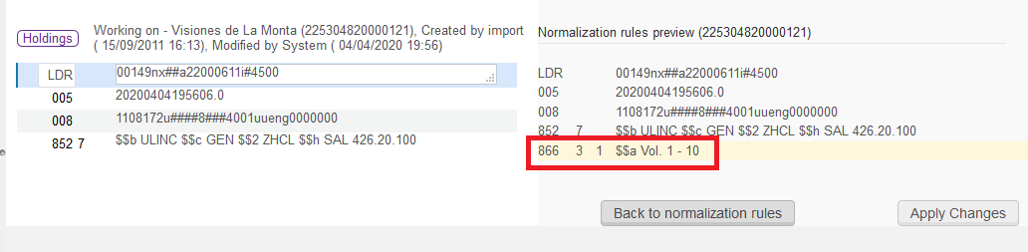

**THREE**

Now we need to add the normalization rule above which is called “YK - add field 866 subfield a Vol. 1-10” to a holding record process. This is done via “resource management configuration menu > Cataloging > Metadata Configuration > MARC21 Holding > Normalization tab > add process”

* In the “general information” tab call it whatever you want. Below we call it “YK - add field 866 subfield a Vol. 1-10”
* In the “normalization” tab add “MarcDroolNormalization”
* In the “task parameters” tab add the rule the rule we made in the metadata editor called “YK - add field 866 subfield a Vol. 1-10”

YK - add field 866 subfield a Vol. 1-10

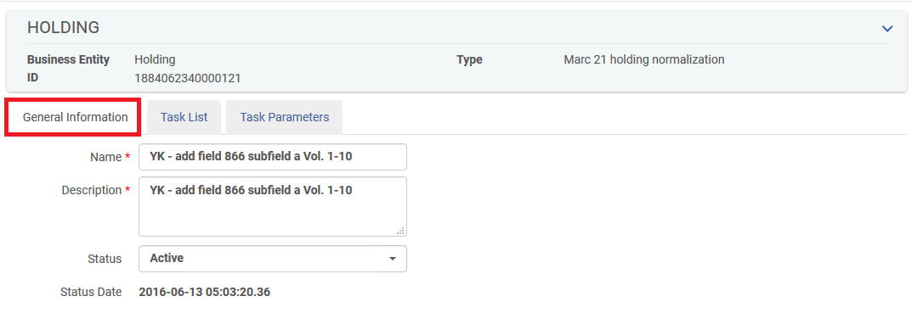

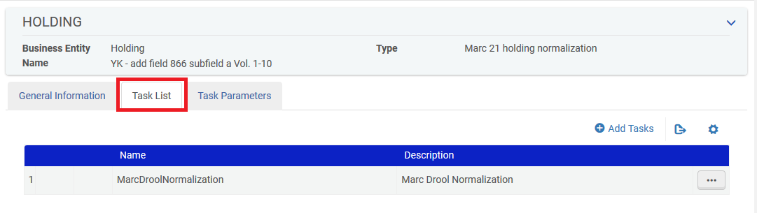

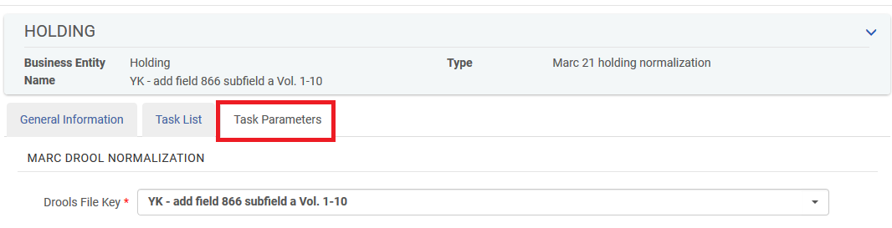

**FOUR**

Create a set to run the process on. The set can be “all titles” or “physical titles”.

We will run the process on the “physical titles” set called “Montana”.

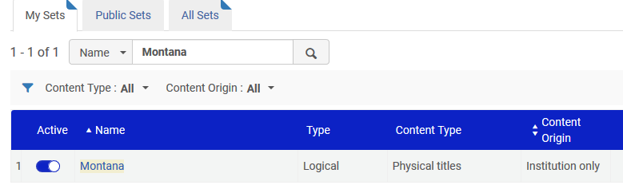

**FIVE**

Run the process called “Change holding information” from “Administration > Manage Jobs > Run a job”

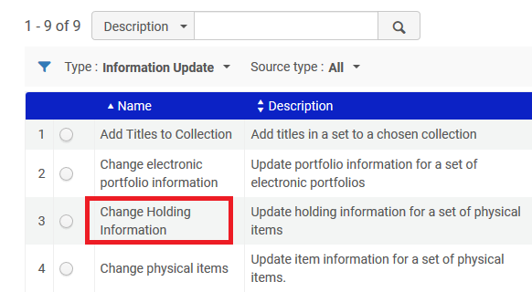

When running the process choose the desired set

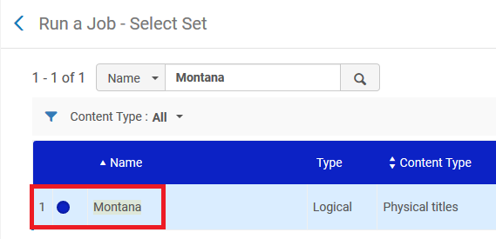

**SIX**

Fill in parameters as desired and in the field “Correct the data using normalization rules” fill in the process we made above which includes the desired normalization rule. Below we chose the one we made above called “YK - add field 866 subfield a Vol. 1-10”



**SEVEN**

Now in results of the set we can see the field was added. In other words, the process worked on the holding records. The bibliographic record was not touched.

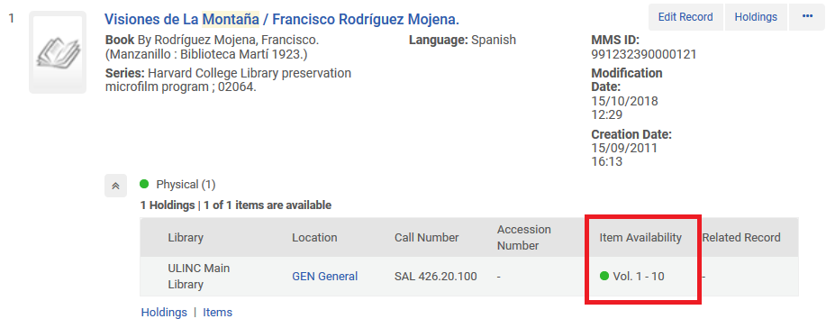

And in the actual holding records we can see it was added

