|  |  |
| --- | --- |
| **How to use the period for replaceContents and addField** |  |



**The replaceContents parameter**

When a period is used in a normalization rule with the replaceContents parameter then it should be preceded with four backslashes.

For example if we have this

24500 $$a Feminist literary theory. : $$b a reader / $$c edited by Mary Eagleton.

2460 $$a F.L.T.

And we want to

1. Remove the period after the “y” in the word “theory”
2. Remove the periods in the string F.L.T. so it will be FLT

Then we could use this normalization rule:

rule "remove period in 245 and 246 subfield a (replace it with nothing) period is specified by preceding it with four backslashes"

when

(TRUE)

then

replaceContents "245.a.\\\\." with ""

replaceContents "246.a.\\\\." with ""

end

Before and after (on the right the periods are gone)

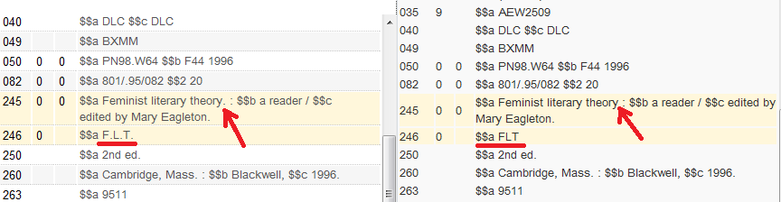

**The addField parameter**

When a period is used in a normalization rule with the addField parameter then it should be preceded with four backslashes.

Note:

1. When the period is not immediately followed by another character then it must have the four backslashes preceding it
2. When the period is immediately followed by another character then it does not require the preceding of four backslashes
3. In both of the above cases preceding it with four backslashes will work, thus it is best practice to always use the four backslashes

Thus is we want to add these two fields:

906 $$a Architecture.

907 $$a F.L.T.

Both of these options will work:

**Option 1**

rule "Add field 906 with text Architecture and period at end and also add field 907 with F.L.T."

salience 100

when

TRUE

then

addField "906.a.Architecture\\\\."

addField "907.a.F.L.T\\\\."

end

**Option 2**

rule "Add field 906 with text Architecture and period at end and also add field 907 with F.L.T."

salience 100

when

TRUE

then

addField "906.a.Architecture\\\\."

addField "907.a.F\\\\.L\\\\.T\\\\."

end

Before (on left) and after (on right):

