|  |  |
| --- | --- |
| **Synchronizing Fund Information from a Financial System to Alma** |  |



**Yoel Kortick**

**Senior Librarian**

**Introduction**

This document will explain the steps in synchronizing fund information from a financial system **to Alma**. Note that it is possible to retrieve fund information from Alma **to a financial system** via an API using the GET option, and more can be learned about this [here](https://developers.exlibrisgroup.com/alma/apis/acq/GET/gwPcGly021oUHLI4O/zpt8U7ewiJYRLM/d5b14609-b590-470e-baba-9944682f8c7e). To update the fund information an Excel sheet or csv file with the relevant information is used. The Excel sheet or csv file contains transaction information for the funds, and in this way it is possible to automatically allocate amounts to the funds.

**The integration profile**

The “Funds Allocation Loader” appears in the “Actions” tab of the integration profile of type “Finance”. See [here](https://knowledge.exlibrisgroup.com/Alma/Product_Documentation/Alma_Online_Help_(English)/Integrations_with_External_Systems/020Acquisitions/010Financial_Systems) for more about this type of integration profile. Via this integration profile the Excel sheet or csv file will be picked up from the ftp server and the funds will receive the relevant allocations.

The integration profile is created via “External systems > Integration Profiles” under the General Configuration menu.

Here in the “General Information” tab the integration type and the ftp server is chosen.

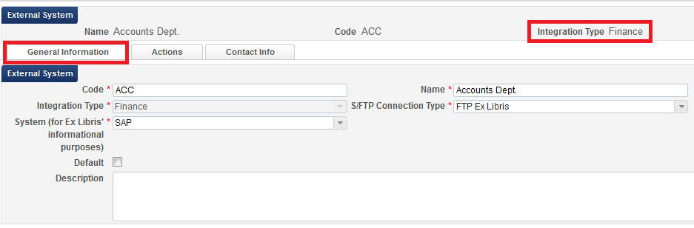

Here in the “Actions” tab we have defined that

* The “Funds Allocation” will occur every day at 02:00 and will be taken from the directory “fundsallocation” on the ftp server.

Note that the job can also be run manually.

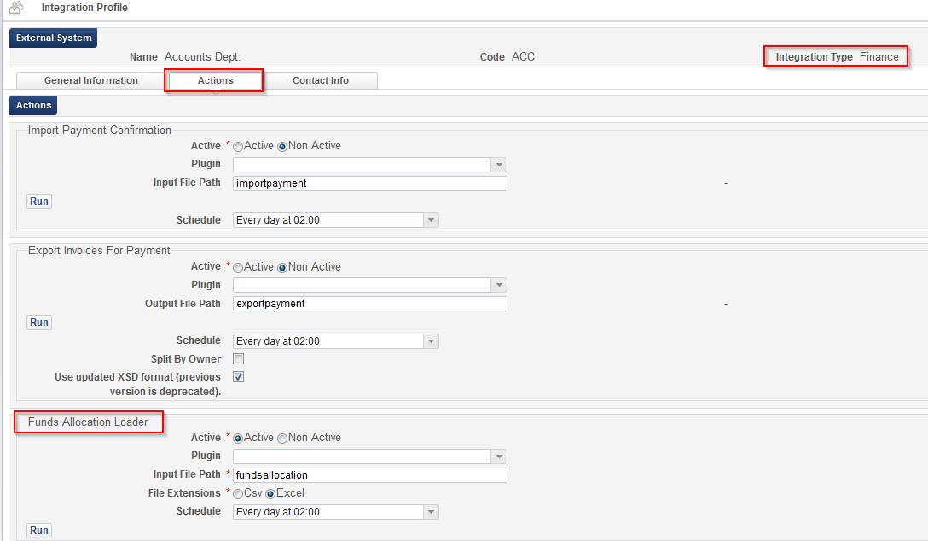

**The excel file is created and ready to be picked up by the system**

For a description of the Excel sheet see [here](https://developers.exlibrisgroup.com/alma/integrations/finance/fund).

For the sample Excel file used here see [this file](https://knowledge.exlibrisgroup.com/@api/deki/files/52376/Acquisitions_-_Fund_Allocation_Loader.xlsx).

Here is the example for our case

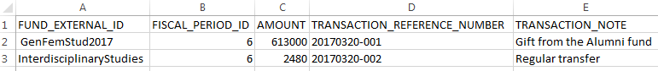

It is on the ftp server in the specified location

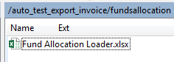

In the Excel file the FUND_EXTERNAL_ID can come from one of these two places.

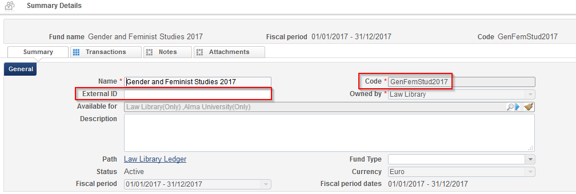

The Fiscal Period ID comes from the ID here in the table in the “Acquisitions Configuration Menu > General > Fund and Ledger Fiscal Period”:

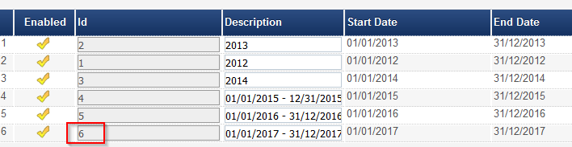

**The “Update Fund Transaction Job” runs**

The “Update Fund Transaction Job” runs as defined in the “Actions” tab of the “Finance” integration profile.



**Results**

We see from the report that two records were loaded and successfully processed.

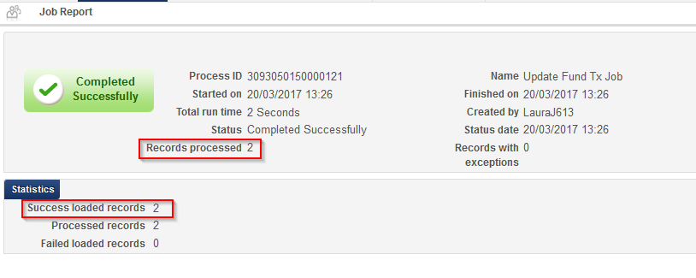

The file on the ftp server gets a suffix “handled” so that it will not be taken again the next time the jib runs.

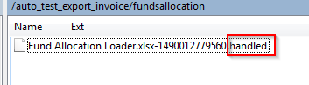

Here we see the first allocation from the Excel file

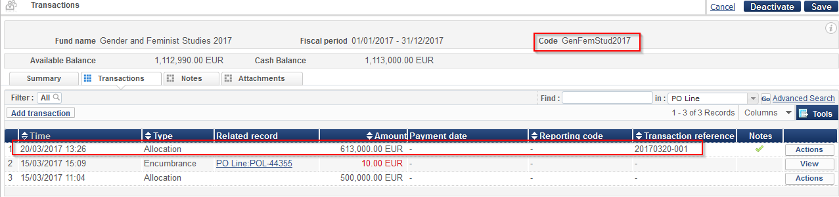

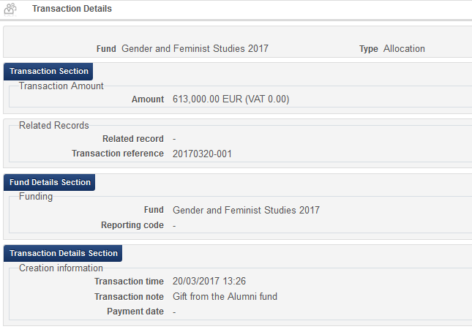

Here we see the second transaction from the Excel sheet

