How to enable the DirectLink sidebar

The sidebar menu of SFX is a replacement for the old DirectLink banner. With the sidebar the user is linked directly to the full text platform but will still see a library service menu on the right hand side of the screen. The sidebar is designed to show only the most important services upfront such as alternative full text options and help functions and the bX recommender if enabled. It has in additional “more” button to open the full SFX link menu.
Link
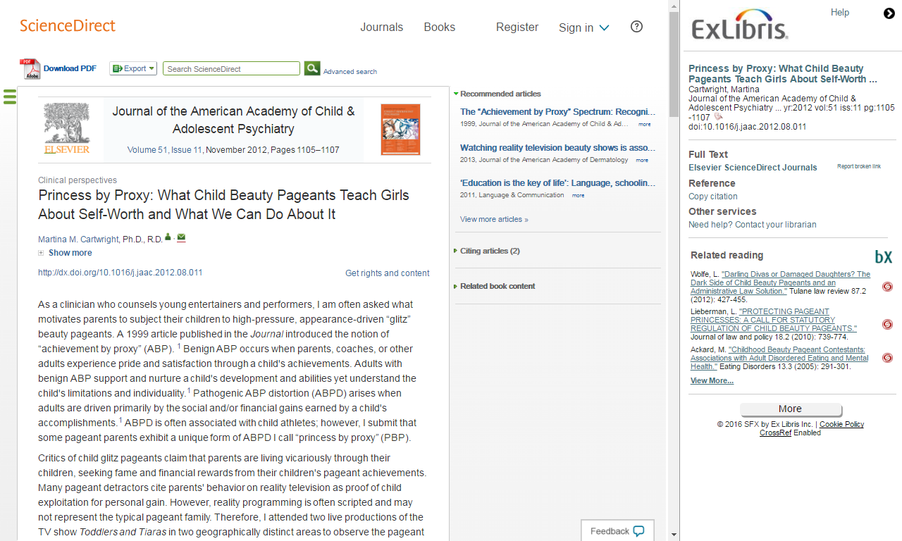

The sidebar minimizes after a few seconds and the user can open it again if desired.
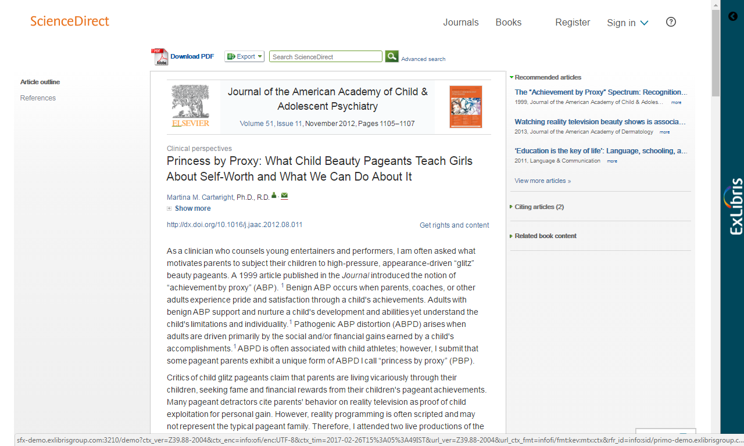

The sidebar enables the user to go directly to the full text without losing the context of the library.
To enable the sidebar from the SFX back office you need to enable DirectLink with the sidebar option

URL: http://sfx-demo.exlibrisgroup.com:3210/sfxadmin/sfxtst4
- Go to SFXAdmin -> Menu Configuration -> DirectLink banner configuration
- Make sure that the DirectLink banner V2 is enabled (if V1 is enabled highlight V2 and click on submit)
- Go to SFXAdmin -> Menu Configuration -> DirectLink
- Switch on DirectLink by selecting the radio button
- Check “Enable Menu Banner/Sidebar for DirectLink”
- Check “Enable DirectLink when multiple targets available”

There are a number of configuration options available. You can just go by the default settings or choose your own:
To the look & feel of the sidebar go to SFXAdmin -> Menu Configuration -> DirectLink banner configuration.
This includes CSS, images and other options to tailor the look and feel to the needs of your institution.
To define the Conditions under which the sidebar is used is go to SFXAdmin -> Menu Configuration -> DirectLink.
For example, you can define the behaviour in case the full text platform does not support showing a sidebar, or choose to show the sidebar only if the user is coming from specific databases or sources.
To customize the Text for services and their headings go to SFXAdmin -> Translations & Display -> Service Public Names.
This allows you to change labels and also to add languages if you want to show the menu in different language versions.

As for Testing the Sidebar,
You have various options to test the sidebar before you release it to your users. If you have an SFX Test instance then you are completely independent and you can test settings without affecting your users at all. If you test on your production instance, here’s what you can do to make sure edits are not yet exposed to users:
- Check css changes via an option in the SFXAdmin -> Menu Configuration -> DirectLink banner configuration section by restricting it to a specific IP
- Restrict DirectLink with the sidebar to a source that you define specifically for testing or that is already defined but not in use in your library

For more information about enabling and configuring your SFX DirectLink Sidebar please refer to the Ex Libris Knowledge Center, where you can find the General User Guide. And a How To article that guides you on enabling the sidebar. Links are provided in the video description.
Thanks!

