|  |  |
| --- | --- |
| **The account discount percent for manual and API POL creation** |  |



This document explains the behavior of the following two aspects when creating a POL (Purchase Order Line) which has a vendor account with a default “account discount percent”:

1. Pricing of the POL (Purchase Order Line)
2. Encumbrance of the fund

Both of these aspects are shown for both manual POL creation and creation via an API from an xml.

Examples of the xml are attached.

As we will see:

* When the POL is created manually the default amount which appears in the “funding” information of the POL is calculated as follows: the “list price” - “account discount percent”. This amount is calculated “on the fly” and can manually be changed and when the order is saved. This is the amount which is encumbered against the fund. See number 1-3 below.
* When the POL is created via an API from an xml the amount which appears in the fund_distribution section of the xml is what is used for encumbering against the fund. There is no “on the fly” calculation of the “list price” - “account discount percent”. If there is no sum in the fund_distribution section of the xml then no sum is encumbrance on the fund. See number 4 below. The amount which gets encumbered on the fund is the amount in the fund_distribution section of the xml. See number 5-6 below. Therefore, the important point is as follows: **if the xml used by the API contains a discounted price then the already discounted price should be put into the fund_distribution section of the xml**.

**ONE**

**This a vendor account which has an “account discount percent”.**

Vendor ‘RBN Press’ has an account with code ‘RBNPrimaryAccount’ and name ‘RBN Primary Account’.

This account has an ‘Account discount percent’ of ‘10’.

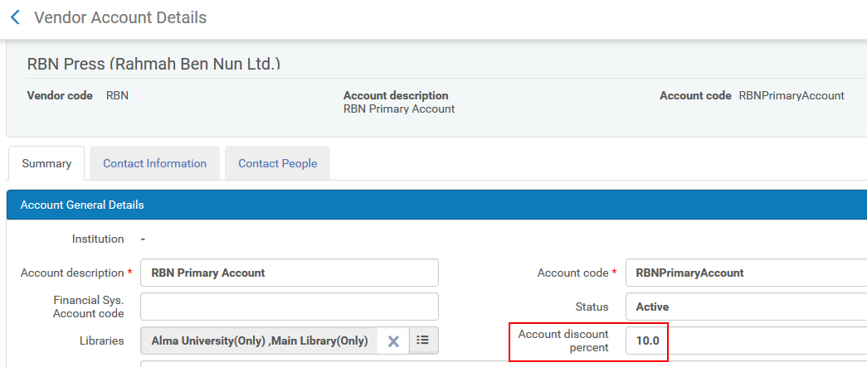

**TWO**

If this vendor account is chosen in the POL (Purchase Order Line) then the discount of 10% automatically appears. If a price of 50 Euro is manually put into the POL (Purchase Order Line) …

In this screenshot the List Price is 50.00, the discount is 10 %, and the fund amount is still 0.00

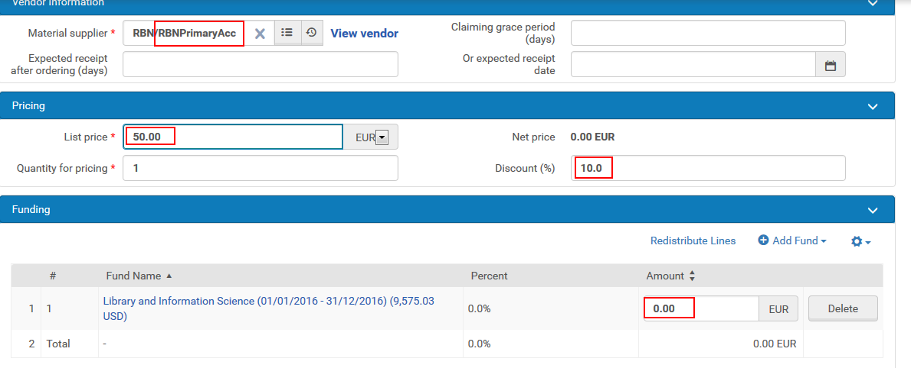

In this screenshot we see that after moving the mouse focus to the “Funding” section of the POL the amount automatically is calculated as 45.00 (which is 50.00 List price * 5.00 discount)

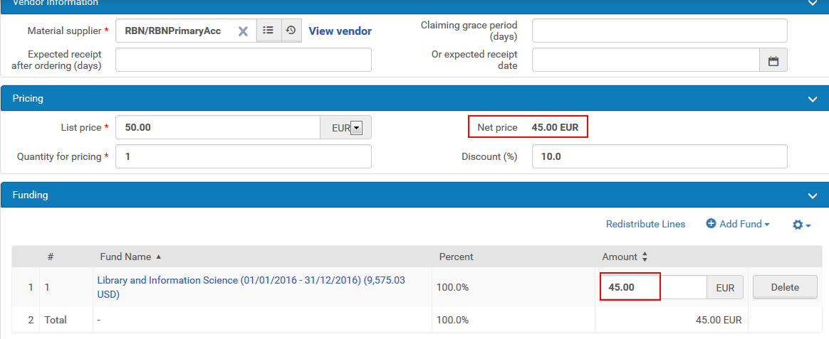

In this screenshot we see the encumbrance on the fund in local currency.

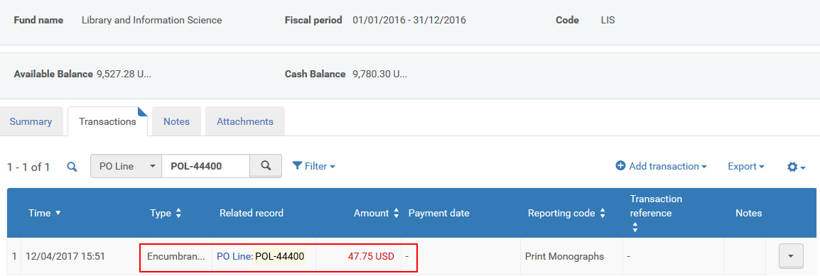

In this screenshot we see that the encumbrance on the fund Euro was 45.00.

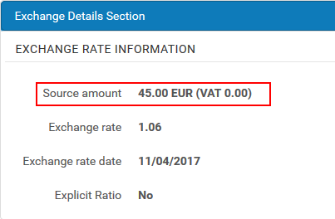

**THREE**

Now we will see the xml of the above fund.

The full xml is called [1 PO Line with correlation between the price and discount with the fund_distribution.xml](https://knowledge.exlibrisgroup.com/@api/deki/files/53390/Acquisitions_-_1_PO_Line_with_correlation_between_the_price_and_discount_with_the_fund_distribution.xml?origin=mt-web)

If we retrieve this POL (POL-44400) via an API we see the following relevant sections:

<po_line>

<number>POL-44400</number>

<status desc="Sent">SENT</status>

<owner desc="Main Library">ULINC</owner>

<type desc="Physical - One Time">PRINT_OT</type>

<vendor desc="RBN Press (Rahmah Ben Nun Ltd.)">RBN</vendor>

<vendor_account>RBNPrimaryAccount</vendor_account>

<acquisition_method desc="Purchase">PURCHASE</acquisition_method>

<rush>false</rush>

<cancellation_restriction>false</cancellation_restriction>

<price>

<sum>50.0</sum>

<currency desc="Euro">EUR</currency>

</price>

<discount>10.0</discount>

….

<fund_distributions>

<fund_distribution>

<fund_code desc="Library and Information Science">LIS</fund_code>

<amount>

<sum>45.0</sum>

<currency desc="Euro">EUR</currency>

</amount>

</fund_distribution>

</fund_distributions>

**FOUR**

Now we will see that the fund_distribution section in the xml must be filled in if there will be any encumbrance amount on the fund.

There is no automatic calculation from the “sum” and “discount” in the xml.

For an example of what happens when the fund_distribution is empty see [2 PO Line with a 10 percent discount and no amount in the fund_distribution.xml](https://knowledge.exlibrisgroup.com/@api/deki/files/53392/Acquisitions_-_2_PO_Line_with_a_10_percent_discount_and_no_amount_in_the_fund_distribution.xml?origin=mt-web)

If a POST were done and no amount was in the fund_distribution section of the xml, for example like this

<po_line>

<number>POL-44400</number>

<status desc="Sent">SENT</status>

<owner desc="Main Library">ULINC</owner>

<type desc="Physical - One Time">PRINT_OT</type>

<vendor desc="RBN Press (Rahmah Ben Nun Ltd.)">RBN</vendor>

<vendor_account>RBNPrimaryAccount</vendor_account>

<acquisition_method desc="Purchase">PURCHASE</acquisition_method>

<rush>false</rush>

<cancellation_restriction>false</cancellation_restriction>

<price>

<sum>50.0</sum>

<currency desc="Euro">EUR</currency>

</price>

<discount>10.0</discount>

….

<fund_distributions>

<fund_distribution>

<fund_code desc="Library and Information Science">LIS</fund_code>

<amount>

<sum></sum>

<currency desc="Euro">EUR</currency>

</amount>

</fund_distribution>

</fund_distributions>

then

The order will be created with no encumbrance on the budget

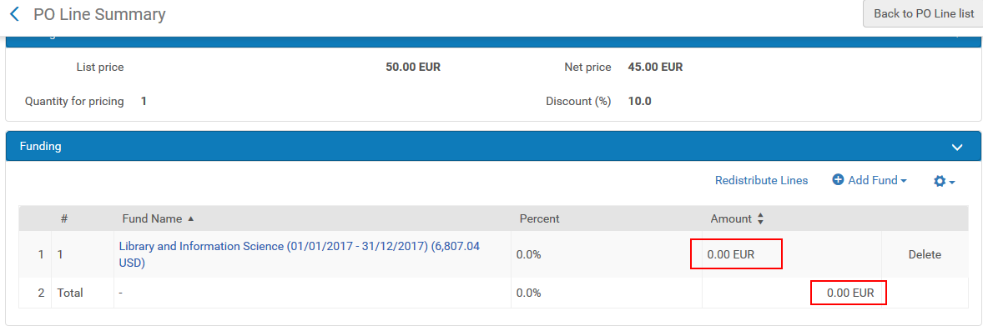

**FIVE**

In order to show that “what really matters” is the fund_distribution section we will make an xml as follows, where there is no real correlation between on the one hand the list price and discount fields and on the other hand the fund_distribution section.

For an example of this API see [3 PO Line with no correlation between the price and discount with the fund_distribution.xml](https://knowledge.exlibrisgroup.com/@api/deki/files/53391/Acquisitions_-_3_PO_Line_with_no_correlation_between_the_price_and_discount_with_the_fund_distribution.xml?origin=mt-web)

In this example the list price is 100 and the discount is 40 percent.

But … in the fund_distribution section the amount is 5.0 (and not 100 – 40 = 60).

This is so that we can demonstrate and prove the point that the encumbrance on the fund comes from the fund_distribution section and not from the list price and discount.

<po_line>

<number></number>

<status></status>

<owner desc="Main Library">ULINC</owner>

<type desc="Physical - One Time">PRINT_OT</type>

<vendor desc="RBN Press (Rahmah Ben Nun Ltd.)">RBN</vendor>

<vendor_account>RBNPrimaryAccount</vendor_account>

<acquisition_method desc="Purchase">PURCHASE</acquisition_method>

<rush>false</rush>

<cancellation_restriction>false</cancellation_restriction>

<price>

<sum>100.0</sum>

<currency desc="Euro">EUR</currency>

</price>

<discount>40.0</discount>

…

<fund_distributions>

<fund_distribution>

<fund_code desc="Library and Information Science">LIS</fund_code>

<amount>

<sum>5.0</sum>

<currency desc="Euro">EUR</currency>

</amount>

</fund_distribution>

</fund_distributions>

**SIX**

The POL which gets created has an encumbrance of 5.

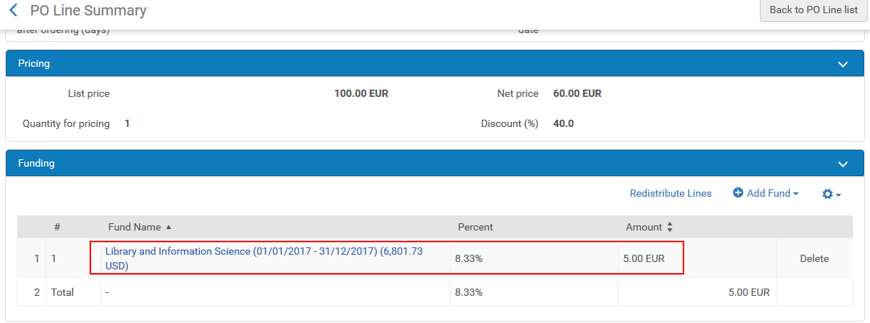

In this screenshot we see the encumbrance in the local currency.

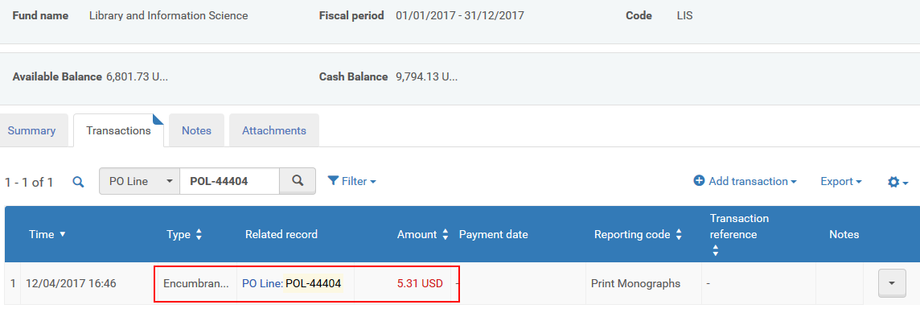

In this screenshot we see the encumbrance in the original currency.

