|  |  |
| --- | --- |
| **How to create an Alma Analytics report of all courses which do not have a reading list** |  |



In order to create an Alma Analytics report of all courses which do not have a reading list you may do as follows:

**ONE**

Create a report in the Course Reserves subject area

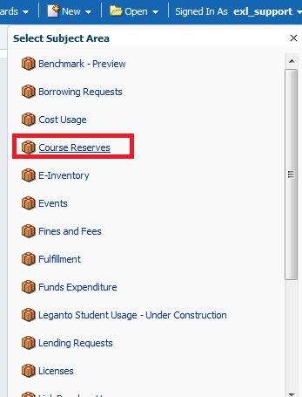

**TWO**

In the criteria tab retrieve only the course code.

Filter by the course code is not null

Filter by the reading list code is not null.

This will give a list of all courses which **do** have a reading list

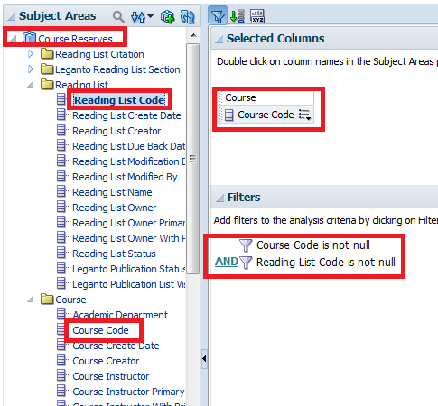

**THREE**

Save the report (for example) as “All course codes which have a reading list”

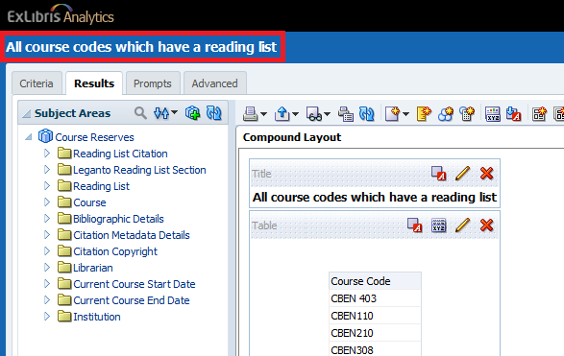

**FOUR**

Create another report in the Course Reserves subject area.

Display whatever fields you want, for example the course code and the course name.

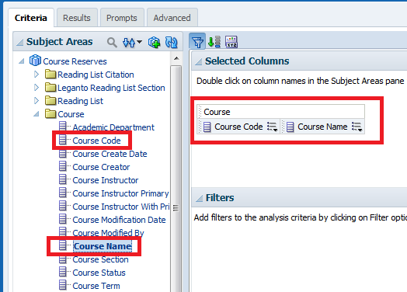

**FIVE**

Filter the course code so that we will get only the course codes which are not in the report we previously made called “All course codes which have a reading list”. This way we will have “All courses which **do not** have a reading list”.

Filter the course code and choose “Is based on results of another analysis”.

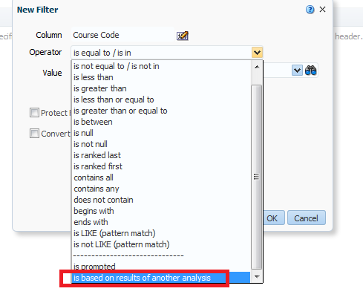

**SIX**

Choose the report we made above called “All course codes which have a reading list”.

Choose relationship “is not equal to any”.

Choose column “Course Code”.

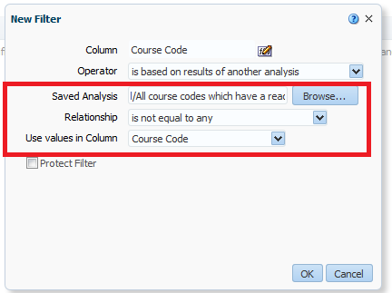

**SEVEN**

See results. We will randomly now check the 1st, 5th and 10th result to make sure in Alma that they really no not have a reading list. We see that in fact they do not have a reading list. We have successfully retrieved all courses which do not have a reading list.

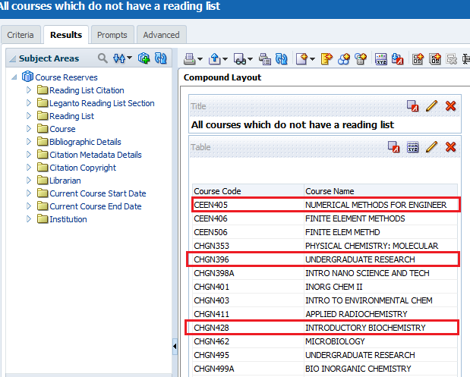

Here is CEEN405:

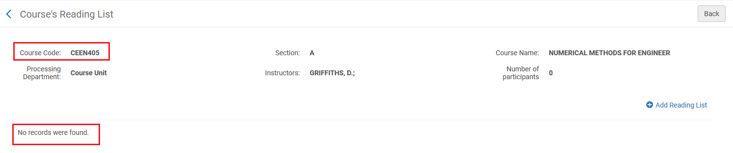

Here is CHGN396:

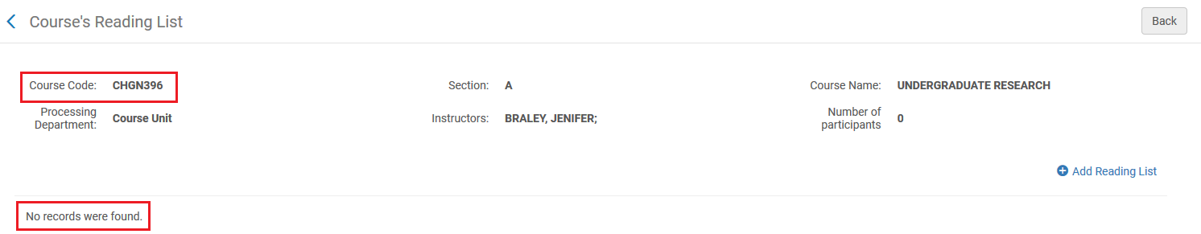

Here is CHGN428:

